Numerische methoden voor de simulatie van landouwkundige en biologische processen

Eindrapport

Modellering van het micromechanisch gedrag van vruchtweefsel

Inhoud

1. Algemeen: over het project 6

1.1. Partners 6

1.2. Object: het studieobject van de eerste biënnale 6

1.2.1. Probleemstelling 6

1.2.2. Oplossingsstrategieën 6

1.3. Werkpakketten 6

2. Experimenteel werk 6

2.1. Overzicht 6

2.2. Biologische achtergrond 7

2.2.1. Celwand van de ui 8

2.2.2. Modellen van de celwand 9

3. Biologische acthergrond 9

3.1. Functions 9

3.2. Composition of cell wall 10

3.2.1. Pectic acid 10

3.2.2. Pectin 10

3.2.3. Cellulose 11

3.2.4. Starch 11

3.2.5. Hemicellulose 11

3.2.6. Structural proteins 12

3.2.7. Functional proteins 12

3.3. Cell expansion 12

4. Plant Cell Walls 14

4.1. Overview 14

4.1.1. The major polysaccharides in the primary wall are: 16

The covalently cross-linked model 16

4.1.2. Techniques used at the CCRC to study walls 1

The primary structures of wall polysaccharides 2

4.1.3. The conformation and interaction of wall polysaccharides 2

4.1.4. The biosynthesis of pectic polysaccharides 2

5. Biomechanische achtergrond 2

5.1. Stress 2

5.2. Strain 3

6. Physical states of a material 5

6.1. Classical ideal materials 5

Ideal elastic behaviour 5

Ideal plastic behaviour 5

Ideal viscous behaviour 5

6.2. Non-classical materials 5

Inelastic behaviour 5

6.3. Time effects 6

6.4. Rheological models 6

Maxwell model 6

Kelvin model 6

Burgers model 6

6.5. Stresses 6

6.6. Poisson’s ratio 6

6.7. Strength 12

6.8. Viscosity 14

6.9. Appendix A: SI units 1

6.10. Appendix B Geometry 2

7. Meshgeneratie 1

7.1. Programma Contour 1

7.2. WritingConfiguration 1

7.2.1. Constant volume 1

7.3. WritingConfiguration03 en 04 3

7.4. Willekeurige inputfiles genereren met WritingConfiguration05 3

7.5. WritingConfiguration07 6

7.5.1. Tissue 01 6

7.5.2. Tissue 02 7

7.5.3. Tissue 05 7

7.5.4. Tissue 06 7

7.5.5. Tissue 03 8

7.5.6. Tissue 04 8

7.6. SelectObject01 10

7.7. Convex hull 10

7.7.1. Schema 10

7.7.2. Parabola 12

7.7.3. Circle 12

7.7.4. Continuous convex hull condition 13

8. SoftTissue 13

8.1. Literatuurstudie 13

8.2. Eerste plan voor een model van plantenweefsel: 13

8.2.1. Kenmerken 14

8.3. Programma SoftTissue02 14

8.4. Programma SoftTissue03 15

8.5. Programma SoftTissue04 17

8.6. Programma SoftTissue05 18

8.6.1. Niet-lineaire veren 18

8.6.2. Visualisatie van de stress 20

8.7. Constant volume vanaf SoftTissue06 21

8.8. SoftTissue18 21

8.8.1. Non-linear behaviour 22

8.8.2. Plasiciteit 22

8.8.3. Hysteresis tgv van viscositeit 23

9. MicroMech 23

9.1. Programma MicroMech01 23

9.2. Programma MicroMech10 24

9.3. Programma MicroMech20 24

9.3.1. Grid search 24

9.3.2. Gevalstudie: 27

9.3.3. Clustering 27

9.3.4. Variabele deeltjesgrootte 27

9.3.5. Individuele massa 28

9.3.6. Simulatie van de stroming in een buis 28

9.3.7. Zwermgedrag 31

9.3.8. Adaptieve tijdstap 31

9.4. MicroMech21 31

9.5. Programma MicroMech23 32

9.6. Stappenplan van 25/11/03 33

9.7. Implementing a Maxwell element 33

9.7.1. Determination of the relation between kSCB and kSPB 36

9.7.2. Exact solution of a Maxwell element 37

9.7.3. Creëren van een realistische inputfile.txt 41

9.8. Meetresultaten 41

9.9. Virtuele experimenten met SoftTissue17forPaperAuto 42

9.10. SoftTissue17resurrection 42

9.11. SoftTissue25 etc. 44

9.12. Onion3D 44

9.13. WritingOnion3D 46

9.14. Tomato 47

9.15. Pitt82 47

10. Compression of single cells 54

10.1. Symbols 54

10.2. Problem statement 56

Model assumptions 56

Coordinate systems 56

Meridian and circumferential direction 58

Infinitesimal arclengths 58

Principal stretch ratios 59

Principal curvatures 60

Principal stress resultants 65

Strain-energy function 65

Strain invariants 66

Principal stresses 66

Principal stress resultants 67

Equilibrium equations 67

10.3. How Feng and Yang did it in 1973 73

About the authors 73

Derivation of the formulas 73

10.4. Debugging papers 74

10.5. Maple 75

10.6. Simulation results 75

Things to contemplate about 81

Tomato05 82

10.7. Introduction 82

Overview of the papers and their relation to one another 82

About the sea urchin 82

10.8. Lardner and Pujara, 1980 83

Introduction 83

Assumptions 83

Experiments 83

10.9. Hiramoto, 1963 83

Assumptions 83

Experiments 83

10.10. Yoneda, 1964 83

Experiments 83

Conclusions 83

10.11. First results for compression of tomato cell 84

11. Finite Element Method for 2D trusses 86

11.1. Problem description 86

11.2. Preprocessing 86

11.3. Initialisation 87

Degrees of freedom 87

Stiffness matrix 87

Element stiffness matrix 87

Transformation matrix 88

11.3.1. Assembly 89

Force term 89

11.4. Partitioning 90

11.5. Solving the equation 90

12. Integration schemes 90

12.1. IntegrationSchemes 90

12.1.1. System with one mass 90

12.1.2. System with two masses 94

12.1.3. Leap Frog Schema 96

12.1.4. Het aanleggen van een kracht 97

12.1.5. Simuleren van de trekproef 97

12.1.6. Berekening van de parameters 98

12.2. Introduction 99

12.2.1. Goals 99

12.3. Gear predictor-corrector algorithm 99

12.3.1. Predictor step 99

12.3.2. Force evaluations 99

12.3.3. Corrector step 100

12.4. Verlet Algorithm 100

12.4.1. Original Version 100

12.4.2. Leap Frog Scheme 101

12.4.3. Velocity version 101

12.5. Test Setup 102

12.5.1. Underdamped Systems 102

12.5.2. Critically Damped System 103

12.5.3. Overdamped System 103

12.6. Solving an inhomogeneous first order differential equation 103

13. Smooth Particle Hydrodynamics 103

13.1. Introduction 104

13.2. Fundamentals 104

13.2.1. Golden rules from Monaghan 104

13.2.2. Integral interpolation 104

13.2.3. Kernels 104

13.3. Equations of motion 105

13.3.1. The momentum equation 105

13.3.2. The continuity equation 106

13.3.3. The thermal energy equation 106

13.4. Equation of state 106

13.5. Smoothing length 107

13.6. h varying with time but constant in space 107

13.7. h varying with time and in space 107

13.8. Time step 108

13.9. Time integration 108

13.10. X-tra 109

13.10.1. XSPH variant 109

13.10.2. Individual time steps 109

13.11. Implementation 109

13.11.1. Initialization 109

13.11.2. General scheme 109

13.11.3. Particle attributes 110

13.11.4. Obstacles 110

13.11.5. Data structures 110

13.11.6. Hierarchical tree 110

13.11.7. Linked list 110

13.12. Validation 110

13.12.1. Double shock tube problem in 1D 110

13.13. Resultaten 111

14. Molecular Dynamics 112

14.1. Lennard-Jones potential 112

14.1.1. Properties of Lennard-Jones potantial: 113

15. Werkschema 113

15.1. Mijlpalen 113

16. Publicaties 113

16.1. Partec04 paper 113

16.2. AgEng04 113

16.3. Paper02 113

17. Gevolgde cursussen 113

17.1. Numerieke Benadering en Geometrische Modellering 114

17.2. GraSMech 115

18. Opportuniteiten 115

19. Referenties 116

# Algemeen: over het project

## Partners

Vlaams Centrum voor Bewaring van Tuinbouwproducten

Willem de Croylaan 42, B-3001 Heverlee, Belgium

Laboratorium voor Landbouwwerktuigkunde

Kasteelpark Arenberg 30, B-3001 Leuven, Belgium

Nieuwe structuur: MeBioS

## Object: het studieobject van de eerste biënnale

### Probleemstelling

Voorspellen van vervorming en breuk van vruchtweefsel

Traditioneel gebeurt dit aan de hand van. impactenergie (slinger)

Problemen

* Niet statisch (→ elektronische vruchten met krachtsensoren)
* Verschillende soorten: vrucht-vrucht, vrucht-wand, normaal- en schuifspanningen
* Tijdrovend, geen volledige controle
* Niet optimaal voor het verwerven van inzicht en het uitvoeren van gevoeligheidsstudies

### Oplossingsstrategieën

*Macroscopische* benadering: Het weefsel is een visco-elastisch continuüm dat beschreven kan worden in termen van de continuümmechanica

*Microscopische* benadering: Eindige elementen method (FEM of an apple fruit cell, Wu en Pitts, 1999) is hierbij een mogelijkheid, maar dit wordt al snel zeer rekenintensief wanneer een gans weefsel bestaande uit duizenden cellen gemodelleerd moet worden. Een techniek die minder rekenintensieve benaderingen toelaat is de discrete elementen methode.

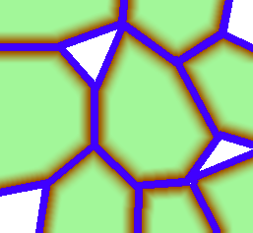

celinhoud

celwand

midellamel

intercellulaire ruimte

## Werkpakketten

1. Experimenteel werk
   * 2D ui
   * pectine
   * 3D appel
2. Eindige elementen model
   * microscopisch (ui + pectine)
   * macroscopisch: risicoanalyse
3. Discrete elementen model
   * microscopisch (ui + pectine)
   * meso- en macroscopisch (appel)

# Experimenteel werk

## Overzicht

Zaken die onderzocht kunnen worden aan de hand van experimentele methoden en later gebruikt kunnen worden om de opgestelde modellen te valideren zijn onder andere:

In 2D richten we onze aandacht op het epidermaal weefsel van ui aangezien dit slechts één cellaag dik is. De preparatie zou kunnen gebeuren zoals beschreven in Wilson et al., 2000. Van dit weefsel kunnen we de *kracht-vervormingscurve* opmeten met de micromechanische trekbank die aangekocht werd door het VCBT, simultaan worden cameraopnamen van de *vervormingen* gemaakt. De *turgordruk* zou kunnen gemeten worden aan de hand van een microcapillair, pressure probe genaamd. Helaas blijkt deze meting zeer moeilijk uit te voeren en diegene die daar een expertise in had Andy van het VCBT is niet langer bereikbaar of zo.

De dunne laag op de scheiding tussen twee plantencellen is de pectinefractie. Hiervan moeten we de *adhesieve eigenschappen* bepalen om te komen tot een model van een weefsel. Dit zou haalbaar moeten zijn met de universele testmachine (UTS), hoewel het niet duidelijk is hoe deze fractie geisoleerd kan worden zonder haar mechanische eigenschappen te veranderen.

In 3D zullen blokjes parenchymweefsel van appel bestudeerd worden waarbij de validatie vooral kan gebeuren aan de hand van *kracht-vervormingscurves* en karakterisering van de *breukvlakken.*

## Biologische achtergrond

Een typische plantaardige cel ziet er als volgt uit:



Het vochttransport doorheen de celwand is een cruciale factor bij de modellering

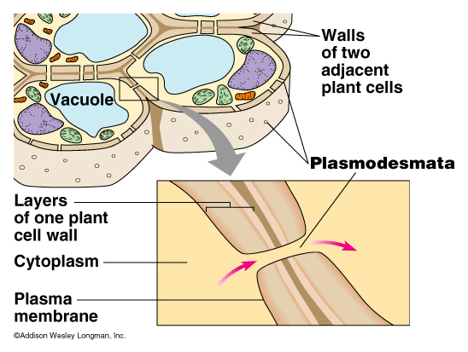

Dit vochttransport vindt plaats doorheen de plasmodesmata, maar ook gewoon via diffusie.

### Celwand van de ui

Microfibrillen bestaan uit cellulose en hemicellulose (xyloglucan). Ze zitten ingebed in een matrix van pectine (veel galactine). De grootste volumefractie bestaat uit water hetgeen bepalend is voor de rheologische eigenschappen.

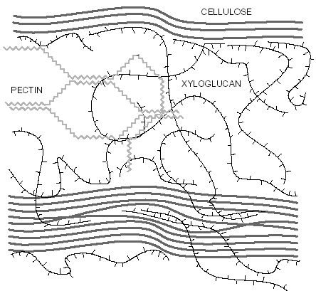

Uit de literatuur halen we dat een gemiddelde uicel ca. 125 x 40 μm (Wilson, 2000) meet. Met behulp van Infrarood Spectroscopie is het mogelijk de oriëntaties van de microfibrillen te meten. De cel wordt vervormd tot 175 x 22 μm.

De cellulose ketens oriënteren zich blijkbaar parallel met de richting van uitrekking, gegevens over hun orientatie bij wortels Mirokawa en Senda, 1978 spreken dit echter tegen. Deze uitrekking resulteert in een plastische vervorming.

De pectineketens loodrecht op de richting van uitrekking ondergaan slechts een kleine elastische vervorming. Er schijnt geen directe koppeling tussen cellulose en pectine te bestaan.

Kort samengevat ziet het mechanisme bij uitrekking er ongeveer als volgt uit: Het eerste mechanische dat in werking treedt vangt spanningen op door de flexibele pectine-matrix (middellammellen inbegrepen): 0.6 ms sneller dan de gemiddelde respons. Verolgens vervormt de cellulose-matrix: 2.0 ms trager dan de gemiddelde respons van het weefsel

Whitney, 2000 publiceerde verschillende schijnbare spannings-vervormingscurves voor uniaxiale rek. Hierbij werd de cellulose en xyloglucan geproduceerd door Acetobacter xylinus. Bij de curve voor cellulose en xyloglucan zien we een niet-lineaire trend t.g.v. heroriëntatie van cellulosefibrillen.

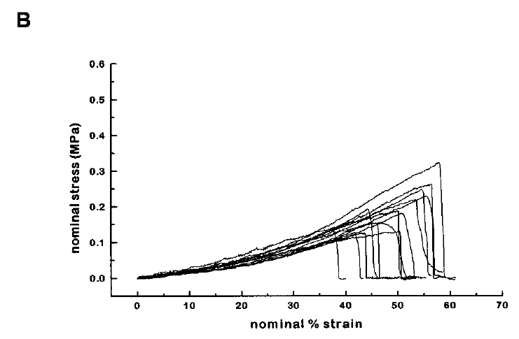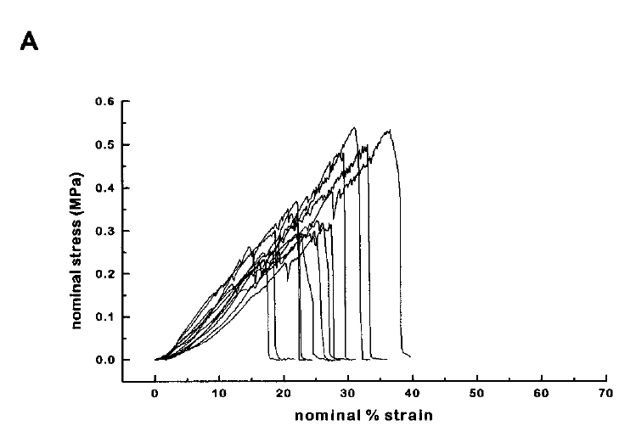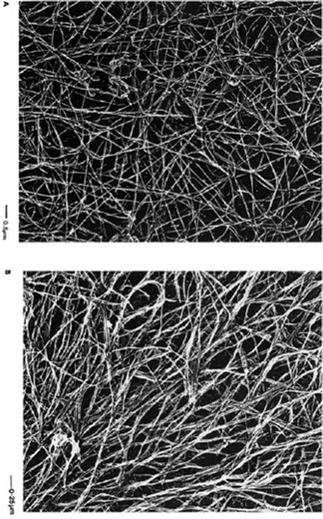

cellulose

cellulose+xyloglucan

Specifieke experimenten op uiweefsel werden uitgevoerd door Wei, 2001. De turgordruk bleek 0.54 ± 0.02 MPa te bedragen hetgeen overeenstemt met de resultaten van Lintilhac, 2000. De Young’s modulus E = 8.0 (10 tot 100 x groter in andere studies). Als Poisson’s ratio werd ν = 0.30 genomen. Bij een longitudinale strook bedroeg de elasticiteitsgrens: 18 gf en het brekingspunt: 40 gf. Bij een transversale strook bedroeg de elasticiteitsgrens: 13 gf en het brekingspunt: 20 gf, zoals te zien is op volgende figuren.

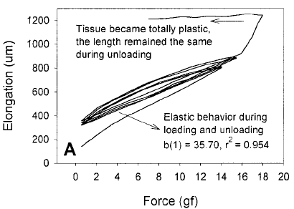

Force (gf)

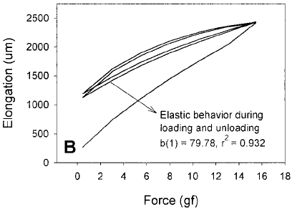

wrinkels in tissue  
bondings on surface

Het verschil in tussen de eerste uitrekking en de volgende werd toegeschreven aan onzuiverheden aan het oppervlak of ‘kreuken’ in het weefsel. Dit fenomeen wordt echter ook geobserveerd bij rubbers en andere materialen, waar het voortvloeit uit de microscopische interacties van moleculen.

### Modellen van de celwand

Nilsson model + uitbreidingen

Anisotroop homogeen composietmodel (Cowdrey en Preston, 1966)

Veronderstellingen

* trekspanningen veroorzaken een heroriëntatie
* elke celwandlaag ondervindt een andere spanning

Multinet model

* nieuwe microfibrillen ┴ toekomstige lengterichting

Helical spring model

* microfibrillen in ║lagen waarvan de oriëntatiehoek meedraait met de klok (Preston, 1966; Hepworth, 1998)

# Biologische acthergrond

## Functions

* Provide tensile strength and limited plasticity which are important for:
* keeping cells from rupturing from turgor pressure
* turgor pressure provides support for non-woody tissues
* Thick walled cells provide mechanical support
* Tubes for long-distance transport
* Cutinized walls prevent water loss
* Provide mechanical protection from insects & pathogens
* Physiological & biochemical activities in the wall contribute to cell-cell communication

During growth and development

* Cell division involves synthesis of new cell wall
* Cell enlargement involves changes in cell wall composition
* Cell differentiation involves changes in cell wall composition

Cell walls consist of 3 types of layers

* **Middle lamella**: This is the first layer formed during cell division. It makes up the outer wall of the cell and is shared by adjacent cells. It is composed of pectic compounds and protein.
* **Primary wall**: This is formed after the middle lamella and consists of a rigid skeleton of cellulose microfibrils embedded in a gel-like matrix composed of pectic compounds, hemicellulose, and glycoproteins.
* **Secondary wall**: formed after cell enlargement is completed. The secondary wall is extremely rigid and provides compression strength. It is made of cellulose, hemicellulose and lignin. The secondary wall is often layered.

## Composition of cell wall

Link: http://sunflower.bio.indiana.edu/~rhangart/courses/b373/lecturenotes/cellwall/cellwall.html

### Pectic acid

* polymer of around 100 galacturonic acid molecules
* very hydrophilic and soluble - become very hydrated
* forms salts and salt bridges with Ca++ and Mg++ that are insoluble gels
* major component of middle lamella but also found in primary walls

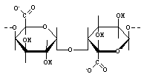

galacturonic acid

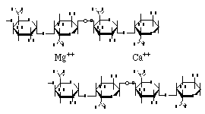

Pectic acid with salt bridges

Because the carboxyl groups on the galacturonic acid molecules are weak acids, they can exist in negatively charged and uncharged states depending on protonation (see fig below). The extent to which the molecules are protonated is pH dependant and related to the pKa (the pH at which the two forms are in equilibrium).

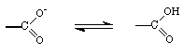

### Pectin

* polymer of around 200 galacturonic acid molecules
* many of the carboxyl groups are methylated (COOCH3)
* less hydrated then pectic acid but soluble in hot water
* another major component of middle lamella but also found in primary walls

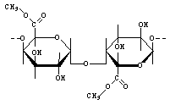

### Cellulose

polymer of glucose - typically consisting of 1,000 to 10,000 beta-D-glucose residues - major component of primary and secondary wall layers.

Cellulose polymers associate through H-bonds. The H-bonding of many cellulose molecules to each other results in the formation of **micro fibers** and the micro fibers can interact to form **fibers**. Certain cells, like those in cotton ovules, can grow cellulose fibers of enormous lengths.

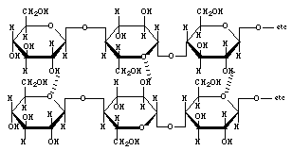

Cellulose fibers usually consist of over 500,000 cellulose molecules. If a fiber consists of 500,000 cellulose molecules with 5,000 glucose resides/cellulose molecule, the fiber would contain about 2.5 billion H-bonds. Even if an H-bond is about 1/10 the strength of a covalent bond, the cumulative bonding energy of 2.5 billion of them is awesome. It is the H-bonding that is the basis of the high tensile strength of cellulose.

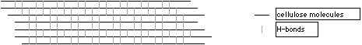

### Starch

Starch is also a polymer of glucose. However, instead of a beta-1,4 linkage between glucose molecules, starch uses an alpha-1,4 linkage. The difference is due to the conformation of the ring structure. The alpha-1,4 linkage causes the polymer to take on a twisted configuration instead of the linear shape of cellulose. Thus, starch forms globular structures. Starch molecules are often branched, which also prevents linear arrays from forming. In plants, starch is only found in plastids (not in walls or cytoplasm).

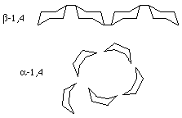

### Hemicellulose

Hemicellulose is a polysaccharide composed of a variety of sugars including xylose, arabinose, mannose. Hemicellulose that is primarily xylose or arabinose are referred to as xyloglucans or arabinoglucans, respectively.

Hemicellulose molecules are often branched. Like the pectic compounds, hemicellulose molecules are very hydrophilic. They become highly hydrated and form gels. Hemicellulose is abundant in primary walls but is also found in secondary walls.

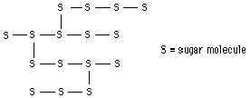

### Structural proteins

In addition to carbohydrates, cell walls contain a variety of proteins. One type of cell wall proteins, called **glycoproteins** contains carbohydrate side chains on certain amino acids. One common group of cell wall proteins are characterized by having an abundance of the amino acid hydroxyproline. Strucural proteins are found in all layers of the plant cell wall but they are more abundant in the primary wall layer.

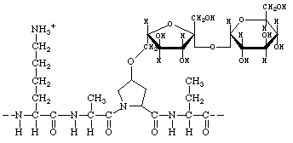

Like the cell wall carbohydrates, glycoproteins are hydrophilic and can form H-bonds and salt bridges with cell wall polysaccharides.

In addition to hydroxyproline, cell wall proteins are often high in the amino acids proline and lysine. The NH3+ on lysine provides positive charges along the peptide backbone. The positive charges residues can associate with negatively charged groups on pectic acids, etc. In addition to electrostatic interactions, H-bonds also form between amino acid side chains and cell wall carbohydrates.

Another type of structural cell wall protein, called **extensin**, can form covalent bonds with other extensin proteins through the amino acid tyrosine. In extensin, the tyrosines are evenly spaced and when they bond with tyrosine on another extensin molecule, the can wrap around other cell wall constituents "knitting" the wall together.

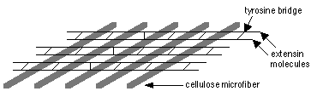

The amount of extensin changes with development. Cells that have thick, hard walls are often rich in extensin (i.e., sclerids and fibers). the amount of extensin produced is dependent on mechanical wounding, infection and these responses are mediated by plant hormones.

### Functional proteins

Cell walls also contain functional proteins. Enzymatic activities in cell walls include:

Oxidative enzymes - peroxidases

Hydrolytic enzymes - pectinases, cellulases

"Expansins" - enzymes that catalyze cell wall "creep" activity

General functions of cell wall enzymes include protection against pathogens, cell expansion, cell wall maturation.

## Cell expansion

**Cell expansion** involves loosening of existing wall materials and production of new material. Cell wall loosening can occur by at least 3 mechanisms:

1) Wall acidification - H+ATPase in plasma membrane 'pumps" H+ from cytoplasm into cell wall. The pH of the wall drops and carboxylic acids become protonated and 'salt bridges" are broken.

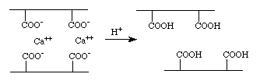

2) In addition, the enzyme "expansin" is activated and causes cellulose micro fibers to slip (mechanism of expansin action is unknown). This results in cell wall "creep".

3) Hydrolytic enzymes like cellulase and pectinase, “degrade” cell walls by breaking polymers into smaller subunits or by breaking crosslinks.

Link: <http://www.ccrc.uga.edu/~mao/intro/ouline.htm>

# Plant Cell Walls

Complex Carbohydrate Research Center – The University of Georgia

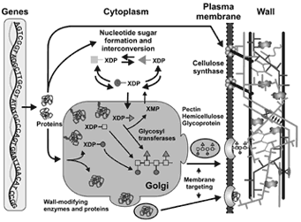

## Overview

Plant cell wall research at the CCRC is carried out by six independently funded groups. These groups study diverse topics that include the primary structure and three-dimensional conformations of wall components, the interactions of wall components, and the biosynthesis of wall components. In addtion we are studying the role of the cell wall as a source of biological active molecules and as a barrier to plant pathogens.   
What is a primary cell wall

Growing plant cells are surrounded by a polysaccharide-rich primary wall. This wall is part of the apoplast which itself is largely self-contiguous and contains everything that is located between the plasma membrane and the cuticle. The primary wall and middle lamella account for most of the apoplast in growing tissue. The symplast is another unique feature of plant tissues. This self-contiguous phase exists because tube-like structrues known as plasmodesmata connect the cytoplasm of different cells.  
  
Plants differ in shape and size. These differences result from the different morphologies of the various cells that make up the vegetative and reproductive organs of the plant body. Changes in tissue and organ morphology that occur during plant growth and development result from controlled cell division and growth together with modification and structural reorganiztion of the wall, and the synthesis and insertion of new material into the existing wall.

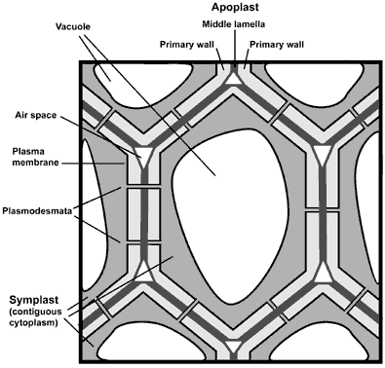

**Some of the functions of the primary wall:**

* Structural and mechanical support.
* maintain and determine cell shape.
* resist internal turgor pressure of cell.
* control rate and direction of growth.
* ultimately responsible for plant architecture and form.
* regulate diffusion of material through the apoplast.
* carbohydrate storage - walls of seeds may be metabolized.
* protect against pathogens, dehydration, and other environmental factors.
* source of biologically active signalling molecules.
* cell-cell interactions.

Primary walls are the major textural component of plant-derived foods. The ripening of fruits and vegetables is associated with changes in wall structrue and composition. Plant-derived beverages often contain significant amounts of wall polysaccharides. Some wall polysaccharides bind heavy metals, stimulate the immune system or regulate serum cholesterol. Wall polysaccharides are used commercially as gums. gels, and stabilizers. Thus, cell wall structure and organization is of interest to the plant scientist, the food processing industry and the nutritionist.

**Primary wall composition and architecture**  
  
Primary walls isolated form higher plant tissues and cells are composed predominantly of polysaccharides together with lesser amounts of structural glycoproteins (hydroxyproline-rich extensins) , phenolic esters (ferulic and coumaric acids), ionically and covalently bound minerals (e.g. calcium and boron), and enzymes. In addition walls contain proteins (expansins) that are believed to have a role in regulating wall expansion. Lignin, a macromolecule composed of highly cross-linked phenolic molecules, is a major component of secondary walls.

### The major polysaccharides in the primary wall are:

**Cellulose** - a polysaccharide composed of 1,4-linked [β-D-glucose](http://www.ccrc.uga.edu/~mao/monos/text.htm) residues

[Hemicellulose](http://www.ccrc.uga.edu/~mao/xyloglc/Xtext.htm) - branched polysaccharides that are structurally homolgous to cellulose because they have a backbone composed of 1,4-linked [β-D-hexosyl](http://www.ccrc.uga.edu/~mao/monos/text.htm) residues. The predominant hemicellulose in many primary walls is xyloglucan. Other hemicelluloses found in primary walls include arabinoxylan, glucomannan, and galactomannan.

[Pectin](http://www.ccrc.uga.edu/~mao/galact/gala.htm) - a family of complex polysaccharides that all contain 1,4-linked [α-D-galacturonic acid](http://www.ccrc.uga.edu/~mao/monos/text.htm). To date three classes of pectic polysaccharides have been characterized: Homogalacturonans, rhamnogalacturonans, and substituted galacturonans.

The organization and interactions of wall components is not known with certainty and there is still considerable debate about how wall organization is modified to allow cells to expand and grow. Several models have been proposed to account for the mechanical properties of the wall:

The covalently cross-linked model  
Peter Albersheim and colleagues in 1973 proposed that the wall matrix polymers (xyloglucan, pectin, and glycoprotein) are covalently linked to one another. The binding of xyloglucan to cellulose microfibrils results in a non-covalently cross-linked cellulose-hemicellulose network that gives the wall tensile strength. This model has been questioned because of the lack of evidence for the existence of covalent linkages between xyloglucan, pectin and glycoprotein.

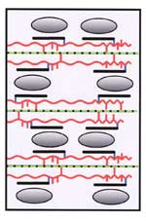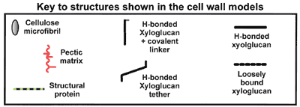

|  |  |  |
| --- | --- | --- |
| **The tether model** | **The diffuse layer model** | **The stratified layer model** |
| Xyloglucan molecules are hydrogen bonded to and cross-link cellulose microfibrils. The cellulose-xyloglucan network is emeshed in a non-covalently cross-linked pectic network. | Xyloglucan molecules are hydrogen bonded to the surface of cellulose microfibrils but do not directly cross link them. The tightly-bound xyloglucan is surrounded by a layer of less-tightly bound polysaccharides. The cellulose and xyloglucan are embedded in a pectic matrix. | Xyloglucan molecules are hydrogen bonded to and cross-link cellulose microfibrils. The cellulose-xyloglucan lamellae are separated by strata of pectic polysaccharides. |

Much research is sitll required to provide a complete description of the primary wall at the molecular level. Moreover, there is increasing evidence that primary walls are dynamic structures whose composition and architecture changes during plant growth and development.

### Techniques used at the CCRC to study walls

We are interested in several aspects of the primary wall including:

* The primary structure of wall polysaccharides
* The conformation and interactions of wall polysaccharides
* The biosynthesis of wall polysaccharides
* The molecular and genetic mechanisms involved in wall formation
* Developmentally-associated changes in wall structure
* The role of the wall in plant-pathogen interactions

We use primary walls isolated from plants and suspension-cultured plants cells:

|  |  |
| --- | --- |
| **Plants** | **Suspension-cultured cells** |
| Arabidopsis | Arabidopsis |
| Tomato | Tomato |
| Tobacco | Sycamore |
| Lemna | Rice |
| Ferns | Soybean |
| Horsetails | Grapefruit |
| Lycopods | Coleochaete(green algae) |
| Mosses | Microcystis (cyanobacterium) |
| Liverworts |  |
| Hornworts |  |

The primary structures of wall polysaccharides  
Pectic polysaccharides (RG-I, RG-II, and oligogalacturonides) are released by treating walls with endopolygalacturonase. High molecular weight pectic polysaccharides are solubilized with aqueous buffers and chelators such as CDTA.

Xyloglucan oligosaccharides are solubilized by treating walls with endoglucanse. High molecular weight hemicelluloses are solubilized by treating walls with 1 and 4M KOH

The solubilized polysaccharides are then purified by size-exclusion and anion-exhchange chromatographies.

**The primary sequence of a polysaccharide is known when the following have been determined:**

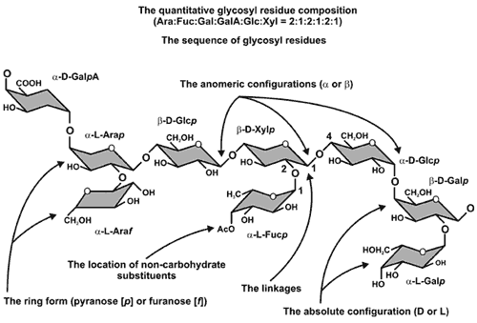

### The conformation and interaction of wall polysaccharides

These studies involve extensive use of 2D NMR spectroscopy and computer-aided molecular modeling techniques. We are also growing plants in a 13C-enriched environment to generate isotopically labeled polysaccharides that can be characterized using 13C NMR spectroscopy. Further information is available by clicking on [Xyloglucan](http://www.ccrc.uga.edu/~mao/xyloglc/Xtext.htm).

### The biosynthesis of pectic polysaccharides

We have developed methods for the purification and assay of enzymes involved in pectin biosynthesis, and for enzymes involved in the formation of various nucleotide sugars. In addition we are using molecular techniques to clone and express numerous enzymes involved in cell wall biosynthesis. Further information can be obtained by clicking on [Biosynthesis](http://www.ccrc.uga.edu/~mao/biosyn/text.htm)

# Biomechanische achtergrond

## Stress

[N/m²]

x

τxy

σx

τxz

y

τyx

σy

τyz

σz

τzy

τzx

z

* **Uniaxial stress**: e.g. pulling in one direction
* **Biaxial stress**: e.g.created by inflating a balloon
* **Triaxial stress**: e.g. due to hydrostatic pressure

There are three **normal stresses** σx, σy, σz,following the Cartesian axis, and six **shear stresses** τxy = τyx, τxz = τzx, τyz = τzy the first subscript indicates which axis is perpendicular to the plane in which the shear stress is working. The second subscript indicates which of the two directions of the plane are followed.

P

P

θ

θ

A

A’

σx

σs

σn

τ

σ-

compression

σ+

tension

θ

2θ

τ+

τ-

* **Nominal stress**Also called **engineering stress**. The assumption is made that the cross-sectional area remains constant, which is true when the loading doesn’t change appreciably (less then 5%) over time or for materials that deform little over a broad range of loading.
* **True stress**Here the above simplification doesn’t hold and one must have an instantaneous measure of the cross-sectional area.
* **Normal stress**The stress is perpendicular to a plane on which the force acts. It can be either **tensile stress** or **compressive stress**.
* **Shear stress**There are three types of shear stress:  
  **Direct shear**: at the interface of two objects that are forced to slide past one another. The materials deform little or not at all, except for the abrasion due to friction (e.g. rubbing two branches over one another)  
  **Simple shear**: elements of material within a solid slide past one another and simultaneously experience tensile and compressive distortion in the direction of shearing.(e.g. deforming a rectangular piece of gelatine)  
  **Pure shear**: is equivalent with the state of stress produced within a material submitted to tension in one direction an equal compression in the perpendicular direction. This means that the resultant of the normal tensile and compressive stress components has zero magnitude and thus the center of Mohr’s circle coincides with the origin.
* **Torsional stress**  
  The shear stress on a transverse cross section resulting from a twisting action
* **Deviatoric stress component** is the stress which is responsible for change in shape.
* **Isotropic stress component** is the stress which is responsible for change in volume.

## Strain

Strain is the unit change, due to force in the size or shape of a body referred to its original size or shape.

[dimensionless]

* **Linear strain** or **normal strain** can be tensile or compressive strain and is due to two opposing forces on the same carier.
* **Axial strain** is linear strain in a plane parallel to the longitudinal axis.
* **Transverse strain** is linear strain in a plane perpendicular to the longitudinal axis.
* **Shear strain** or angular strain is the tangent of the angular change between two lines originally perpendicular to each other through a point in a body.

The gradient of shear strain is given by



where x is in the direction of the shearing force and z is the vertical dimension

θ

τxz

τxz

τzx

τzx

z

x

as can be seen from the figure, γ = tan θ = x/z, where θ is the rotation angle.

The normal strain components εx, εy, εz, they can be calculated in three ways

* **Cauchy strain**

Also called **engineering strain** or **conventional strain** symbolized by ε,



where *l*0 is the original dimension and *l* is the current one. *l*/*l*0 is called the **extension ratio**.

* **Henchy strain**

Also called **true strain** or **natural strain**, symbolized by εt,



This method should be used for significant deformations (bigger than 5%)

As follows from the above definitions, the true and the conventional strains are related by



* **stretch ratio**

Symbolized by λ is simply the extension ratioλ *= l*/*l*0 This technique is typically used for rubbery materials.

# Physical states of a material

The state of a material typically depends on the load and deformation history, as well as temperature and moisture content.

Sharma (1965) described the state of a material in terms of creep compliance function and relaxation modulus function plotted against time.

* **Creep compliance function** *J*(*t*) is the ratio of shear strain to shear stress when the stress is kept constant.

Zone I

perfect elastic

Zone II

visco-elastic

Zone III

perfect elastic

Zone IV

perfect elastic

time, log t

creep compliance function , log J(t)

*tc*

* **Relaxtation modulus function** *G*(*t*) is the ration of shear stress to shear strain when the strain is kept constant.

Zone I

perfect elastic

Zone II

visco-elastic

Zone III

perfect elastic

Zone IV

perfect elastic

time, log t

relaxation modulus function , log G(t)

*tc*

All the materials having linear response will display behaviour corresponding to one or more zones of these diagrams.

* Zone I: perfectly elastic materials

## Classical ideal materials

### Ideal elastic behaviour

Hookean body

store and return the energy instantaneously by returning to the original shape

### Ideal plastic behaviour

St. Venant body

braking or energy has dissipated

### Ideal viscous behaviour

Nowtonian liquid

no elastic component, all energy is dissipated, permanent deformations

## Non-classical materials

### Inelastic behaviour

Hyperelastic model: (rubber-like materials) the behaviour is history-independent and thus reversible.

σ

ε

Elastic-plastic model: (many metals and some soil materials at room temperature) the behaviour is irreversible and independent of the strain rate. Most of the time it is assumed that the unloading and reloading path has the same slope as the initial loading path.

σ

ε

Elastic-viscoplastic model: (metals at high temperature, soils, polymers) strain rate sensitive.

σ

ε











## Time effects

**Viscoelasticity**: large deformations with slow recovery

A combined solid-like and liquid-like behaviour in which the stress-strain relationship is time dependent.

Linear viscoelasticity, here the ratio of stress to strain is a function of time alone and not of the stress magnitude.

## Rheological models

### Maxwell model

* **Relaxation time** is the rate of stress decay in a material subjected to a sudden strain. It is the time required for the stress to decay to 1/*e* of its original value.

### Kelvin model

* **Retardation time** is the rate at which the retarded elastic deformation takes place in a material creeping under dead load. It is the time required to deform to (1-1/*e*) of its total deformation.

### Burgers model

## Stresses

## Poisson’s ratio



where t denotes the transverse direction and n the direction of the normal axial stress component.

This makes that for a block with the depth, width and length respectively x, y and z

, and 

The first index of the **Poisson’s ratio** identifies the axis parallel to the direction of the applied force (in this example the z-axis, or length. The second letter indicates the dimension in which the transverse strain has been measured.

Poisson’s ratio is a measure for the ability of a material to change in volume versus its ability to change in shape. When it is used beyond the proportional limit, the range of stress should be stated. For anisotropic materials there may be up to six different values.

Typical values for υ range from 0 to 0.5, where crystalline materials approach 0 and fluids approach 0.5. Negative values are possible however.

Isotropic materials

Elastic material properties are independent from the direction in which they are measured (υzy = υzx). They shear in tension along planes inclined 45° to the axis submitted to tension.

Anisotropic materials

-axisymmetric materials have two mutually perpendicular directions of symmetry

- orthotropic materials have three mutually perpendicular directions of symmetry: for wood these three directions are: the longitudinal direction (along the stem), the radial direction (in a cross-section through the center), and the tangential direction perpendicular to the radial one. Because of its growth rings wood requires six Poisson’s ratios: υLR, υRL, υLT, υTL, υRT and υTR.

Material moduli of isotropic materials

Bulk modulus K



Where ℘ is a uniformly applied hydrostatic pressure and  is the volumetric compressive strain (also called the cubical dilatation) consequentially K has the units of pressure.

1/K is called the compressibility

**Elastic modulus** E

Also called **modulus of elasticity**, **Young’s modulus**, **stiffness** or **rigidity**

It indicates the capacity to resist elongation or compression. For a nonlinear stress-strain relationship below the proportional limit the following terms may be used for the **apparent modulus**.

stress, σ

strain, ε

*Ei*

*Es*

*Et*

*Ec*

* initial tangent modulus *Ei*
* tangent modulus *Et*
* secant modulus *Es*
* chord modulus *Ec*











**Shear modulus** G

Also called **modulus of shear** or the **rigidity** of the material.

capacity to resist shearing





Measuring the material moduli

Elastic modulus

**Hooke’s law**  defines linear elastic materials.

Stress-strain diagram

stress, σ

strain, ε

proportional limit





plastic

region

elastic

region

the **proportional limit** or **elastic limit** indicates the maximum stress level below which the material behaves elastically and thus recovers completely when the stress is released. This limit can differ for tension versus compression.

σ+

σ-

ε

elastic

region

Anelastic behaviour

When loading results in a linear relationship, but unloading is not linear.

- The **degree of elasticity**

the ratio of the elastic (recovered) deformation *De* to the total deformation (elastic *De* and plastic *Dp*) when a material is loaded to a given stress level and then unloaded to zero stress.

σ

ε

*Dp*

*De*

- Elastic hysteresis

the amount of energy internally dissipated during a loading-unloading cycle

σ

ε

σ

ε

σ

ε

σ

ε

perfectly elastic

perfectly plastic

elastic-plastic

viscoelastic with  
full recovery

perfectly elastic: no reorganization at the atomic level and thus full recovery of the original form

perfectly plastic: permanent deformation due to atomic/structural reorganizations

elastic-plastic: both

viscoelastic: the deformations are not instantaneous, but occur over measurable time

σ

ε

permanent

strain

elastic

hysteresis

**Permanent strain** or **permanent set**, although it is called permanent the time elapsed between removal of the load and the measurement should always be stated.

nonlinear elastic materials

tangent modulus ET or instantaneous elastic modulus

measuring

uniaxial tension with clamps

-clamps restrict deformation at the ends and thus increase the apparent elastic modulus.

samples should be at least ten times longer then they are wide in order to neglect end-wall effects.

Plastic deformations

Plastic behaviour is the result of permanent molecular (or microstructural) reorganizations within a simple (or composite) material.

Strain hardening occurs when the tangent modulus increases, when it decreases, we speak of strain softening.

Strain hardening coefficient 

**Viscosity** η

* **Apparent viscosity** is the slope of a straight line connecting the chosen point on the non-linear curve to the origin, in other words it is the slope of the secant.



dynamic viscosity μ



where γ is the shear strain



where H is the activation energy of the material, k is the Boltzmann’s constant and T is the temperature

* **fluidity**  such that one can state **Newton’s law for viscous flow**



A fluids that obeys Newton’s law for viscous flow is called a **Newtonian fluid**.

**Non-Newtonian fluid** has a non-linear relationship between shear stress and shear rate which makes that it behaves much like a solid when stressed quickly, and much like a liquid when stressed slowly. A non-Newtonian fluid can be either **dilatant** or **pseudoplastic**.

shear stress τ

rate of shear 

* **Thixotropic** **liquid** shows a decrease in shear stress with time of shear at a given shear rate.
* **Rheopectic liquid** shows an increase in shear stress with time of shear at a given shear rate.

It exhibits a time-dependent response to shear strain rate over a longer period than that associated with changes in the shear strain rate. It may liquefy on being shaken and then solidify (or not) when this has stopped.

Experiments to quantify the mechanical properties of viscoelastic materials

Dynamic experiments

Either stress or strain is varied cyclically with time and the mechanical response of the material is measured over various frequencies of deformation.

For perfectly elastic materials the stress is highest where the strain is highest, when there is no elastic component however, the highest stress will be when the stress rate is the highest. For sinusoidal fluctuations one obtains Lissajous figures as the stress-strain plots.

Viscous modulus  where ω is the frequency of the sinusoidal signal. Thus *G″* is a measure of the energy lost within the system resulting from viscous processes.

Transient experiments

-Stress-relaxation experiment

Relaxation time *TR* measures the time required to deform a material’s molecular structure; for a perfect elastic material this is infinity and for a fluid it is zero, viscoelastic materials have measurable relaxation times.







thus the relaxation time is the time required for the stress to decrease to 1/*e* of the original stress.

For cell walls curves typically are described by the following empirical formula



where and  are the maximum and minimum relaxation times and *σr* is the residual stress at the end of the relaxation period.

Creep experiments

When a constant load is applied, there is an instantaneous elastic deformation *De*1 followed by a relatively slow, time-dependent deformation called creep, which is composed of an elastic component *De*2, and a plastic component *Dp*.

*De1*

*De2*

*Dp*

*De2+Dp*

*De1*

*time*

*deformation*

linear viscoelastic materials



where *D*(*t*) is the tensile compliance , which is the reciprocal of the tensile relaxation modulus 

The relaxed compliance *DR* is the slope of the asymptote when the tensile relaxation is measured over log time, similarly *DU* is called the unrelaxed compliance.

*EU*

*DR*

*ER*

*E*(*t*)

*DU*

*D*(*t*)

*log time*



## Strength

This is the maximum stress required to cause a material to break or undergo plastic deformation, respectively called breaking and plastic yield strength.

Most of the time the **tensile strength** is almost the double of the **compressive strength** for woody materials.

* **Shear strength** is the maximum shear stress a material can sustain. It is calculated from the maximum load during a shear or torsion test an is based on the original dimensions of the cross sectional area.
* **Yield point** the first stress in a material, less than the maximum attainable stress, at which an increase in strain occurs without an increase in stress. Note that only materials that exhibit the unique phenomenon of yielding have such a yield point.
* **Yield strength** is the stress at which a material exhibits a specified limiting deviation from the proportionality of stress to strain., usually a strain deviation or offset of 0.2 percent is used.
* **Bioyield point** is an equivalent of the yield point used for biological products and indicates an initial cell rupture. It is located beyond the proportional limit and corresponds with failure in the microstructure.
* **Bioyield strength** is equivalent to the yield strength.
* **Rupture point** an axially loaded specimen exhibits puncture of shell or skin, cracking, or fracture planes. It is failure of the macrostructure.

stress, σ

strain, ε

proportional limit

plastic

region

elastic

region

bioyield point

rupture point

* **Ultimate strength** is the stress corresponding to the rupture point.
* **Thoughness** is the work required to cause rupture in the material and can be approximated by the area under the stress-strain curve up to the rupture point.
* **Resilience** is the capacity of a material for storage of strain energy in the elastic range. It corresponds to the area under the unloading curve.
* **Mechanical hysteresis** the energy absorbed by a material in a cycle of loading and unloading, evaluated a the area between the loading and unloading curve. It is a measure for the damping capacity or the ability to dissipate the strain energy in heat.

σ

ε

resilience

mechanical hysteresis

Strain energy U

It can be computed as the area under the stress-strain diagram. When comparing materials, one has to normalize the energy in terms of volume such that energy densities are obtained.

Elastic resilience is the capacity to absorb and subsequently release strain energy

Fracture mechanics

brittle materials: the energy required to break the atomic bonds is supplied by the material in the immediate vicinity of the crack.

-weak brittle materials: *W* ≈ the true surface energy e.g. glass loses much of its strength when the surface is damaged.

-strong brittle materials: *W* >> true surface energy e.g. steel

Ductile materials: here the area over which the external force is dissipated is larger. Necking is often observed as the rearrangement of atoms or molecules in this area.

Griffith critical crack length *LG*



where *W* is the work of fracture

When a crack has a length below the critical crack length, the material will not fracture.

Fracture toughness *KC* is the resistance a material offers to the propagation of a crack and corresponds to the energy required to fracture a material. It can thus be calculated as the area under the stress-strain diagram.

For isotropic materials



For anistropic and nonbrittle materials



where *Sy* is the tensile yield strength, *l\** is the plastic zone width at the onset of cracking, and *εf* is the true fracture strain in tension

There are two rheological properties of particular importance to hydrocolloid science. These are their gel and flow properties.

## Viscosity

When a force is applied to a volume of material then a displacement (deformation) occurs. If two plates (area, A), separated by fluid distance (separation height, H) apart, are moved (at velocity V by a force, F) relative to each other, Newton's law states that the **shear stress** (the force divided by area parallel to the force, F/A) is proportional to the **shear strain rate** (V/H). The proportionality constant is known as the (dynamic) viscosity().

The effect (**shear strain**) is quantified by the displacement per unit height (D/H) and the rate of this effect (**strain rate**) is the velocity per unit height (V/H), where the height is the distance to a relatively unaffected position. The viscosity () is the tendency of the fluid to resist flow and is defined by:

Increasing the concentration of a dissolved or dispersed substance generally gives rise to increasing viscosity (i.e. thickening), as does increasing the molecular weight of a solute.

## Appendix A: SI units

|  |  |  |
| --- | --- | --- |
|  | SI Unit or Prefix | Symbol |
| Physical quantity |  |  |
| Length | Meter | m |
| Mass | Kilogram | kg |
| Time | Second | s |
| 6.023 1023 objects | Mole | mol |
| Energy | Joule | J |
| Force | Newton | N |
| Power | Watt | W |
| Pressure | Pascal | Pa |
| Frequency | Hertz | Hz |
| Multiple |  |  |
| 101 | Deka | da |
| 102 | Hecto | h |
| 103 | Kilo | k |
| 106 | Mega | M |
| 109 | Giga | G |
| 1012 | Tera | T |
| 1015 | Peta | P |
| 1018 | Exa | E |
| Submultiple |  |  |
| 10-1 | Deci | d |
| 10-2 | Centi | c |
| 10-3 | Milli | m |
| 10-6 | Micro | μ |
| 10-9 | Nano | n |
| 10-12 | Pico | p |
| 10-15 | Femto | f |
| 10-18 | Atto | a |

## Appendix B Geometry

cross section

transverse surface

tangential surface

radial surface

# Meshgeneratie

## Programma Contour

De structuur van het celweefsel kan overgenomen worden met behulp van getContour.m en saveXY.m. Eerst wordt de bitmap ingeladen in Matlab, waarna de gebruiker alle relevante hoekpunten aanklikt. De coördinaten worden weggeschreven in ascii formaat, deze file wordt nog aangevuld met de beschrijving van de hoekpunten voor iedere cel en kan daarna ingelezen worden via C++.

## WritingConfiguration

Dit kleine programma creëert een weefsel van hexagonale cellen.

De celnummers lopen op van onder naar boven en van links naar rechts. De hoekpunten die tot een bepaalde cel behoren, worden overlopen in wijzerzin en men begint bij het hoekpunt links boven.

1

2

3

4

5

6

7

8

9

…

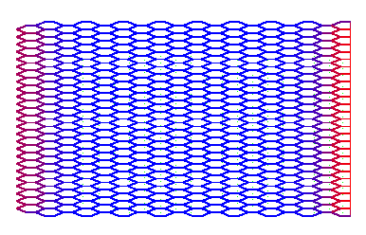

* **Massa** van het weefsel (2 mm x 5mm x 75 μm) of zo’n 7.5 10-10 kg/cel.
* **Breedte** van een cel is ca. 75 μm. Of 26 cellen op 2 mm.
* **Lengte** van een cel is ca. 400 μm. Of 37 cellen op 5mm.

Zodoende kunnen we een weefsel opstellen met 981 hoekpunten en 459 cellen zoals hierboven werd afgebeeld.

### Constant volume

Er werd een bug gevonden in de krachtenberekening, waardoor de drukkrachten niet symmetrisch waren en het geheel sneller onstabiel werd bij hogere drukken.

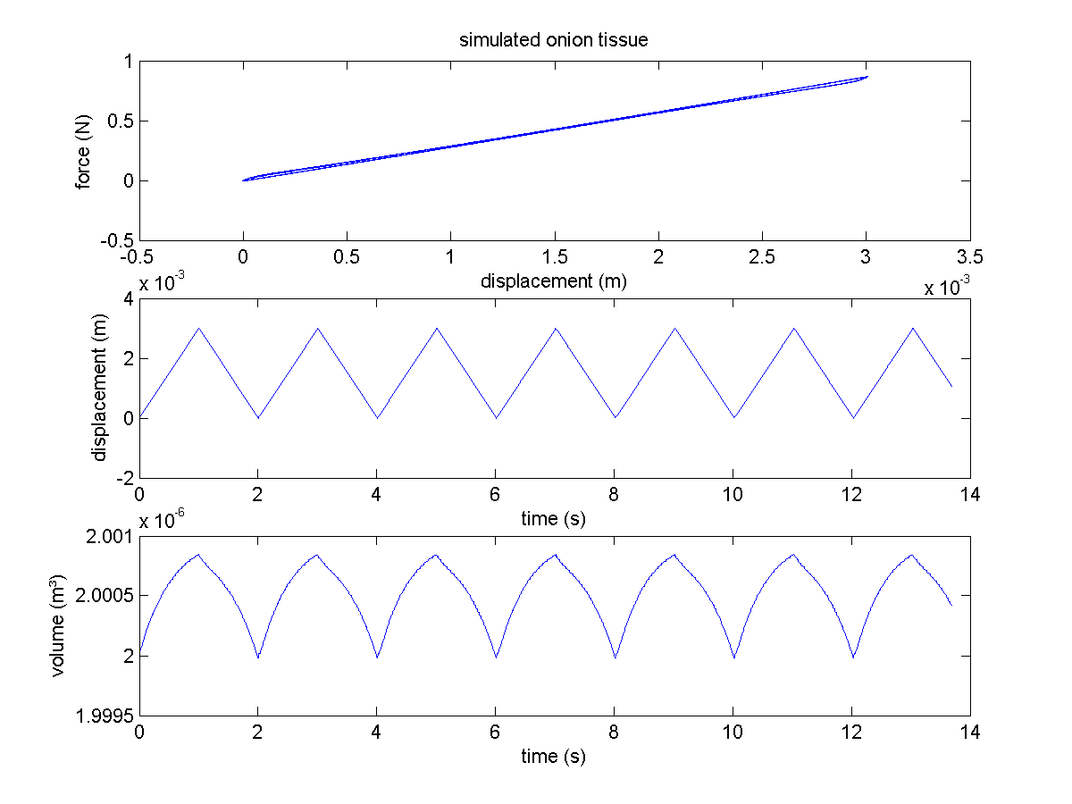

Bovenstaande figuur geeft de drukvariatie voor een opstelling waarin slechts één enkele cel onder druk staat. De fout kan men ‘willekeurig’ klein maken door de invloed van de drukkrachten te verhogen via de parameter kVolume.

Wanneer men echter het uiweefsel met cellen onder druk beschouwt blijkt het al veel moeilijker om de volumefout kleiner te maken. De kVolulme werd groter en groter genomen tot het geheel onstabiel werd…

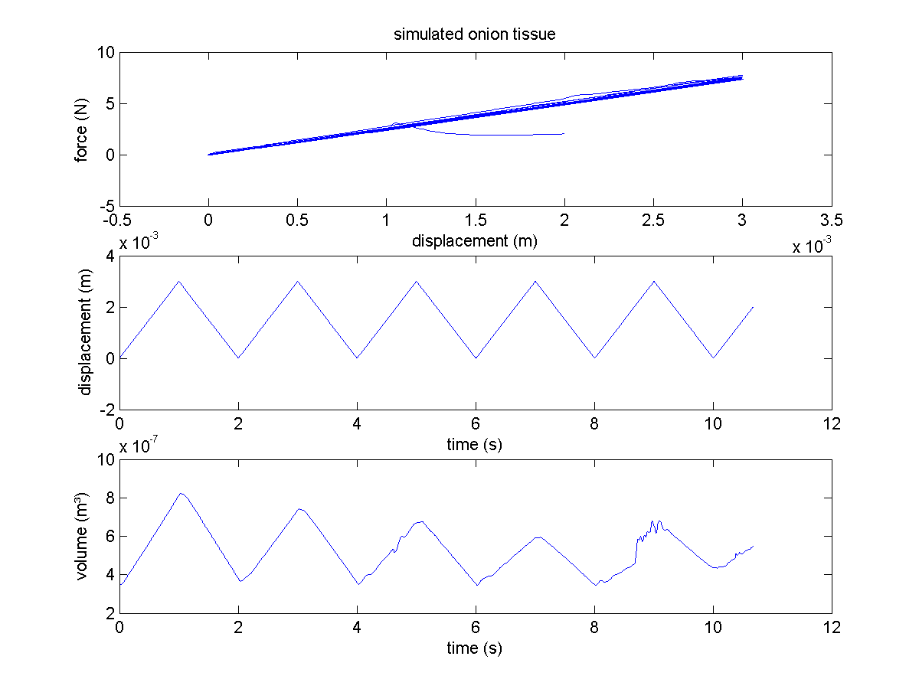

Wanneer een nog groter aantal hexagonale cellen genomen wordt bekomt men:

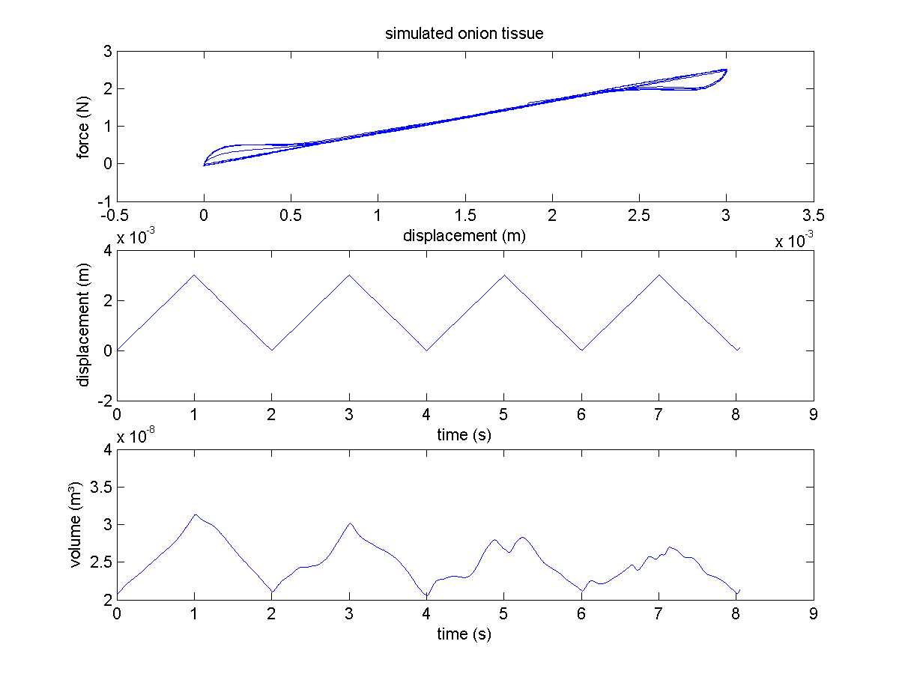

## WritingConfiguration03 en 04

In WritingConfiguration03 wordt een weefsel van hexagonale cellen gemaakt en in WritingConfiguration04 zijn het rechthoekige cellen in een baksteenstructuur met een onderscheid tussen cell wall en plane boundaries.

## Willekeurige inputfiles genereren met WritingConfiguration05

Hiermee kan je je eigen geometrie tekenen. Eerst dien je je werkblad in te stellen: het aantal gridpunten in x en y en de min en max waarden voor beide assen. Dan wordt een tekenwindow gemaakt waarop je met de muis aan de slag kan. Een lijn teken je door de linkermuisknop in te drukken (het dichtsbijzijnde gridpunt wordt geselecteerd als beginpunt), ingedrukt te houden en pas los te laten wanneer je op het punt bent waar het eindpunt zou moeten komen (ook hier wordt weer het dichtsbijzijnde gridpunt als eindpunt geselecteerd).Er wordt nagegaan of begin en einde wel degelijk verschillen, en of het lijnstuk al niet gedefinieerd was.Je kan zo zowel de cell boundary als de plane boundary springs definiëren. Switchen tussen verschillende modes doe je door op ‘m’ te drukken. Na deze twee eerste modes kom je in de ‘define cell mode’. Nu dien je enkel in een gesloten aaneenschakeling van

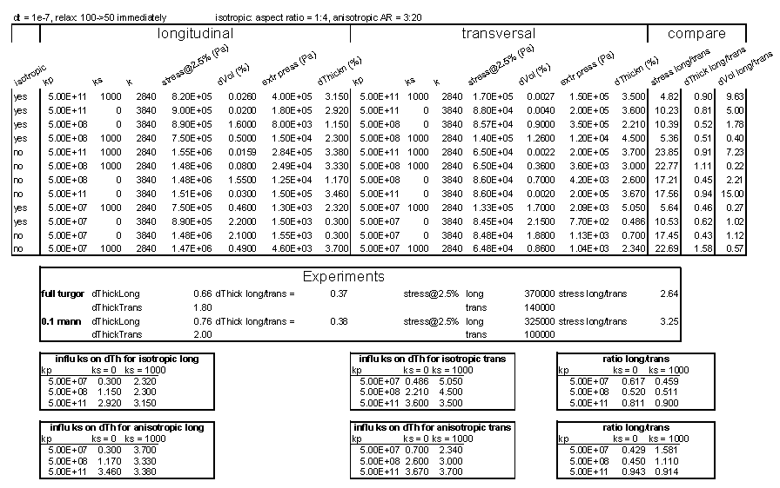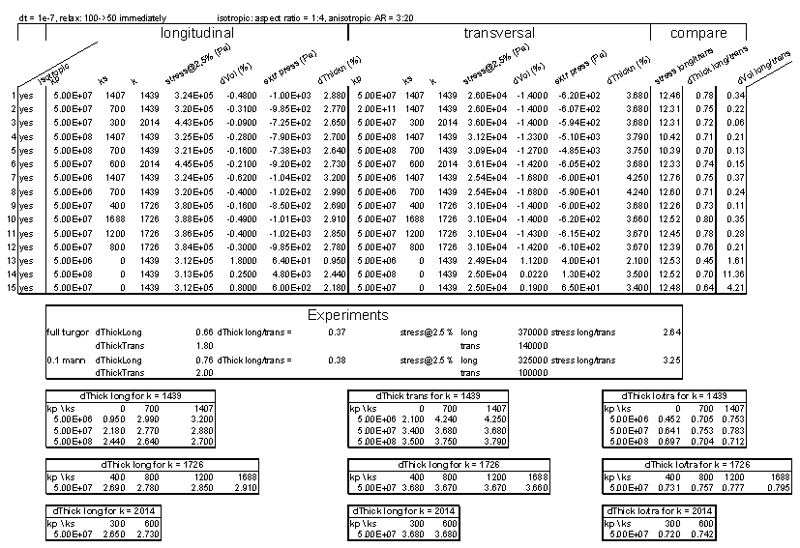

cell boundary springs te klikken om de bijhorende cell te definiëren: de hoekpunten worden in wijzerzin afgelopen en opgeslagen evenals de cell boundary springs.

Elk van de bovenvernoemde bewerkingen kan je ongedaan maken door op ‘u’ van undo te drukken. De laatste bewerking in de huidige mode wordt tenietgedaan.

Dan komen we bij het selecteren van het noord en zuidpunt (om de dikte van een strip te meten). Dit doe je net zoals je een veer definieert, je bent wel zelf verantwoordelijk om zinvolle punten te kiezen (nl punten die aan de kant liggen en verbonden zijn door cell boundary springs).

Dan kan je nog de east en west cornerpoints definiëren door er gewoon op te klikken.

Vergeet tenslotte niet op ‘s’ save te drukken om de uiteindelijke inputFile weg te schrijven in de folder ‘data’.

Je kan kiezen of cell boundary, plane boundary springs en of cellen weergegeven dienen te worden door respectievelijk met ‘1’ ‘2’ of ‘3’ te toggelen.

Druk op ‘h’ voor help en je zal een korte samenvatting zien van de mogelijkheden.

## WritingConfiguration07

Loading and saving is included and tested as well. A special export mode is added such that the file can be read into **SoftTissue17forPaperIO**. A renumbering of the corners was necessary for this, it was implemented into the corners as **nr4SoftTissue** which coexists next to **nr**.

The following configurations were created:

### Tissue 01

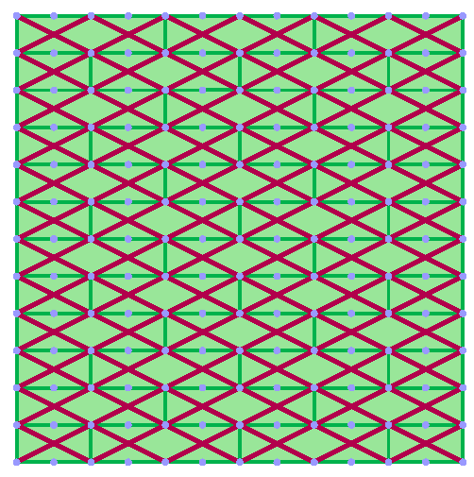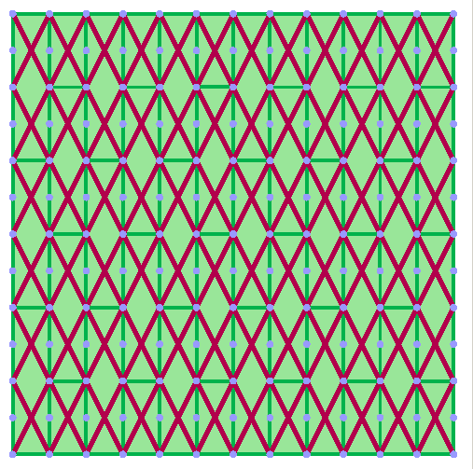

aspect ratio **4:1**, **anisotropic** plane boundary spring network, **loose coupling** between the networks

### Tissue 02

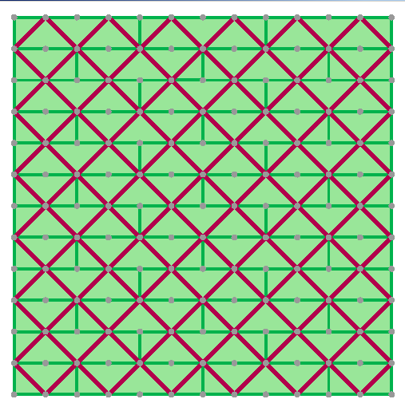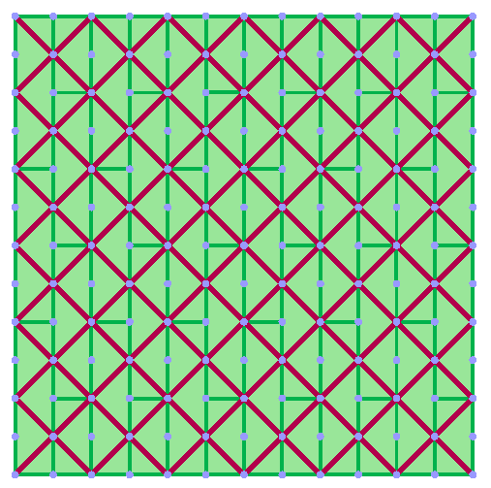

aspect ratio **4:1**, **isotropic** plane boundary spring network, **loose coupling** between the networks

### Tissue 05

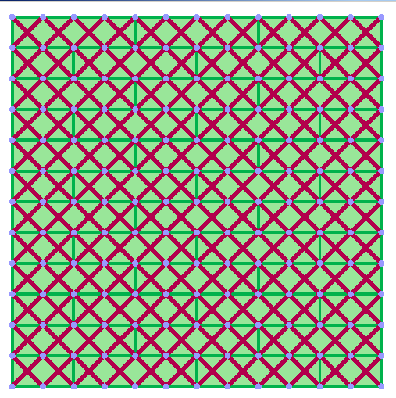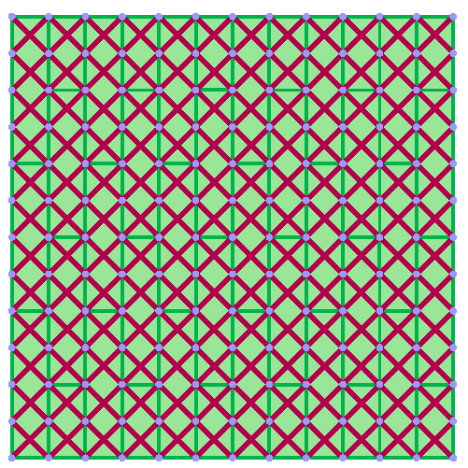

aspect ratio **4:1**, **isotropic** plane boundary spring network, **fixed coupling** between the networks

### Tissue 06

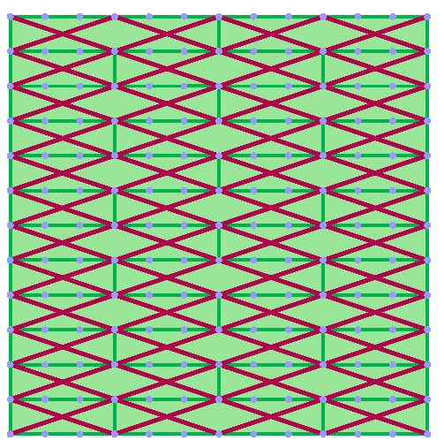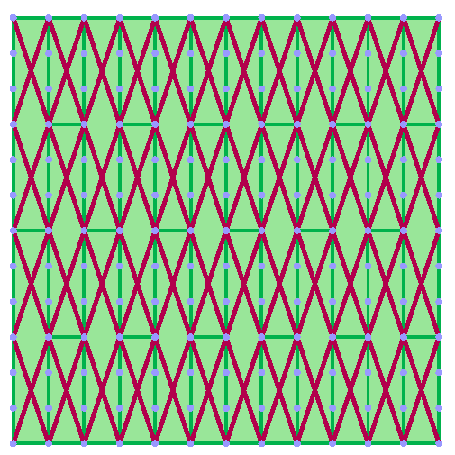

aspect ratio **6:1**, **anisotropic** plane boundary spring network, **very loose coupling** between the networks

### Tissue 03

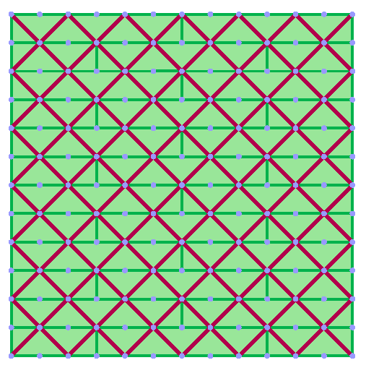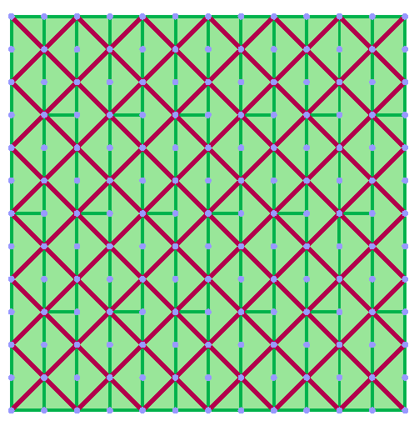

aspect ratio **6:1**, **isotropic** plane boundary spring network, **loose coupling** between the networks

### Tissue 04

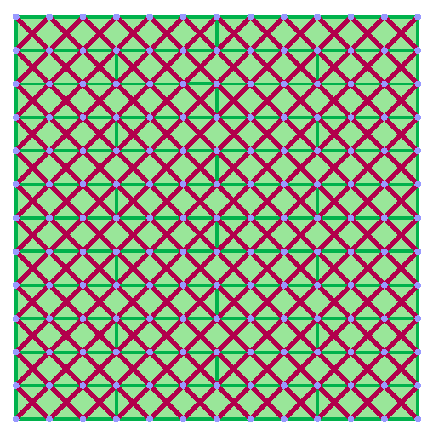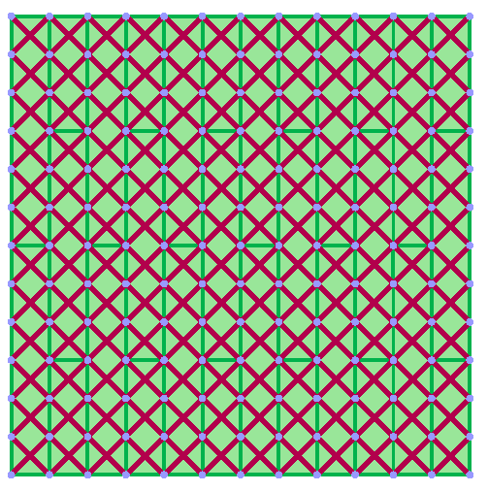

aspect ratio **6:1**, **isotropic** plane boundary spring network, **fixed coupling** between the networks

The simulation results are summarized in the table on the next page. The anisotropic network for the plane boundary only seems to worsen the ratio of lateral contraction between the longitudinal and transversal strips.

Simulatieresultaten

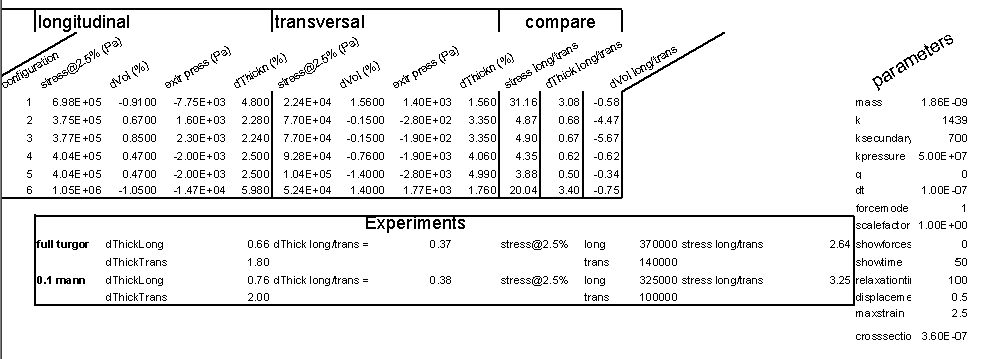

## SelectObject01

Op basis van een demo van verkeerslichten heb ik dit progje geschreven waarin de basistechnieken verwerkt zitten om objecten te selecteren in een 3D OpenGL scene.

## Convex hull

### Schema

Instead of working with spherical particles we would like to define a potato-like shape for our potato project.

a

c

b

(0,0)

x

y

**nrStacks = 4**

beta

corner

centerJ

ySlice

centerBottom

transitionPoint

**nrSlices = 16**

x

z

The transitionpoint is defined as the point where the curvature of the parabola equals the curvature of the sphere at one of the extremes.

### Parabola

#### formula

y=kx²

c-b

a

y

x

c-b = ka² => k = (c-b)/a²

#### first derivative

dy/dx = 2((c-b)/a²)x

### Circle

#### formula

x²+y² = r²

y = sqrt(b²-x²) since r=b

#### first derivative

dy/dx = (1/2)(b²-x²)-1/2(-2x)

= -x/sqrt(b²-x²)

### Continuous convex hull condition

In order to be a continuous convex hull the derivative of the circle and the parabola must equal at the transition point, giving

2((c-b)/a²)x = (1/2)(b²-x²)-1/2(-2x)

# SoftTissue

## Literatuurstudie

De pioniers wat betreft het toepassen van de discrete elementen methoden op plantenweefsel zijn

Schembri en Harris, 1996. Zij modelleerden het vermalen van suikerriet aan de hand van impacts. De parenchym cellen werden hexagonaal gemodelleerd terwijl de vasculaire cellen als 18-hoeken werden beschouwd.

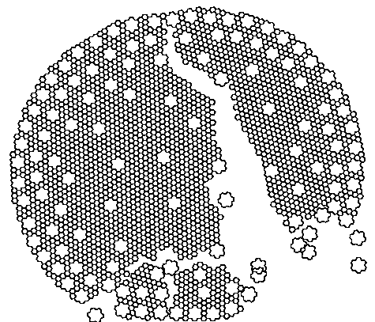

## Eerste plan voor een model van plantenweefsel:

Het weefsel wordt geabstraheerd tot een vakwerk met behulp van een quasi-evenwichtsbenadering. Hiertoe hebben we een schatting van de elasticiteitsmodulus en treksterkte van het celwand-middellamelcomplex nodig. De eigenschappen van de celwand (elasticiteit en treksterkte) moeten geschat worden door numerieke experimentenen te vergelijken met reëele experimentele data. De eigenschappen van de middellamel (adhesie) zou kunnen gemeten worden. De validatie bestaat uit het vergelijken van de kracht-vervormingscurve en een visuele vegelijking van de vervormingen en breukvlakken.

De eerste toepassing was de simulatie van een virtuele trekproef binnen het elastisch regime. De celwand werd gemodelleerd als een lineaire veer. Binnen iedere cel heerste een bepaalde druk die ervoor zorgde dat het celvolume constant bleef. Eventueel latere uitbreidingen betreffen plastische vervorming, wrijving in het wandmodel, implementeren van het anisotroop karakter van de celwand, breuk als het overschrijden van de adhesiekrachten tussen hoekpunten/wanddelen.

Vervorming

Turgordruk

:=

Trekspanningen

+

### Kenmerken

* Dynamica a.h.v. bewegingsvergelijkingen van de hoekpunten
* Wanden als niet-lineaire (gedempte) veren
* Druk ┴ wand, versnelling wordt doorgegeven aan de hoekpunten van die wand
* Adhesie tussen naburige cellen
* Volumeoverdracht naar naburige cellen (plasmodesmata)
* evt. hoekveren voor de vormstijfheid

Celwand

* Niet-lineaire (gedempte) veren in serie
* niet-lineariteit moet in het veermodel zitten
* Netwerk van veren
  + van verschillende lengte ->15° regel benaderen
  + deel van de niet-lineariteit zit in de geometrie
* Link tussen DEM en FEM (Anthonis J., 2003)

Turgordruk

* Toestandsvergelijking:   
  vb. PVgamma = Const
  + ΔV berekenen → ΔP
  + nood aan stabiele implementatie
* Cel vullen met (on)samendrukbare korrels
  + enkel normaalkrachten (geen wrijving)
* FE, FV, FD…
* Smooth Particle Hydrodynamics

## Programma SoftTissue02

Hieronder is het resultaat te zien van zo’n gegevensinvoer.

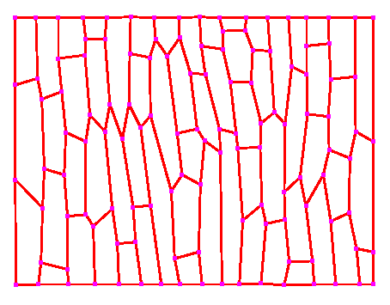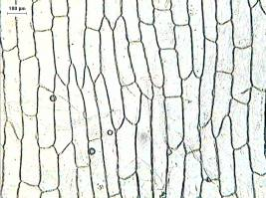

Een typische invoerfile (inputFile.txt) ziet er als volgt uit:

-cornerpoints-

nrcorners 122

0.0000000e+000 9.9767981e-001

5.8004640e-002 9.9767981e-001

...

6.5893271e-001 8.1670534e-001

-end-cornerpoints-

-configuration-

nrcells 60

1 nrcorners 4 numbers 1 2 43 44

2 nrcorners 6 numbers 2 3 40 41 42 43

…

60 nrcorners 4 numbers 100 101 102 99

-end-configuration-

Wanneer we nu voor elke cel de interne druk evenals de veerkracht in de celwanden in rekening brengen zal het geheel relaxeren. Deze vervorming is verrevan realistisch omdat de knooppunten hier als wrijvingsloze scharnierpunten fungeren, terwijl er in realiteit ook een zeker vormvastheid van de celwand is. Onderstaande figuur illustreert zulk een relaxatie.

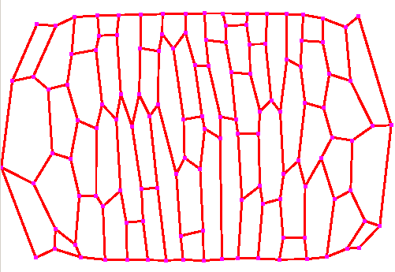

In een later stadium is het zelfs mogelijk dat bepaalde cellen niet langer convex zijn, aangezien de oppervlakte berekend wordt uitgaande van de veronderstelling dat de cellen steeds convex zijn.

A

B

C

Om bijvoorbeeld de oppervlakte van bovenstaande vijfhoek te berekenen wordt iteratief de oppervlakte van de samenstellende driehoeken berekend met de formule van Heroon. Deze driehoeksoppervlakken worden steeds gesommeerd, terwijl dit voor niet-convexe veelhoeken niet opgaat.

Er werden veren toegevoegd zodat elke twee hoekpunten die slechts gescheiden zijn door één hoekpunt eveens verbonden zijn met een veer. Dit werd gedaan voor de vormvastheid.

Voorts werden ook lijsten gemaakt met alle hoekpunten aan de rand van het weefsel, zodat hieraan getrokken kan worden met een gewenste kracht.

## Programma SoftTissue03

Kracht vervormingscurve opgesteld aan de hand van pullForceY en getDeformation() waarbij het verschil in gemiddelde tussen de northFace en southFace punten de vervorming bepaald. Het systeem blijkt een vrij grote traagheid te hebben, daarom werd nagegaan wat de respons is op een input waarbij de kracht als een stap wordt aangelegd.

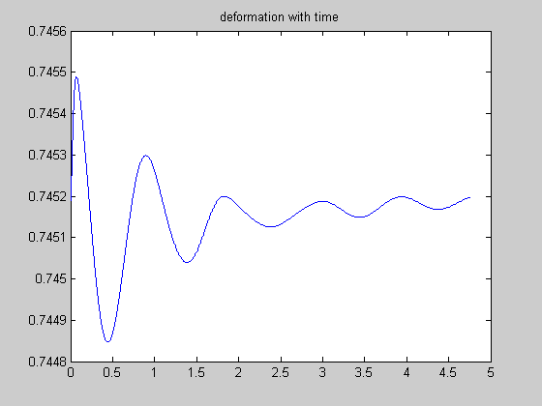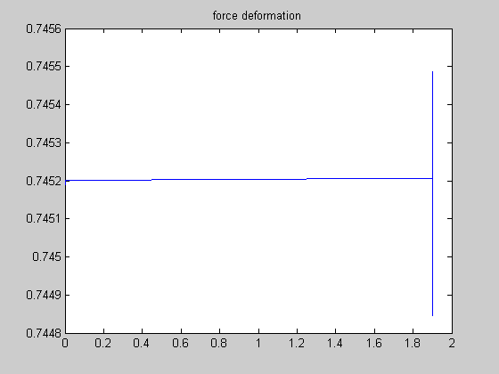

* aangelegde kracht: 1.9 N
* massa hoekpunten: 1 kg
* k van de veren in de wanden: 2000
* k van de veren tussen naburige hoeken: 2000
* c dempingsconstante van beide veren: 70
* gamma: 3

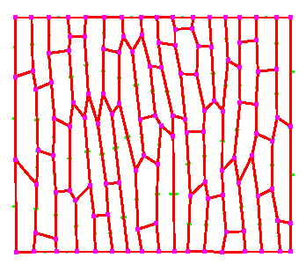

* pressure: 2
* timestep: 0.00005 s
* configuration: zoals op de figuur hiernaast.

Wanneer we als massa voor een hoekpunt 0.1 kg nemen krijgen we:

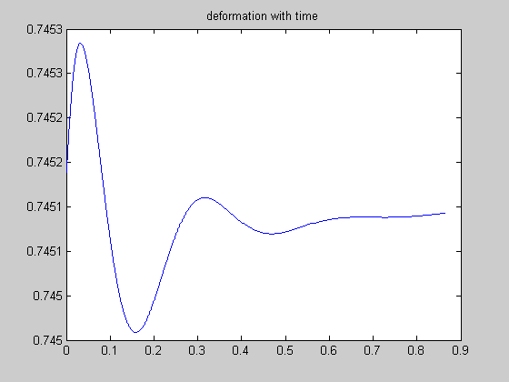

Nemen we de demping dubbel zo groot c = 140 met massa m = 0.1 dan bekomen we

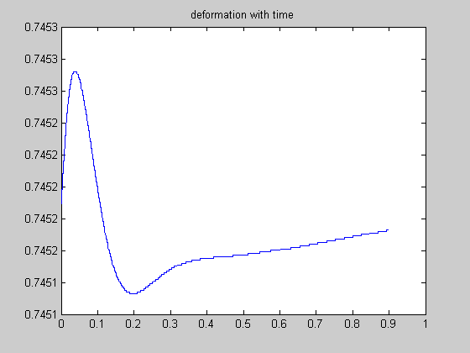

## Programma SoftTissue04

Now there are 122 cornerpoints over which the mass must be distributed, so we have:

m = 6.147e-9; // kg per cornerpoint

k = 16.66; // kg/s²

c = 6.4e-4; // kg/s

v2 = 20; // m/s

dt = 1e-7; // s

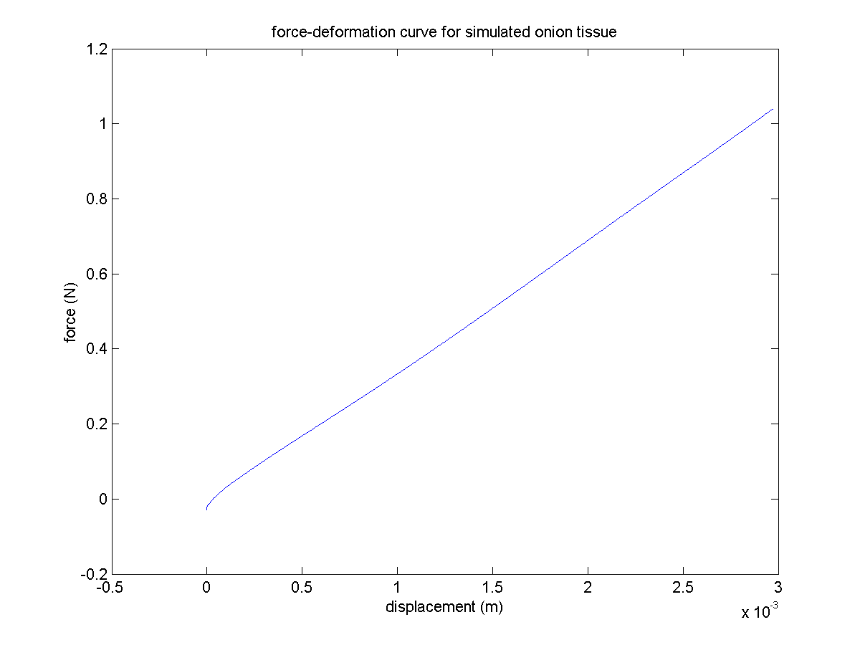

Bovenstaande figuur werd bekomen met de gegeven parameters en geeft inderdaad een kracht van 1 N bij een vervorming van 0.003 m.

Omwille van de kleine tijdstap,10 -7 s, tengevolge van de instabiliteit van het systeem, werdt bij bovenstaande experimenten een vervormingssnelheid van 20 m/s gebruikt.

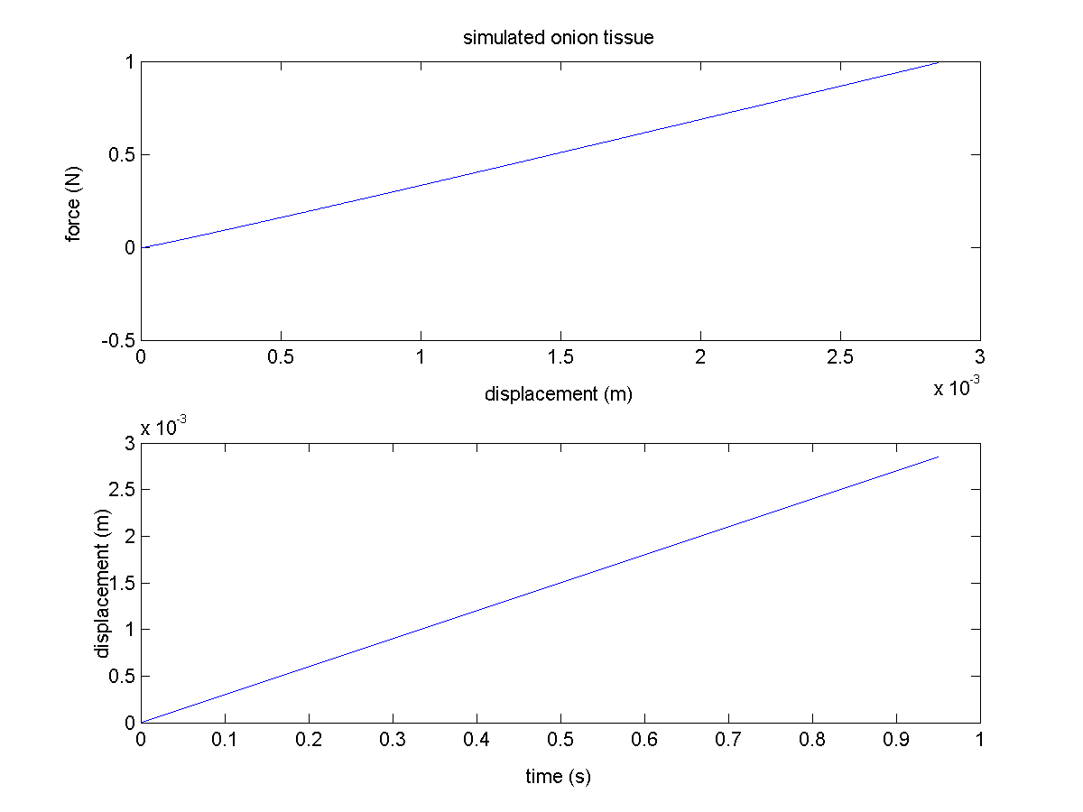

Willen we echter een realistischere waarde van vb. 0.003 m/s gebruiken dan wordt de totale rekenduur ca. 10 minuten om 1s te simuleren. Met nevenstaand resultaat.

Indien men verschillende cycli simuleert bekomt men

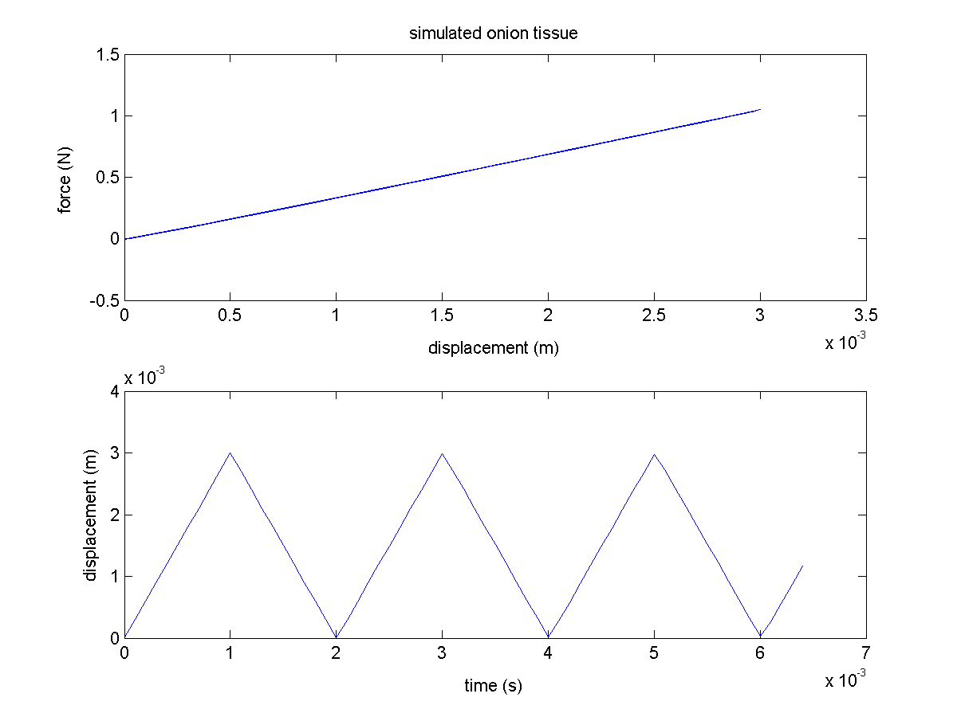

waarbij de verschillende banen elkaar sterker benaderen naarmate de vervormingssnelheid kleiner is en het systeem dus meer tijd heeft om tot rust te komen (minder hard naijlt).

## Programma SoftTissue05

### Niet-lineaire veren

Wanneer een niet-lineair veermodel gebruikt wordt, wordt het systeem onstabieler.

/* Kelvin-Voight */ //return -(k*dx-c*dv)*N;

/* Kuwabara-Kono */ //return -(k*pow(dx,1.5) - c*sqrt(dx)*dv)*N;

/* Goniometric */ return -(k*dx*(cos(1000*dx))-c*dv)*N;

//double magn = (k*dx-c*dv);

/* Parabolic */ //return -(magn+(0.000025-100*(magn-0.0005)*(magn-0.0005)))*N;

Bij het Kuwabara-Kono model divergeert de simulatie, ook al wordt een veel kleinere tijdstap genomen. Slechts wanneer het geïmplementeerde krachtenmodel voldoende lineair is binnen de range waarin de krachten werkzaam zijn, leiden ze tot een stabiele oplossing. Voorbeelden hiervan zijn de Goniometrische en de Parabolische krachtenmodellen.

Om een hysteresiseffect te bekomen moet het systeem blijkbaar ondergedempt zijn en de k-waarden van de naburige, de op-één-na-buren en de dempingsconstante de verhouding van respectievelijk 50, 5 en 19.2 hebben, c mag ook wat groter zijn. De tijdstap dient dan echter weer wat kleiner genomen te worden.

Onderstaande figuren tonen het resultaat van Parabolic en Goniometric met k = 16.66, kCorner = 1.666 en c = 6.410-4.

Parabolic:

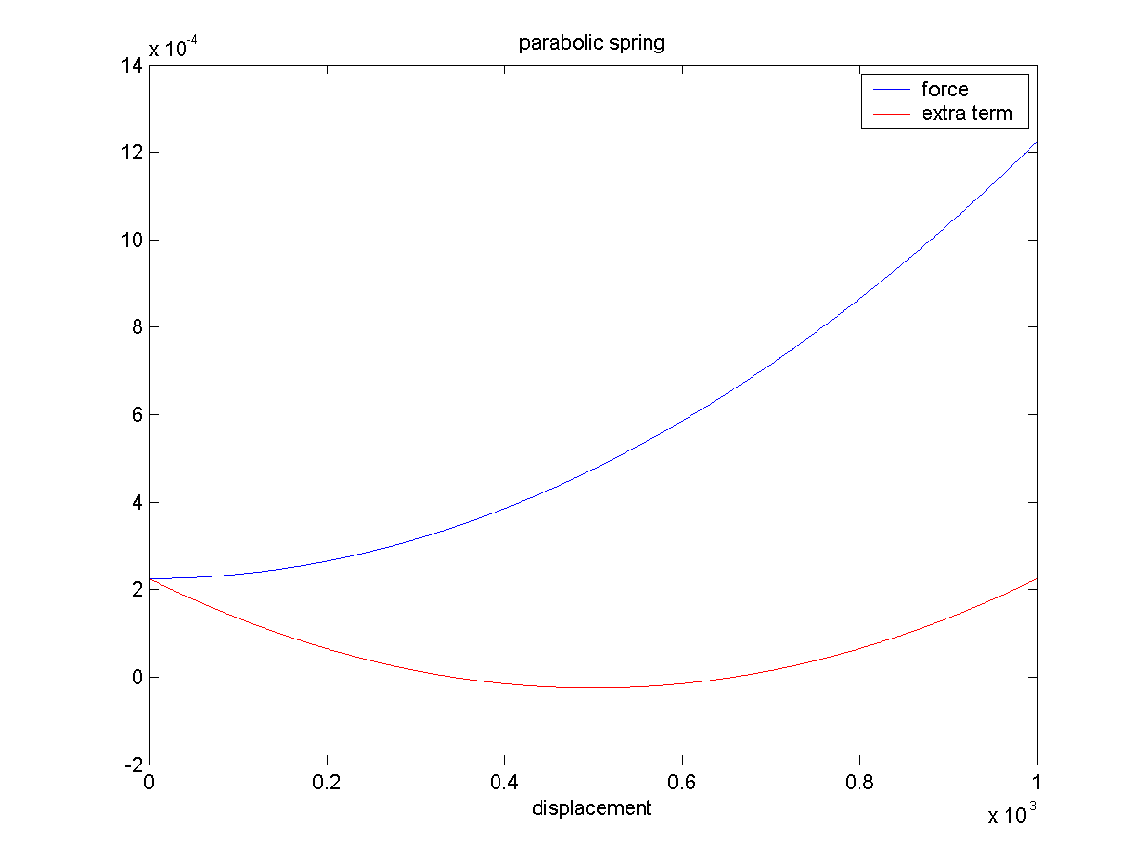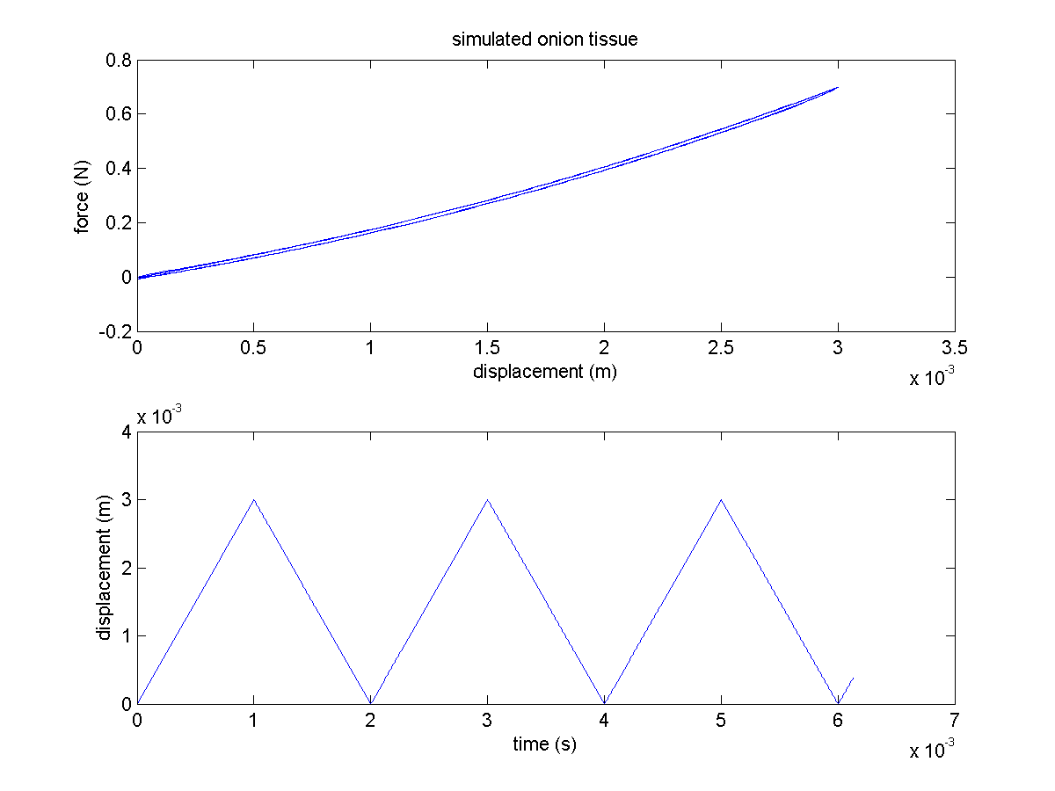

Goniometric:

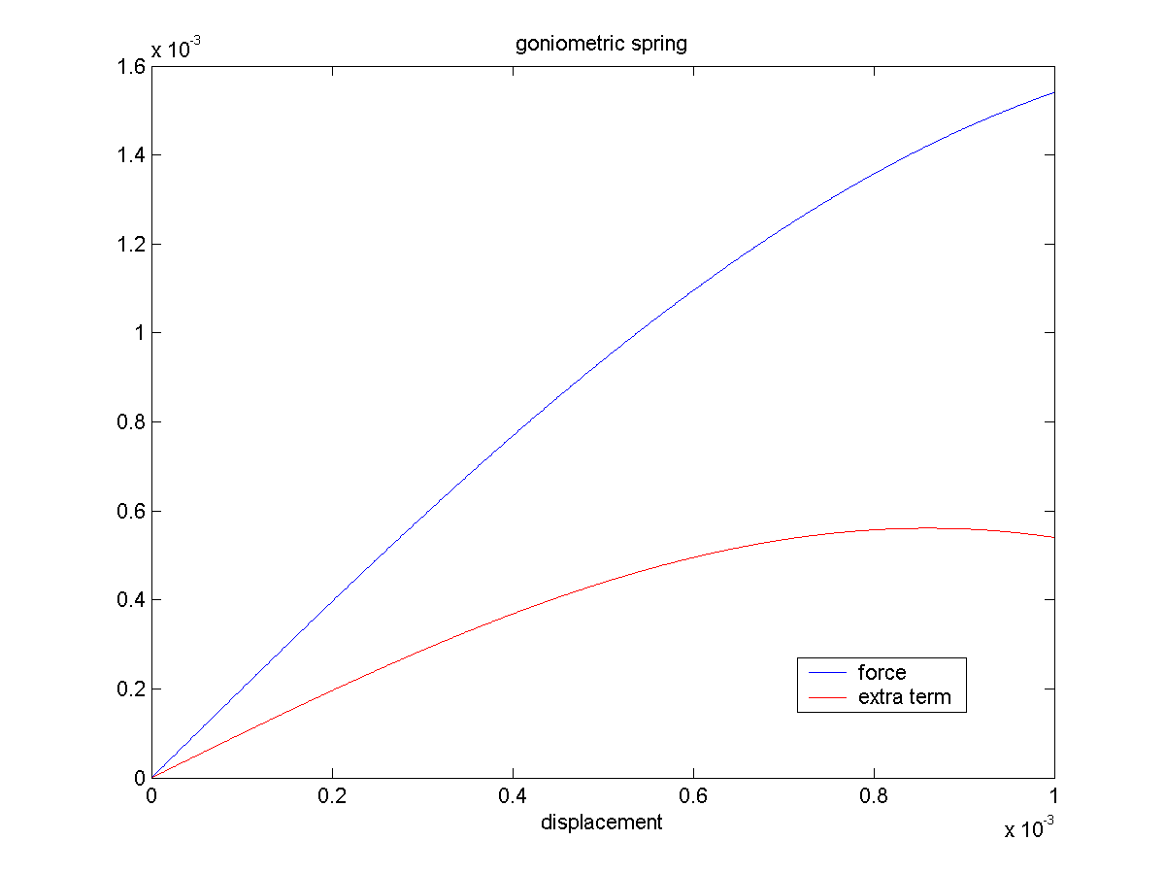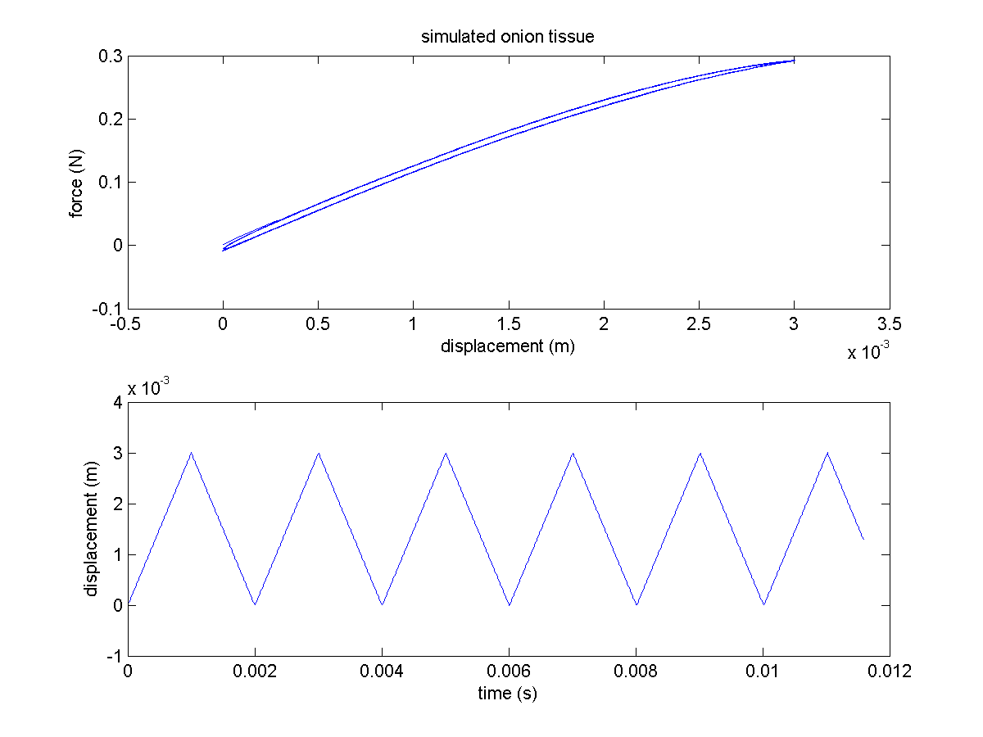

De beste resultaten voor hysteris werden bekomen met

double gamma = 1; // the power for the gas law

double pressure = 1; // pressure inside the circle

double cornerMass = 6.147e-3;//0.1; // mass of one corner

double k = 16.0;// linear spring constant of the contact

double kCorner = 16.0;//

double c = 6.40;// damping constant for the spring

double displacementSpeed = 3; // m/s increment speed in the position of the northface

double dt = 1e-6; // timestep

Zodat de hoekpunten in het midden gewoon blijven liggen en niet bewegen.

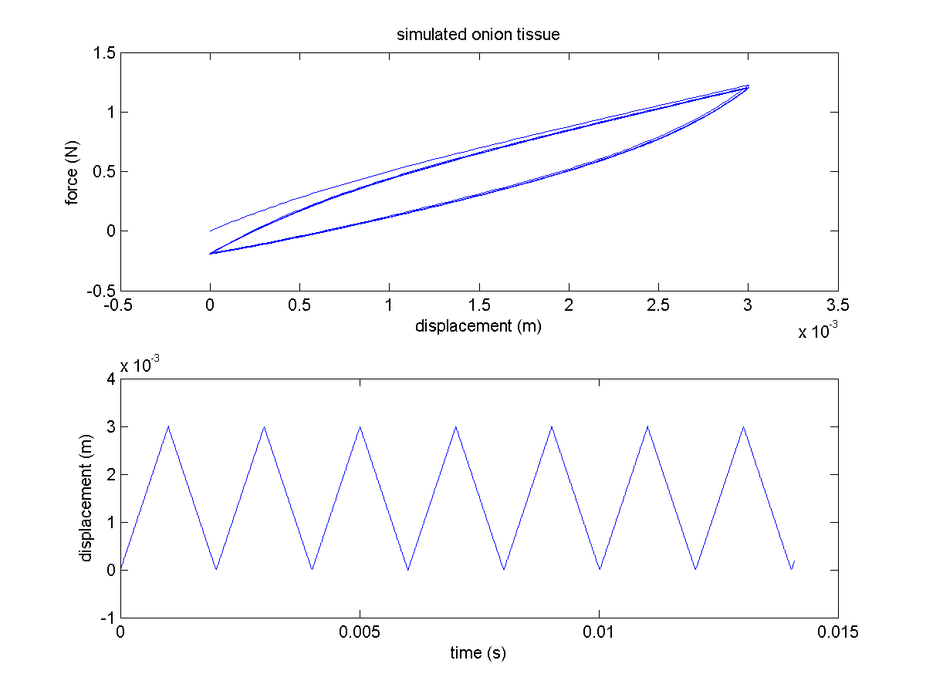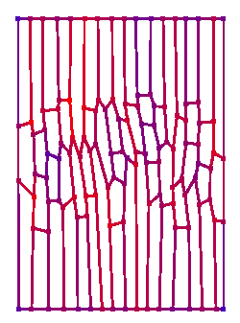

### Visualisatie van de stress

Als maat voor de spanning in een bepaald punt worden de groottes van alle krachten die op dat punt inwerken opgeteld en bijgehouden in de private member load van Corner. In void CCell::draw() wordt dan de kleur toegekend als volgt

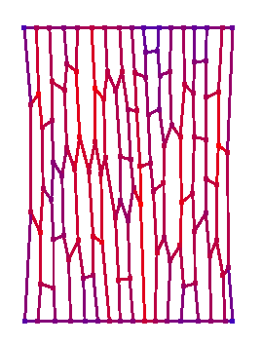

color = (pCornerA[i]->getLoad())/(loadMax);

glColor3f(color,0,1-color); // red = max, blue = min

loadMax is een externe variabele die in main.cpp bij iedere oproep van display() weer op nul wordt gezet en opnieuw berekend wordt op het einde van void CContainer::calculateForces(…).

## Constant volume vanaf SoftTissue06

Het volume wordt constant gehouden aan de hand van een interne drukkracht per cel die verdeeld wordt over de hoekpunten naargelang de ‘zone of influence’.

Niet enkel een proportionele regelactie, maar ook een differentiele. Hiertoe wordt de vorige waarde van het volume van de cel bijgehouden. Cfr een gedempte veer.

Deze interne druk is in feite de turgordruk, dit zou quantitatief ook overeen moeten komen.

## SoftTissue18

Korte samenvatting van de verschillende modellen

Lineaire veer

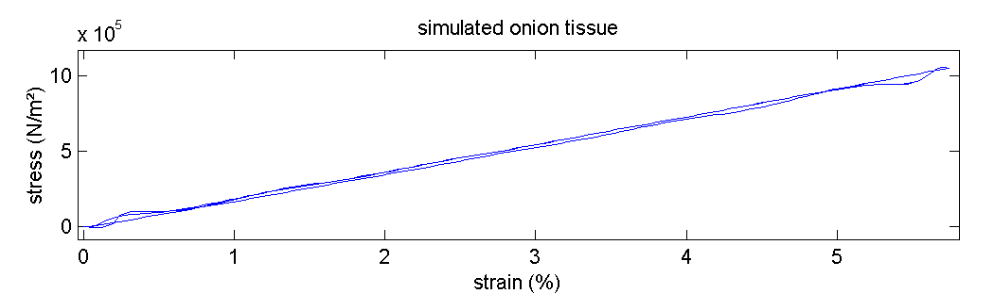

Lineaire veer met plastische vervorming vanaf bepaalde kracht

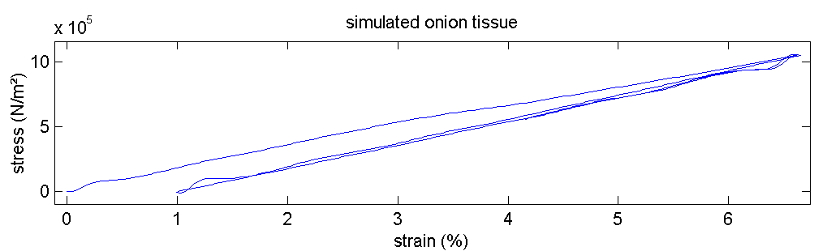

knik

permanente vervorming

Lineaire veer met demper in parallel

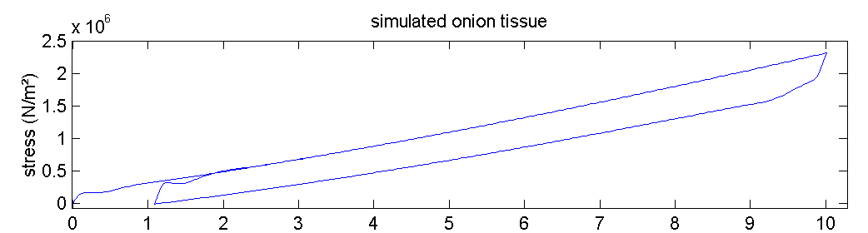

hysteresis

Lineaire, plastische veer met demper in parallel

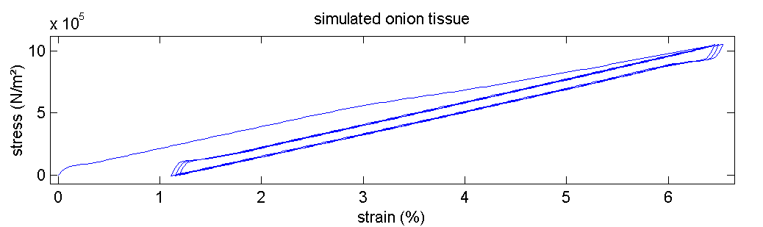

knik

permanente vervorming

### Non-linear behaviour

De herschikking van veren veroorzaakt een stiffening aangezien de veren rechtgetrokken worden in de richting van de uitrekking. Deze heroriëntatie vergt geen kracht, maar eenmaal ze min of meer parallel aan de uitrekrichting liggen moet je ze wel uitrekken om nog verder te kunnen gaan. Dit maakt de stress-strain curve convex.

### Plasiciteit

Wanneer de load in een Spring boven een bepaalde treshold uitkomt is er een kans dat de restLength van de veer verlengd zal worden met vb. 0.0001*restLength. Dit is als het ware de ‘slip’ die optreed wanneer de verschillende chemische ketens naast elkaar afschuiven. Dit is een zeer elegant en zuiver model voor de plasticiteit.

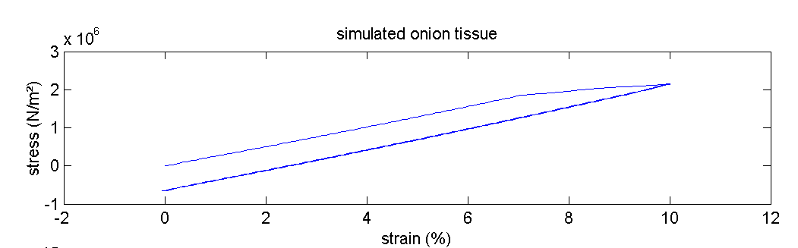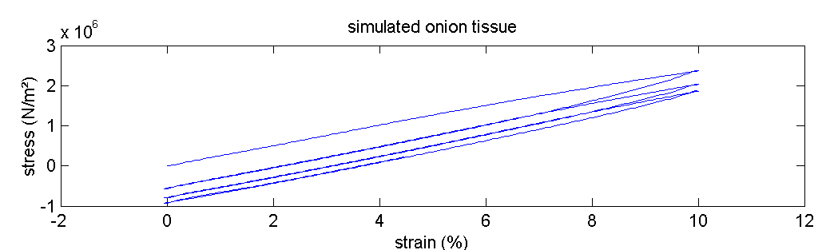

De bovenste curve in bovenstaande figuur geeft een zuivere plasticiteitsgrens weer eenmaal dit yielding point gepasseerd veranderd het gedrag van het weefsel. In de volgende cycli keert de curve terug via de oorspronkelijke helling.

In het onderste deel van de figuur is een curve te zien waarbij een stochastische regel gebruikt werd om te bepalen of een veer al dan niet plastisch zou vervormen.

### Hysteresis tgv van viscositeit

Indien de massa van de cornerpoints verhoogd wordt, de treksnelheid verhoogd wordt of de demping van of de primary of de secundary springs met een factor 12 verhoogd wordt heeft dit tot gevolg dat hysteresis bekomen wordt.

Onderstaande resultaten werden bekomen door de dempingsfactor maal 12 te doen voor de cell wall springs.

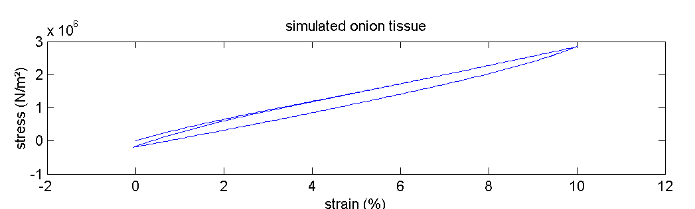

In combinatie met de plasticiteit zoals hierboven reeds werd beschreven geeft dit:

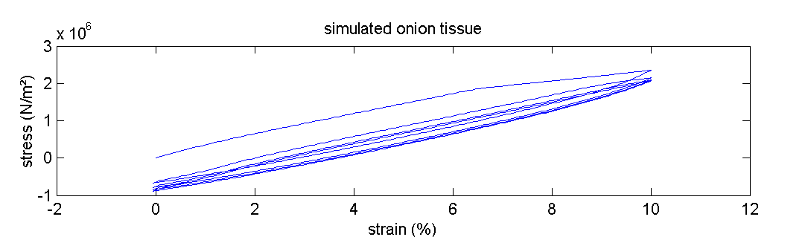

Dit lijkt zeer sterk op de resultaten van Wei 2001 en de metingen van Els evenals de metingen voor andere weefsels!!! Reden tot optimisme!!!

# MicroMech

## Programma MicroMech01

* Onsamendrukbare korrels
* Dynamica zit in de wanden
* Wanden
  + geen rotatie
  + verbonden met veren
* Roerder



## Programma MicroMech10

* Toestandsvergelijking
* Dynamica zit in de hoekpunten
* Wanden als veren
* Drukberekening

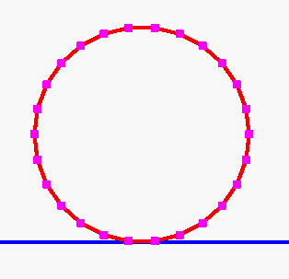

## Programma MicroMech20

Programma geschreven voor sferische deeltjes met enkel een veerkracht in de normaalrichting.

### Grid search

Om met een groot aantal deeltjes te kunnen werken werd een grid search algorithme geïmplementeerd zodat een rekentijd lineair stijgt met het aantal deeltjes in plaats van kwadratisch.

Er kan maximaal één deeltje in een cel, dit maakt de datastructuur eenvoudig.

De volgende grafieken geven de tijd nodig voor één tijdstap in een domein van 0.1 m bij 0.1 m en deeltjes met een straal van 0.0005 m.



Het grid is opgebouwd uit 26569 cellen.



Niet enkel de tijd, maar ook de geheugenruimte is een beperkende factor. Deze wordt ingenomen door voornamelijk 2 grote datastructuren: de lijst van alle deeltjes en het grid waarin ze zich bevinden.

Onderstaande grafieken werden opgesteld aan de hand van simulaties. Hieruit wordt zowel voor het aantal gridcellen als het aantal deeltjes een lineair verband gevonden met de geheugenvereisten.



Ook het grid stelt natuurlijk zware eisen aan het geheugen.



Wanneer men nu een verband vooropsteld tussen het aantal gridcellen en het aantal deeltjes, bijvoorbeeld een verhouding van 3 op 1, dan kan het maximaal aantal deeltjes bepaald worden voor een bepaalde geheugencapaciteit.

### Gevalstudie:

Momenteel is de bovenlimiet voor workstations **4GB RAM** dit maakt dat in een 3:1 verhouding van aantal gridcellen tot aantal deeltjes, **tot 32 miljoen deeltjes** gesimuleerd zouden kunnen worden.

De volgende vraag is echter of dit binnen een aanvaardbare tijd zou kunnen gebeuren.

Het is moeilijk op voorhand te voorspellen hoe groot de tijdstap zal kunnen zijn aangezien dit afhangt van de fysische parameters, de interactiekrachten en het integratieschema, maar een tijdstap van 10-7 s lijkt toch zeker geen te optimistische (grote) tijdstap. Het zou dan 128 s duren per tijdstap, zodat het 40 jaar zou duren om 1 seconde in de realiteit te simuleren.

De bepalende factoren zijn:

* aantal deeltjes
* tijdstap (10-7 s)
* aantal seconden dat men wenst te simuleren
* berekeningstijd per deeltje per tijdstap (4 10-6 s)

Om de beweging van **1 miljoen deeltjes te simuleren gedurende 1 s is momenteel 11 uur nodig, wanneer de tijdstap 10-5 s bedraagt**. Optimalisatie van de code, een snellere pc, hogere orde integratieschemas zouden nog een factor 10 moeten kunnen maken. Bij het gebruik van grote geheugenblokken kan het effect van **cache-misses** de rekentijd aanzienbaar vertragen.

### Clustering

Wanneer demping in het botsingsmodel opgenomen wordt, zou men clustering moeten kunnen waarnemen wanneer men deeltjes simuleert met een random beginsnelheid.

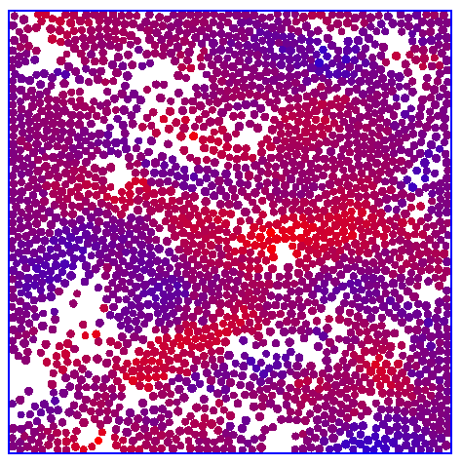

### Variabele deeltjesgrootte

Verschillende deeltjesgrootte mogelijk, grid search past automatisch zijn searchrange aan per deeltje. De deeltjesgrootte is te definiëren aan de hand van de min en max waarden.

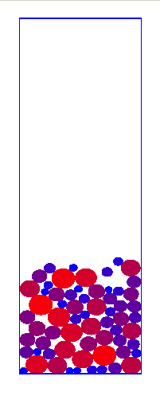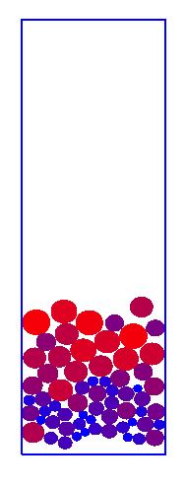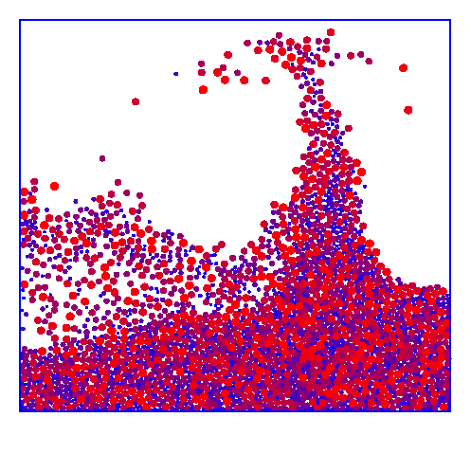

Hierbij kan duidelijk segregatie op basis van deeltjesgrootte worden waargenomen, aangezien alle deeltjes dezelfde massa hebben. De blauwe kleur staat voor een lage waarde terwijl de rode kleur een hogere waarde voorstelt.

### Individuele massa

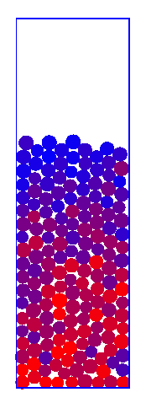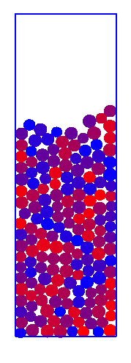

Aanvankelijk werd gewerkt met een uniforme massaverdeling, naderhand kreeg echter elk deeltje zijn eigen massa toegewezen. Hieronder zie je segregatie op basis van verschil in massa. Blauwe deeltjes wegen veel lichter dan de rode.

### Simulatie van de stroming in een buis

* Stationaire onsamendrukbare laminaire stroming in een buis
* Parabolisch snelheidsprofiel aan de inlaat
* No slip randvoorwaarden met de wanden
* Oplossing van het snelheidsprofiel in de x-richting met behulp van FEMLAB

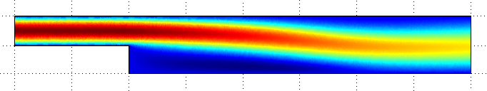

Kort visueel overzicht van de verschillende scenario’s

Zonder wrijving met de wand

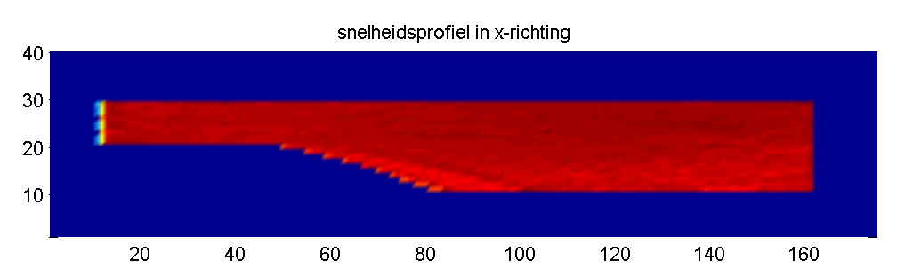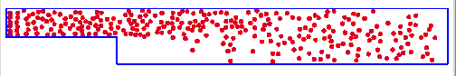

Met wrijving met de wand

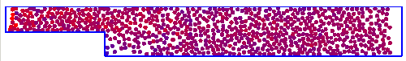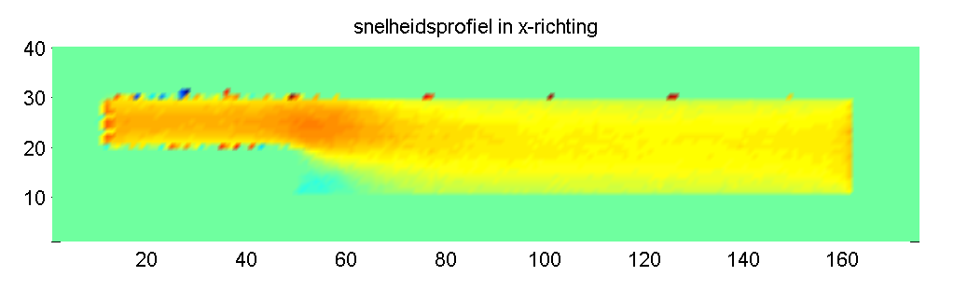

Met veel demping

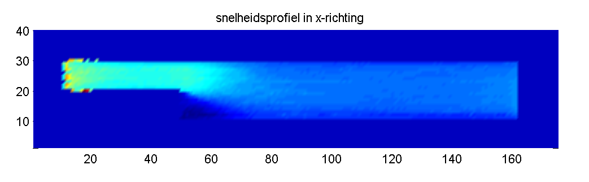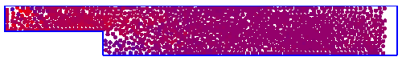

Met zwermgedrag

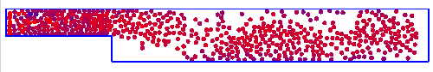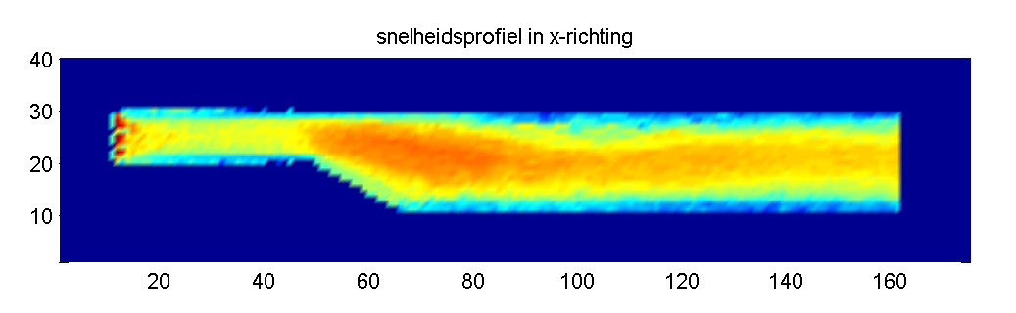

De no-slip conditie met de wand van de buis werd geïmplementeerd als een wrijvingskracht waarbij het deeltje telkens 1% (=1-friction) van zijn snelheid in de x-richting verloor. Dit creëert automatisch een min of meer parabolisch profiel, maar zorgt helaas ook voor een opeenstapeling van potentiële energie die plots vrijkomt wanneer de buis wijder wordt (zie rode vlek hieronder).

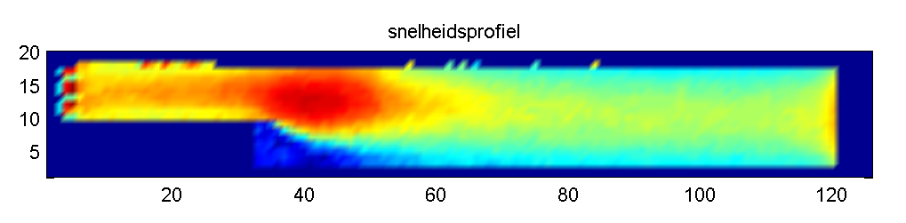

### Zwermgedrag

Om beter informatie door te geven aan naburige deeltjes werd een “zwermgedrag” geïmplementeerd. Hierbij neemt het deeltje voor een te definiëren deel de snelheid van zijn omgeving over. Op onderstaande figuur is een simulatie zonder zwermgedrag te zien, overeenkomstig de bovenstaande figuur.



Wanneer de snelheid iedere tijdstap voor 0.16% (swarmImpact = 0.0016) overgenomen wordt van de naburige deeltjes bekomt men onderstaand profiel.

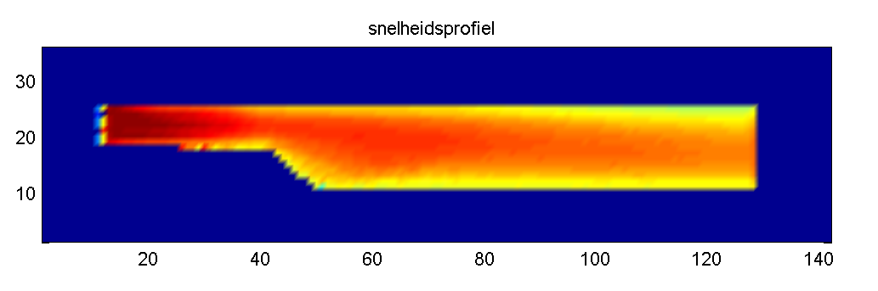

De kleurschalen kunnen echter niet vergeleken worden, maar het is duidelijk dat het verhogen van de zwerm-eigenschap een vergelijkbaar effect heeft als een verhoging van de demping.

### Adaptieve tijdstap

De tijdstap dt wordt automatisch bepaald aan de hand van twee criteria:

1. Minimum aantal tijdstappen per contact
   1. de impactduur wordt theoretisch bepaald als PI/sqrt(k/ballMass-c/ballMass)
   2. deze wordt dan gedeeld door het aantal tijdstappen per contact typisch 15.
2. Maximale overlap
   1. de afstand afgelegd door een deeltje tijdens 1 tijdstap mag niet groter zijn de de toegelaten maximale overlap
   2. deze maximale overlap wordt meestal als 1% van de straal genomen

## MicroMech21

Demo’s gemaakt om clustering te illustreren. Schudbak met verschillende componenten. Beginnen met een homogene verdeling, na een tijdje treedt clustering op.

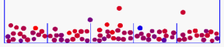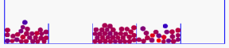

Een tweede toepassing was het Brazil nut probleem waarbij een grote noot in een doos vol noten bovenaan komt ‘drijven’ wanneer de doos geschud wordt.

‘k Heb eveneens de transparantie opgelost in DEMeter++ zodat je deels door de objecten kan kijken. De GLUI is ook geïmplementeerd door Bert in deze periode.

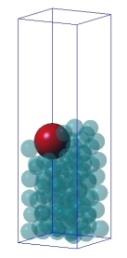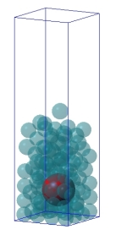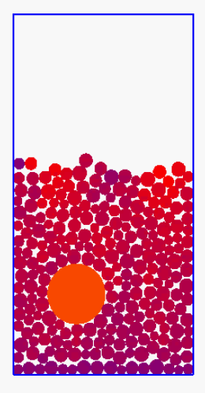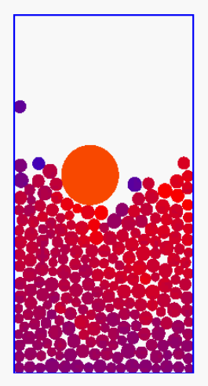

## Programma MicroMech23

Een simulatie met bewegende wanden vb. twee roterende schoepen. En ook een simulatie van fluid-like behaviour. Hierbij gaan deeltjes in hun neighbourhood kijken naar andere deeltjes en trekken deze in zekere mate aan. Hierdoor krijg je de vorming van pakketjes en hoe groter de invloed van de naburige deeltjes hoe visceuser de vloeistof lijkt.

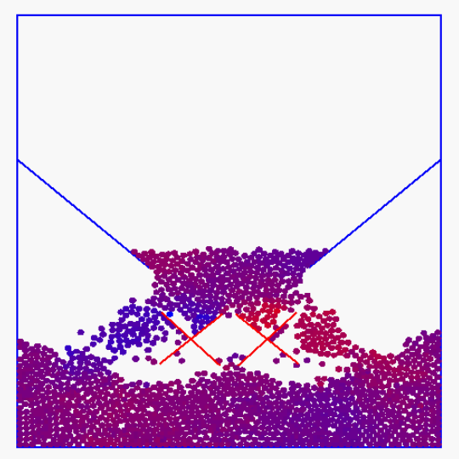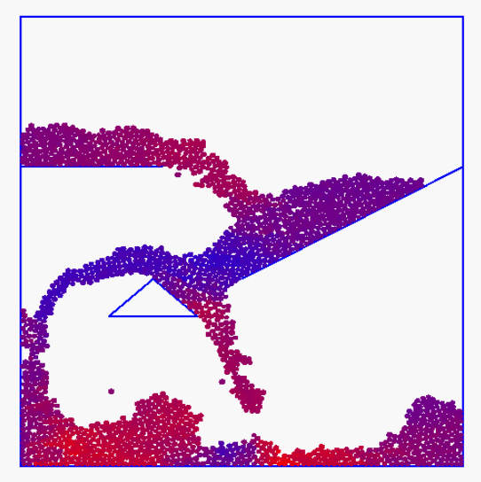

## Stappenplan van 25/11/03

* Grid numbering van de cornerpoints zodat de kleinst mogelijke bandbreedte van de stijfheidsmatrix bekomen wordt
* [K]{a}={f}
* DiffPack + GLUT + timestepping
* Parameter scaling

In voorbereiding van dit ambitieuze stappenplan heb ik de bewegingsvergelijking van een enkele veer trachten op te lossen met een Matlab solver in Werk/FEM/OneSpring en dit werkte, maar ik zag niet hoe ik een visceuze term afhankelijk van dx/dt kon introduceren.

## Implementing a Maxwell element

This is essentially a spring and a dashpot in series and it should be straightforward to implement this.

The equations are the following:

 and 

The parameters describing the current state of the system are εs, and εd from these everything else can be derived. Let’s assume we know the new positions (i.e. ε) from the previous timestep, and we know how much slip occured already (i.e. εd) thus we can calculate εs. This gives us the force

,

which is the same all over the element. So we can calculate the velocity in the damper from

.

So we know how the cornerpoints of the element are moving since we know the force acting on them, which can be integrated over time. And we know how the internal arrangement in the Maxwell element changes, it est how ε is devided over εs εs, and εd know the velocity at which the damper is changing and we calculated the velocity of the cornerpoint, this enables is to calculate εd.

In **springDash2.m** an implementation is given for a Maxwell element the code is as follows, in **springDash.m** the behaviour of the element implemented in **SoftTissue22** is replicated.

close all;

clear all;

m = 4.8e-7;

k = 1400;

c = 1; % 0.01 is nice

N = 10000;

t = linspace(0,3.6e-3,N); % s

dt = t(2)-t(1)

I = ones(size(t));

vel = 0.99; % m/s

dir = 1;

nrCycles = 6;

switchDirInterval = N/(2*nrCycles);

switchDirTime = 0.5*switchDirInterval;

xs = 0*I;

vs = 0*I;

xd = 0*I;

vd = 0*I;

f = 0*I;

for i = 1:N-1

if i>switchDirTime

switchDirTime = switchDirTime + switchDirInterval;

dir = -1*dir;

end

% first spring then dashpot

vs(i) = dir*vel;

xs(i+1) = xs(i) + vs(i)*dt;

xd(i+1) = xd(i) + vd(i)*dt;

f(i+1) = (-k*xs(i+1));

if c ~= 0

vd(i+1) = f(i+1)/c;

else

vd(i+1) = 0;

end

end

This is the graphical result

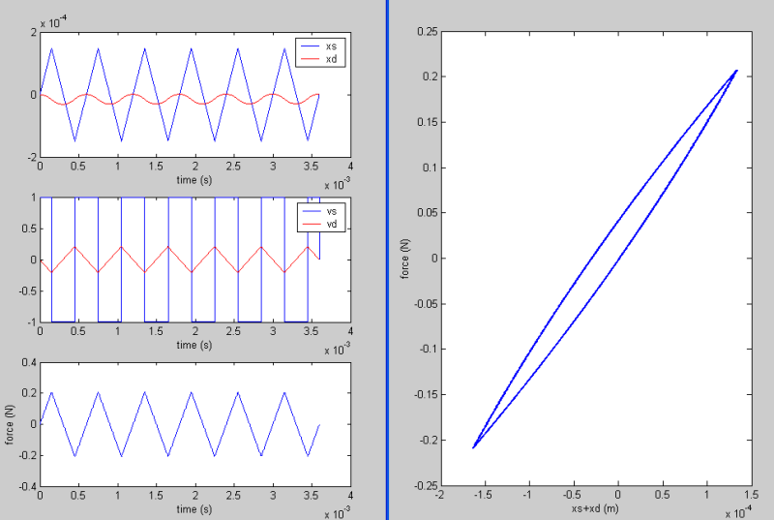

This was ported to the C++ program SoftTissue22 which gave the following results

The code in Spring.h is as follows:

void Spring::calculateForce()

{

Pair N, relVel, F, midPoint;

double dx, newLength;

relVel = pEnd->getVel() - pBegin->getVel();

N = pEnd->getPos() - pBegin->getPos();

newLength = VectorLength(N);

N = N/newLength; // unit length now

slip = slip + slipVel*dt;

if(slip<0){slip=0;}

dx = newLength - restLength - slip;

double dv = relVel*N;

double dxnext = dx + dv*dt;

double IFI = -k*dxnext;

if(c!=0) {slipVel = (-IFI-0.03)/c;} else {slipVel = 0;}

F = -IFI*N;

addForce(F);

}

As one can see an offset of 0.03 N is used to calculate the slipVel. This is to allow for complete recovery even when no actual compression of the spring occurs.

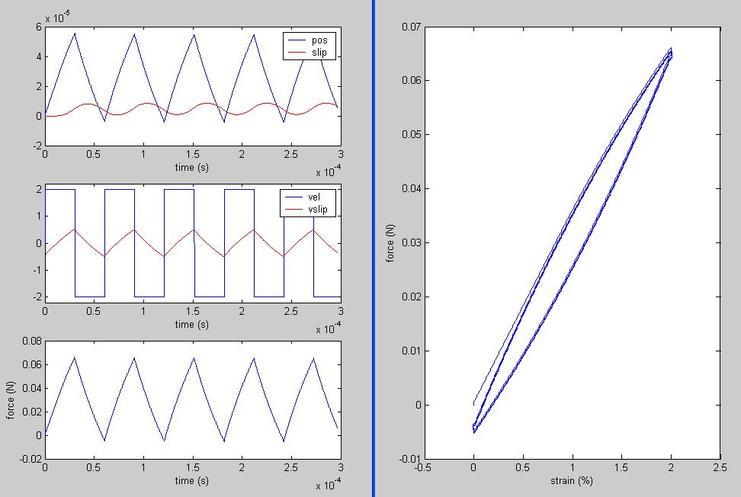

In the force-strain diagram you can see the kink at the ends which follows from the fact that the position of the begin and endpoint of the spring are imposed while it does have its own dynamics. So when a sudden switch in direction is imposed the ‘inertia’ of the spring (it does have a velocity, slipVel) causes it to continue its previous motion.

### Determination of the relation between kSCB and kSPB

The cell boundaries are in fact made of the same material as plane boundaries. They actually represent a piece of cell wall as depicted in the figure below

So we are looking for the realation between kSCB and kSPB  such that this 2D strip can be represented by a 1D series of springs. Actually we use a pseudo 2D model since we assume the thickness of the tissue to remain constant ( at 120 micormeter). So we start from a homogenious strip modeled by cross linked plane boundary springs (kSPB  = 1000), we measure the stress strain relation ( stress = 1.082 104 Pa @ 3 % strain ). Then we replace the plane boundary springs by cell boundary springs, and find that we have to take kSCB = 511 to get the same result. So we can conclude that

kSCB = 1.022 x kSPB  (for stretches from 0 to 3%)

when we want to represent this plane boundary strip (of constant thickness) with a single plane boundary spring. In fact we replace two plane boundary springs (oriented under 45° and thus counting as half) with one cell boundary spring. Normally one would expect kSCB = kSPB , but this is not exactly true since the plane boundaries reorient while stretching and thus they count for a little more than 50% in the x-direction.

### Exact solution of a Maxwell element

The inhomogeneous first order differential equation to be solved is:



Which is of the general form



The general solution of such DE (differential equation) is given by



such that we can write







Initial conditions at *t*=0







Similarly we obtian from







These exact solutions were implemented in matlab **exactspringdash.m** in Matlab01 folder

xd = -(vel*c/k)*I + vel*t + (xd0+(vel*c/k))*exp(-(k/c)*t);

vd = vel*I - k/c*(xd0+(vel*c/k))*exp(-(k/c)*t);

xs = (vel*c/k)*I + (xs0-(vel*c/k))*exp(-(k/c)*t);

vs = -k/c*(xs0-(vel*c/k))*exp(-(k/c)*t);

fs = k*xs;

fd = c*vd;

Graphical results are shown below

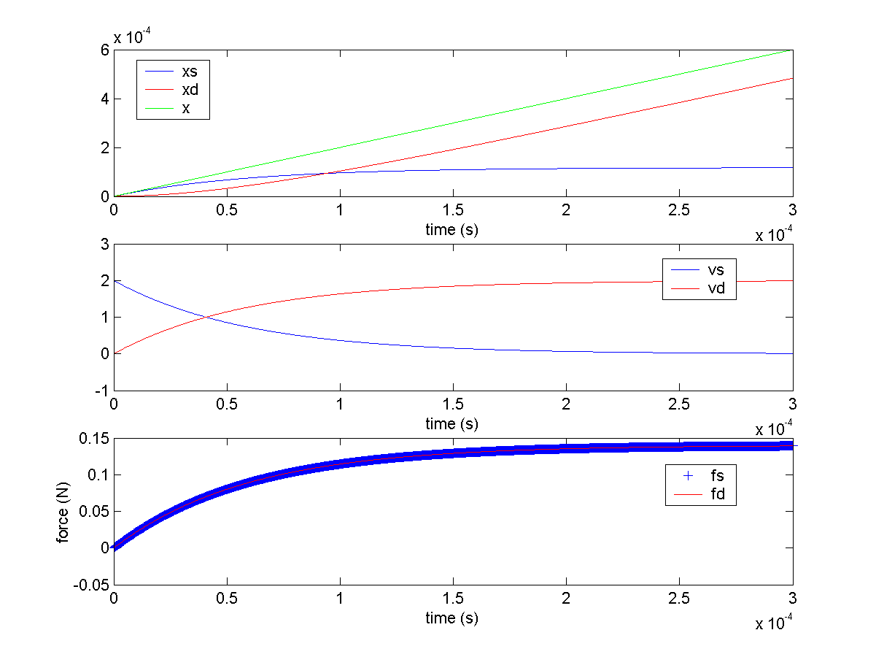

In order to solve the differential equations numerically, the centered difference method was used. In general it replaces a derivative with a difference as follows









This was implemented in **springdash1.m** also in the Matlab01 folder.

for i = 2:N-1

t(i+1) = (i-1)*dt;

pos(i+1) = pos(i) + vel*dir*dt;

xs(i+1) = vel*2*dt-(k/c)*xs(i)*2*dt+xs(i-1);

xd(i+1) = (k/c)*pos(i)*2*dt-(k/c)*xd(i)*2*dt+xd(i-1);

vs(i) = (xs(i+1)-xs(i-1))/(2*dt);

vd(i) = (xd(i+1)-xd(i-1))/(2*dt);

end

fs = k*xs;

fd = c*vd;

**Note on stability:** Since this is a very basic numerical scheme it was expected and found to be not so stable. In fact the timestep had to be reduced from dt=3e-7 to dt=1e-8 to give the following results (first the result for dt=3e-7 are given)

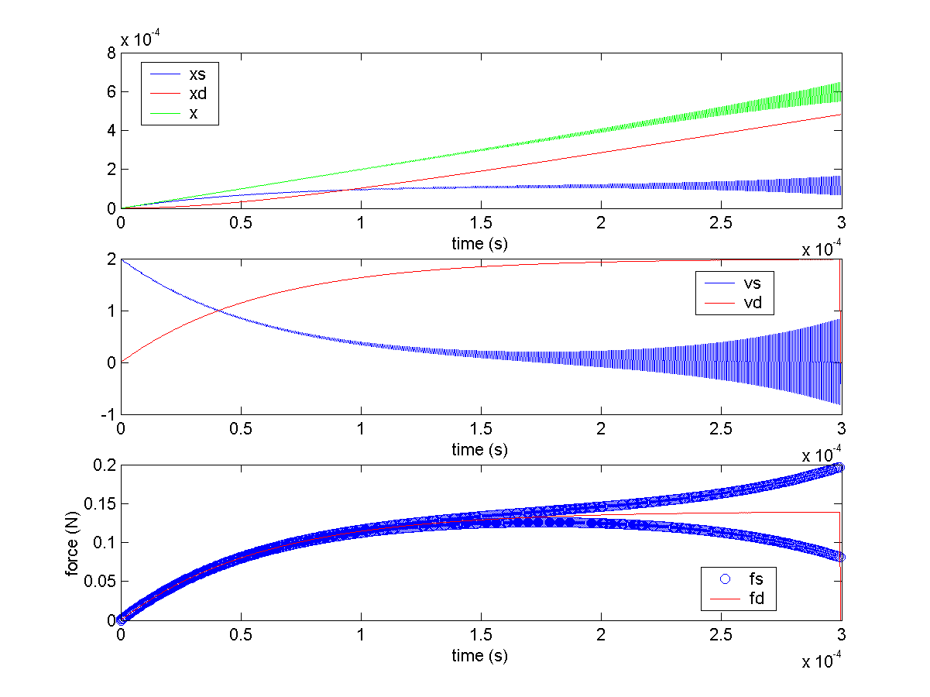

These are the results for dt=1e-8, which are already more stable

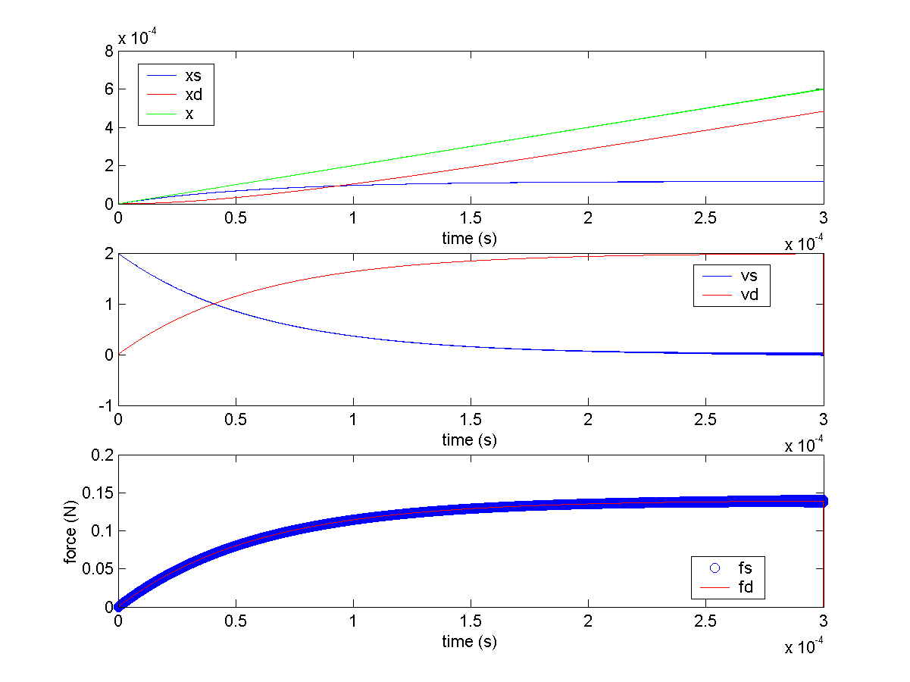

### Creëren van een realistische inputfile.txt

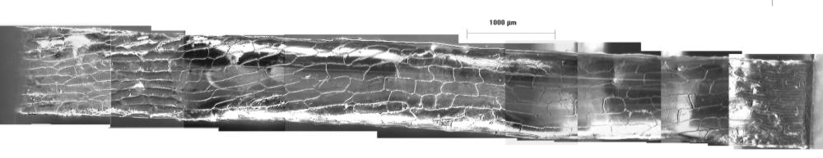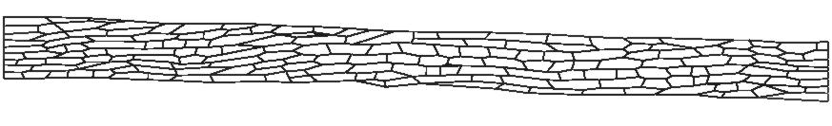

Deze digitale versie bevat 341 hoekpunten en 181 cellen.

## Meetresultaten

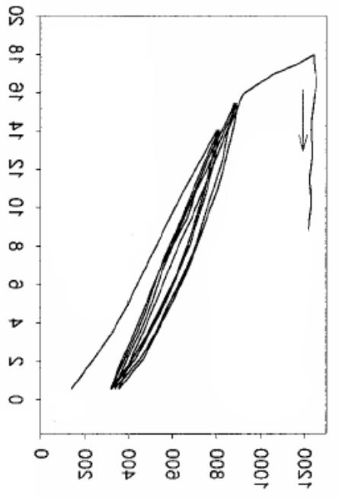

**elongation (um)**

**force (gf)**

tension on cell strip (Wei, 2001)

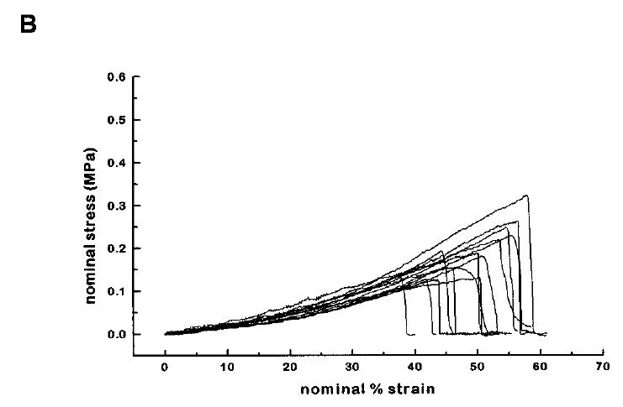

cellulose+xyloglucan (Whitney, 1999)

**nominal % strain**



## Virtuele experimenten met SoftTissue17forPaperAuto

SoftTissue17forPaper werd geautomatiseerd zodat de computer achtereenvolgens een set van experimenten uitvoert en de data in de respectievelijke folders saved.Twee grote experimenten werden uitgevoerd en geanalyseerd, een op 30-06-04 en een op 05-07-04 en zijn in gelijknamige folder te vinden onder ‘data’, de twee tabellen met resultaten zijn ingevoegd in de tekst.

## SoftTissue17resurrection

We stay in 2D and want to model the data observed by Wei et al. 2001.

Thickness d = 1.2e-4m

Width w = 3e-3m

Length l = 1.8e-2m

Mass density ρ = 1040 kg/m³

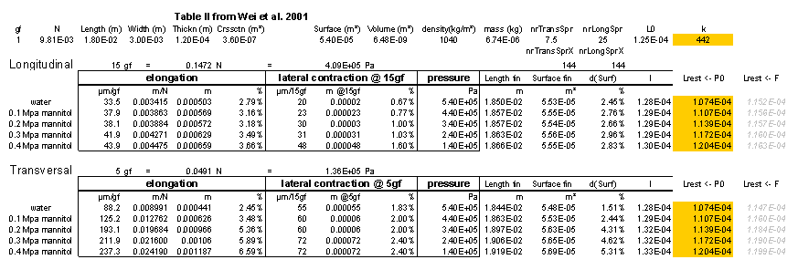

In the above table the final surface “Surface fin” is calculated asif the tissue would contract only in the center as indicated in the middle pane in the figure below

a

b

Length fin

even smaller area  
bigger volume loss

The lateral contraction is the difference of the current width compared to the initial width and is equal to a+b.

Surface fin = Surface – 0.5*Length fin*(Thickness-a-b)

In this way we obtain an underestimate for the volume loss ranging from -0.34% up to -1.28%. The significant difference between the longitudinal strip (-0.83% @ 3.66% strain) and the transversal strip (-1.03% @3.48% strain which is even lower than the strain of the longitudinal strip, 3.66%) might be due to the curling of the sides with the transversal strips (p.1131). Theoretically, if this change in thickness would be due only to the volume loss then it should be more or less equal for both strips at the same strain (the only difference might be the turgor pressure that drives the cell fluid out). Of course part of the volume might disappear in the thrid dimension due to changes in the tissue thickness.

To be sure that the experimental results are not affected by the “curling phenomenon” we will first investigate the longitudinal strip at different turgor pressures.

We need a means to “inflate” all the cells at once while preserving the current geommetry. This can be done by compensating the increase in turgor pressure by increasing the spring constants. The turgor pressure can better be tought of as a dependent variable in our simulations since it is computed through a force balance method as in Pitt82. The volume conservation is implemented by the old PD controller.

In order to start with an inflated structure we need to determine appropriate values for k and Lrest for each spring. These are the only two degrees of freedom since the shape and dimensions are given at the start. We take k to be the independant variable which we will tune to get the force-deformation curve in the right order of magnitude. So the parameter to be determined at the initialization step is the restLength of the springs.

From a force balance with the initial turgor pressure P0 we obtain



When we don’t take the apoplast geometry into account the restLength can be approximated as follows (although this is not the method of preference)

A simple force balance for a crossSection of the strip gives



where n is the number of springs in the y-direction and l is the length of a single spring which can be calculated from the length of the deformed strip (l=Lstrip/nrSpringsX) in which nrSpringsX are the number of springs in the x-direction (typically 144).

**targetSurface**

To control the deviation from the restsurface (since the surface apprarently does not remain constant in Table II from Wei01) a targetSurface is introduced which depends on the strain. When strain reaches strainMax targetSurface = restSurface*(1+deviation), and it approaches this value linearly with strain. Implemented in Cell::calculateForces()

**SoftTissue17resurrection_01**

Input; the desired volume change is imposed per cell. The tissue is stretched and its width and the stress in the cell walls is monitored. The change in width corresponds in order of magnitude to the desired one (which is not such a big thing since the volume change was an input value :o).

**thickness**

A thickness parameter per cell is maintained and updated such that the volume per cell does remain constant. First simulation results show a uniform distribution of volume changes and thus of thickness changes throughout the tissue.

The next step will be to incorporate pressure and external force calculations with these thickness values.

**SoftTissue17resurrection_02**

Cell::calculatePressure() and Container::calculateExternalForce() wer implemented. Simulation trials show that it is important to have enough relaxation steps to let the tissue find its equilibrium state.

## SoftTissue25 etc.

Based on SoftTissue17IO for use with WritingConfiguration07. It handles 3D configurations, but there seems to be a bug in the springlength, also the calculateSurface has to be adapted for 3D.

SoftTissue26: the surface constraint was adapted to 3D instead of a simple rotation to the left, a double sequence of vectorproducts is used in combination with the center of mass of the polygon to determine the outward direction. Working fine

## Onion3D

Adapt WritingConfiguration07 such that it generates the appropriate 3D geometry. The drawing remains 2D, but the configuration is then obtained through sweeping along a displacement vector D (which represents the thickness of the tissue).

D

To implement pressure forces, we need to be able to calculate the surface and volume easily of/enclosed by the different edges.

Per Cell we keep a list of triangles (triples of integers which are the numbers of the corners). This is in fact a typical face list consiting of triangles only. We also need to define a normal list that indicates the outward normal direction associated with that point and that face.

Example for quads:

6

x

y

z

1

2

5

4

3

1

4

8

5

2

6

3

7

|  |  |  |  |
| --- | --- | --- | --- |
| **vertex list** | | | |
| **nr** | x | y | z |
| **1** | 0 | 0 | 1 |
| **2** | 1 | 0 | 1 |
| **3** | 1 | 1 | 1 |
| **4** | 0 | 1 | 1 |
| **5** | 0 | 0 | 0 |
| **6** | 1 | 0 | 0 |
| **7** | 1 | 1 | 0 |
| **8** | 0 | 1 | 0 |

|  |  |  |  |
| --- | --- | --- | --- |
| **normal list** | | | |
| **nr** | x | y | z |
| **1** | 0 | 0 | 1 |
| **2** | 1 | 0 | 0 |
| **3** | 0 | 0 | -1 |
| **4** | -1 | 0 | 0 |
| **5** | 0 | 1 | 0 |
| **6** | 0 | -1 | 0 |

|  |  |  |
| --- | --- | --- |
| **face list** | | |
| **nr** | vertices | normal |
| **1** | 1,2,3,4 | 1,1,1,1 |
| **2** | 2,6,7,3 | 2,2,2,2 |
| **3** | 6,5,8,7 | 3;3;3;3 |
| **4** | 1,4,8,5 | 4,4,4,4 |
| **5** | 4,3,7,8 | 5,5,5,5 |
| **6** | 5,6,2,1 | 6,6,6,6 |

The **normal** can be computed by the **Newell method** which has the advantage that the polygon needn’t be perfectly planar and the vertices may be collinear. This collinearity forced us to work with the CellCenter to compute the outward direction for the planes (as implemented in SoftTissue26).







**Calculating the volume**

A

H



In **Onion3D04** we try to obtain good simulation results for both the stress-strain curve and the lateral contraction at the same time... something which was impossible with a 2D model if we wanted to keep the volume constant. Now there is one degree of freedom (and possible cause of errors) less since there is only one type of spring.

The drawing and calculation of the pressure force is enhanced and the volume and pressure can be saved correctly now.

## WritingOnion3D

[ dOne ] Get the corner list right, just save the list as before, but continue counting and add the same points once more but now translated over D.

[ dOne ] Also increase the spring list with a copy for the translated cornerpoints, and connect every original point with its corresponding translated twin. Now, there is no need anymore to use two different kinds of springs.

[ dOne ] Create a face list, with the numbers of the cornerpoints stored as a triple of integers (x,y,z), and the corresponding normal (only one per trianle since we won’t use smoothed objects in the near future).

[ dOne ] Create a normal list, one normal for every face (triangle in the current case) use the same numbering as for the triangles

[ dOne ] Cell::CalculateForce() calculate the whole cell volume, determine the reactionforce (it est the pressure) and then iterate over the vertex list, compute the surface of each face and distribute the pressure on this face equally over the (three) cornerpoints.

All these features are implemented in Onion3D03.

WritingOnion3D03 writes the same configuration but now the side-face have diagonal springs inside the rectangles. This causes a tendensy to shrink in the y-direction.

So in fact also the upper side wall should be made up of such a spring network.

## Tomato

Automatic generation of a 3D spherical mesh for the simulation of tomato cells in suspension. Experimental results from microscopic compression test Prof. Thomas (Birmingham) can be used.

**Tomato01** the generation of the position of the cornerpoints is ok. The cornerpoints are generated from bottom to top and in a counter clockwise direction for each slice. The number of corners per slice (nrSides) remains constant and the number of slices is given as nrSlices. Other parameters are the position of the center of the sphere its radius.

In **Tomato02** the springs are also generated from bottom to top: first the springs connecting the bottomCenter with the points of the neighbouring face. Then the springs connecting all points belonging to the same face. Then the springs connecting points from neighbouring slices such that the springs are parallel to the y-axis. Then the springs corresponding to the diagonals of the faces between neighboring slices. The last springs are those connecting the top face with the top point.

Also the triangle faces are generated in Cell::initialize.

**Tomato03** is fully functional and incorporates boundary conditions. The BC are a stretching movement imposed on the north and south point of the sphere. Such a deformed sphere can be used as a starting configuration for an **orange cell**...

In **Tomato04** the BC of two approaching plates will be implemented. This involves contact detection, but it can be easily incorporated using **setPosY()**. This might be further enhanced with the implementation of **friction** for the nodes in contact **with the compressing boundary walls**. The force is measured by adding up all the y-components of the forces acting on the nodes belonging to the southern hemisphere. A positive pressure is indicated in green, a negative pressure in red. It is the pressure that is draw with showForces not the actual pressureforce acting on that particular triangle.

## Pitt82

Here we try to reproduce the results described in the paper of Pitt 1982 in order to validate our model. It is about compressing a hexagonal cell. For the moment the whole thing becomes instable when a compressive strain of 35% is reached. It is not yet known wether this is just a matter of setting the parameterFile to better values or more invasive methods must be used to set things right.

**Configuration**

y

x

1

2

3

4

5

6

F

F

yAA

yAB

α

z

**Theoretical calculations**

Cell area



where sin(60°) = sqrt(3)/2 and cos(60°)=1/2

The geometry is such that



The tensile forces are given by



Force balance in the middle of the tissue

α

α

fAB

fAB

fAA



1.7 invullen in 1.8 en daaruit yAA halen om in te vullen in 1.5 samen met de formule 1.6 voor cosAlfa geeft



Compressive strain ε



For the uncompressed initial state one can write



Calculate pressure

where PTAA is the horizontal component of the pressure forces acting on the two AB walls

fAA

fAA

PTAA

2z

Balance



The external vertical force F

PAA

F

yAA

fAB

fAB

α

yAB/2

PAA: the force on yAA due to the pressue P

PAB: the force acting on half of the length of yAB due to the pressure P

fAB: the force pulling on the corners of yAA





True stress σ=F/yAA

Initial turgor p0

No external force F = 0 and no change in shape yAA=yAB=a

Alfa = 60° and cosAlfa = ½ while sinAlfa = sqrt(3)/2



**Pitt82_02**

Finding a new way to preserve the volume in a better and more efficient way. When the BC are moved by moveBC the system needs to be given time to relax and reach its original volume again. This can be done by reserving a fixed amount of iterations for this or by setting a constraint while(volume not preserved) find a better solution...

Both scenarios are implemented but neither seems to work efficiently with the hexagonal cell of Pitt...

Found a set of parameters that gives satisfying results with regard to volume preservation, when using the old method in main as follows:

void doCalculations()

{

container.calculateForces();

if(nrMoves%showTime==0) {

container.saveData(time);

display();

TimeDelta();

nrMoves++;

}

if(timeSteps%relaxationTime==0) {

container.moveBC();

nrMoves++;

} else {

container.applyBC();

}

container.move(dt);

timeSteps++;

time += dt;

}

-parameters-

mass 2e-7

k 1e3

ksecundary 0

kpressure 1e9

maxdeviation 0.001

g 0.0

dt 2e-9

forcemode 1

scalefactorforforces 0.001

showforces 1

showtime 1000

relaxationtime 1

displacementspeed 500

maxstrain 50

crosssectionalarea 3.6e-7

-end-parameters-

Below are the results shown through procesPitt.m

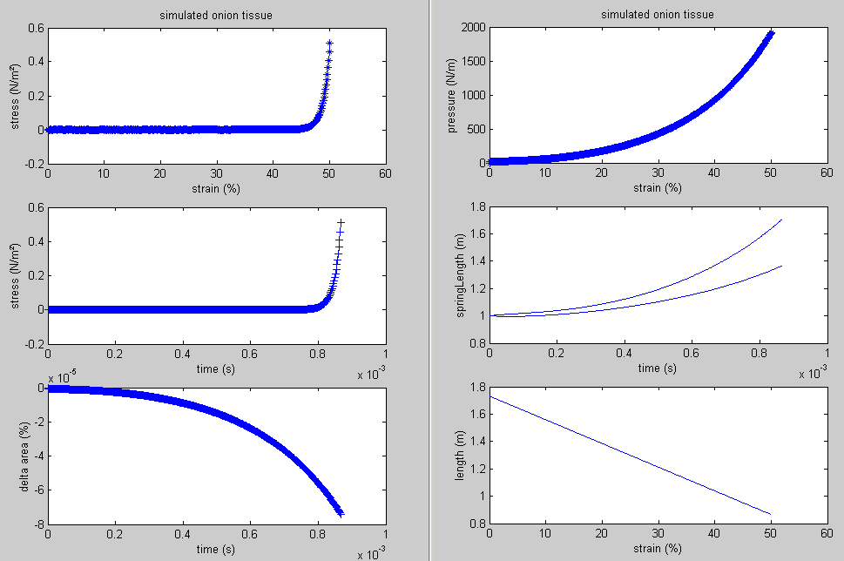

A maximal deviation of the original volume of -8 10-5 % is obtained in realtime simulation of about 5 seconds!

ProcessPitt en solvePitt also calculate the exact solution numerically. The fixed-point iteration method is used in solvePitt to solve equation 7 on p. 1779 of the Pitt82 paper.

The equation goes as



We will search for the zeros of this equation f(x)=0. a is a parameter that gives the initial length of one side of the hexagon in its initial position due to its initial turgor pressure. Since we start from zero pressure a = 1.

The closed formulation goes as g(x) = f(x) + x so we can look for the crossection points of g(x) with the first bisectrice to get the zeros fo f(s).

We introduce a stability factor stab so we can change the stability of a fixed-point by altering this value; changing sign to go from unstable to stable or equal to a value smaller than one to increase the convergence rate!

The recursive formulation is as follows





**Not converging**

**Converging fast**

The above figure illustrates the strategy followed.

The actual solution contains an iteration over z and since f(x) changes for different values of z the stab factor needs to be adaptive too. For the first half of values for z the convergence was too slow so a stab = -0.6 was used for the other half stab was set equal to 1.

The damping factor of the springs has a major influence on the simulation results. It causes a deviation that can only be made smaller by decreasing the mass of the nodes or decreasing the speed of compression.

When the damping factor is low enough however (just high enough to dampen out the oscillations occuring at the start of the simulation) then a much higher accuracy can be obtained.

-parameters-

mass 2e-7

k 1e3

c 0.005

ksecundary 0

kpressure 1e9

maxdeviation 0.001

g 0.0

dt 2e-9

forcemode 1

scalefactorforforces 0.001

showforces 0

showtime 10000

relaxationtime 1

displacementspeed 280

maxstrain 50

crosssectionalarea 3.6e-7

-end-parameters-



The simulation results lie exactly on the theoretical results in all cases except for the volume constraint of course!

Now everything is ready to implement the initial turgor pressure in

**Pitt82_04**

Working with initial turgor pressure; same accuracy as above!!!

A series of experiments will be conducted similar to those in Pitt’s paper of 1982.

1. Stress-strain curve for the cellular conglomerate for p0/k = 0; 0.2; 0.4; 0.6
2. Cell wall stresses (fAA/k, fAB/k) versus strain for p0/k = 0; 0.2
3. Normalized cell turgor pressure p/k versus strain for p0/k = 0; 0.2; 0.4; 0.6
4. Cell wall stresses (fAA/k, fAB/k) versus normalized applied stress sigma/k for p0/k = 0; 0.2

**Pitt82_05**

-parameters-

mass 2e-7

k 1000

c 0.005

turgor0 600 400

kpressure 5e8

maxdeviation 0.001

g 0.0

dt 6e-10 1e-9

forcemode 1

scalefactorforforces 0.001

showforces 0

showtime 10000

relaxationtime 1

displacementspeed 900 1000

maxstrain 50

crosssectionalarea 3.6e-7

-end-parameters-

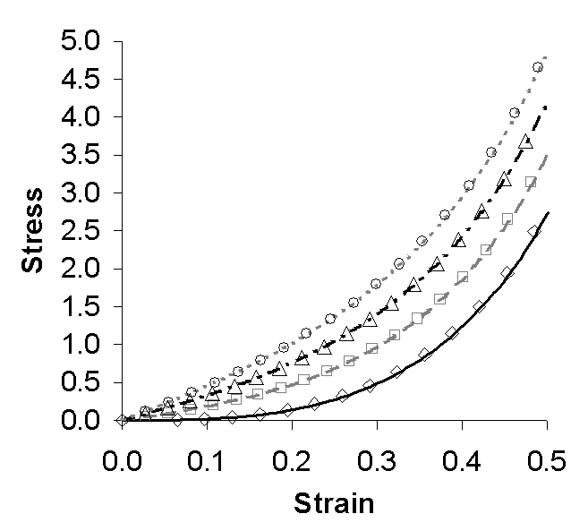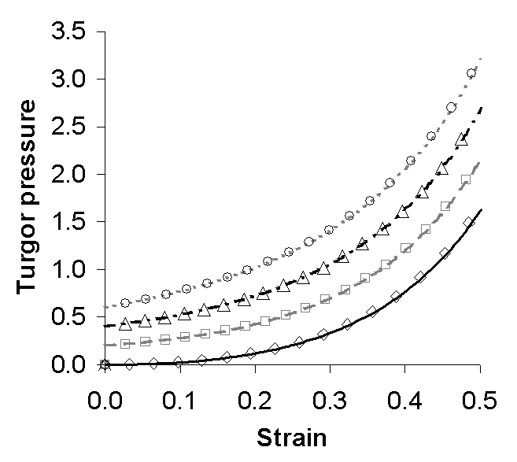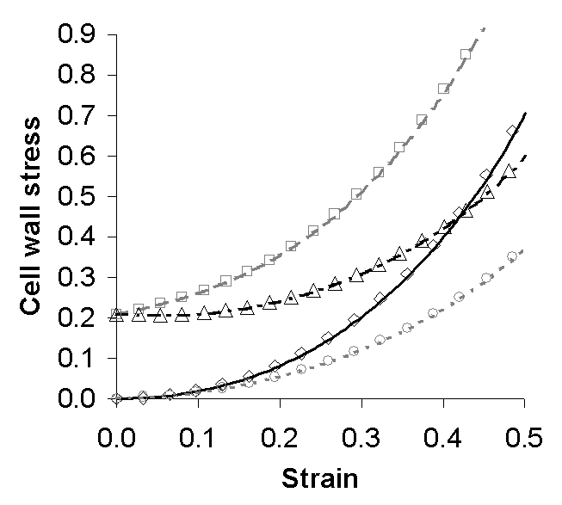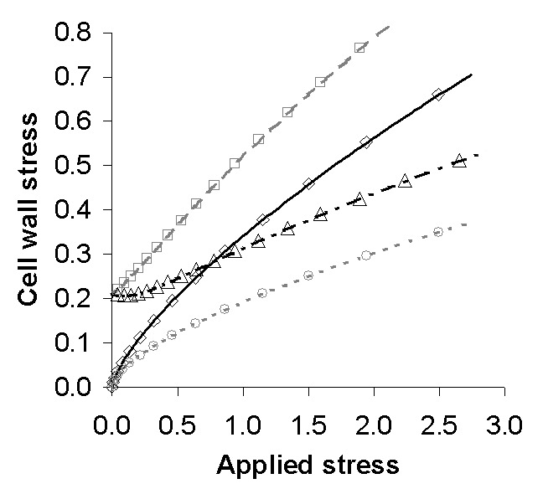

Graphs can be found in Validation.xls in the data map of Pitt82_05.

**Pitt83_01**

Instead of using the simulated values of yAB as initial values for the iteration procedure in solvePitt we will start from an initial guess of yAB0 and use the previous value as a guess for the next iteration round.

# Compression of single cells

## Symbols

 = azimuth angle (in xy-plane) from the x-plane lying between 0 and 2 PI both for cylindrical and spherical coordinates

 = polar angle from the z-axis lying between 0 and PI used in spherical coordinates

 = is the distance of a point to the origin used in spherical coordinates

 = distance from the z-axis used in cylindrical coordinates

 = height (z-value) used in cylindrical coordinates

 = infinitesimal arclenght in circumferential direction before inflation

 = infinitesimal arclenght in circumferential direction after inflation

 = infinitesimal arclenght in meridian direction before inflation

 = infinitesimal arclenght in meridian direction after inflation

 = principal stretch ratio in the meridian direction

 = principal stretch ratio in the circumferential direction

,  = the principal curvature in the meridian / circumferential direction

, = the principal curvature in terms of ,  and 

,  = principal stress resultants per unit length of the deformed surface area

 = strain energy function

,  = material constants for the Mooney-Rivlin model with the same dimensions as in stress

,  = strain invariants

, = principal stresses

 = the initial thickness of the membrane before inflation

,  = the external loads acting on the deformed surface in the normal and tangential direction respectively

 = initial pressure of the inflated sphere before contact

 = pressure inside the sphere during contact

 = volume before contact

 = volume of the compressed sphere during contact

 = initial radius of the ininflated membrane

## Problem statement

We will investigate the mechanics of a spherical membrane with initial thickness  and initial raduis  that has been inflated by an internal pressure , whilst no external pressure is present. Then the inflated membrane is compressed between two large parallel rigid plates (see also Feng and Yang, 1973). This is illustrated in Figure 1.



A



B

C

z

y

x

Figure 1: Different stages of the experiment; A: initial uninflated state, B: inflation due to internal pressure, C: compression of the inflated membrane

### Model assumptions

1. Both the undeformed and the deformed shape of the membranes are axisymmetric around the z-axis and are symmetric with regard to their equatorial-plane (Feng and Yang, 1973).
2. The membrane is composed of homogeneous isotropic material with constant thickness before inflation (Feng and Yang, 1973).
3. The initial thickness of the membrane, , is small compared to the other dimensions, such as the initial radius , such that the bending effects can be neglected (Feng and Yang, 1973).

The above three assumptions allow us to use membrane theory.

Since both the initial and deformed shape of the membrane is axisymmetric (paragraph ‎0) the loadings due to this deformation must be axisymmetric too.

### Coordinate systems

Because of this symmetry we will adopt a description in spherical coordinates, , for the undeformed geommetry and cylindrical coordinates, , for the deformed geommetry (see Figure 2) (Feng and Yang, 1973).



y

z

x







y

z

x





A

B





Figure 2: spherical (A) and cylindrical (B) coordinates of a point 

#### Spherical coordinates

 = azimuth angle (in xy-plane) from the x-plane lying between 0 and 2

 = polar angle from the z-axis lying between 0 and 

 = is the distance of a point to the origin

Their relation to the cartesian coordinates is given by:





#### Cylindrical coordinates

 = azimuth angle (in xy-plane) from the x-plane lying between 0 and 2

 = distance from the z-axis

 = height (z-value)

They are related to the cartesian coordinate system by:



### Meridian and circumferential direction

The meridian direction can be defined for a general surface of revolution as intersection of the surface with a plane containing the axis of revolution, it is indicated throughout the text by a subscript 1. The circumferential direction on the other hand can be defined as the intersection of the surface with a plane perpendicular to the axis of revolution, it is indicated throughout the text by a subscript 2.

meridian ➀

circumferential ➁

axis of revolution

Figure 3: Meridian and circumferential direction

Next we consider infinitesimal arclengths on the meridian and the circumferential direction

### Infinitesimal arclengths

#### Meridian direction

We name the infinitesimal arclenght  (no cap) before inflation and  (capital S) is an infinitesimal arclength after inflation and compression.



y

z

x





A

B

y

z

x







Figure 4: Infinitesimal arc lengths in meridian direction before (A) and after (B) inflation

As can be readily observed from Figure 4 the infinitesimal arclenghts  and  can be expressed in spherical and cylindrical coordinates respectively as:





#### Circumferential direction

In a similar way the infinitesimal arclenght  is defined before inflation and  after inflation and compression for the meridian derection

y

z

x









y

z

x







A

B

Figure 5: Infinitesimal arc lengths in the circumferential direction before (A) and after (B) inflation

As can be readily observed from Figure 5 the infinitesimal arclenghts  and  can be expressed in spherical and cylindrical coordinates respectively as:





### Principal stretch ratios

#### Meridian direction

Such that the principal stretch ratio in the meridian direction is given by

,

where the prime denotes the derivative with respect to .

#### Circumferential direction

In the circumferential direction the principal stretch ratio becomes



and thus



such that from equation it follows that



Which has two solutions, the negative root is chosen since  decreases while  increases from the axis of symmetry (z-axis). Such that



### Principal curvatures





y

z

x









z













Figure 6: The meridian principal curvature in the deformed geometry

Where  stands for the radius of the prescribing circle segment and  is the angle from the positive axis of symmetry to the outward normal  of the deformed membrane surface





The minus sign in Equation for the sine appears since the sine should be negative since the angle  is pointing clockwise in the cartesian frame and thus should result in a negative sine. The  and  are both taken in the positive direction, so a minus sign should be added.

#### Meridian direction

The principal curvature  is in the meridian direction.

From Figure 6 it is clear that



Which for infinitesimal angles  reduces to



which can be written as



Starting from equation we obtain



Derivation with respect to  gives



From this we obtain



Starting from equation we obtain



So we can fill in equations and into to obtain



We will rewrite this equation in terms of cylindrical coordinates. Starting from equation we obtain the following expressions for  and, where the prime stands for derivation with respect to 



Derivation with respect to  gives



Filling in equations and into



Note that this  is opposite in sign with regard to equation 5 in Feng and Yang, 1973.

#### Circumferential direction

The principal curvature  is in the circumferential direction.





y

z

x





Figure 7: The circumferential principal curvature in the deformed geometry

It is clear from Figure 7 that:



Caution must be exerted since  is not the inverse of  because the radius of curvature has to ly in the direction of the surface normal . It is however the inverse of :



such that using equations and transforms equation into



So in short, the principal curvatures in terms of (un)deformed coordinates can be written as





#### Principal curvatures in terms of the principal stretch ratios

Given the expressions for  and  in equations and we will rewrite the formula for the principal curvature in the meridian direction from  (in terms of (un)deformed coordinates) into  (in terms of the principal stretch ratios). In order to reduce the complexity of the followoing formulas an additional variable  is introduced.



Such that equation can be rewritten as



Also equation can be rewritten as



Replacing the above terms in equation gives



Replacing the same terms in equation results in



Such that the principal curvatures in terms of ,  and  ( and )





### Principal stress resultants

Principal stress resultants per unit length of the deformed surface area





where functions T1 and T2 depend on the strain-energy function  described below.

### Strain-energy function

The Mooney model for an isotropic incompressible material is



where = ;  and  are material constants with the same dimensions as in stress. and  are the strain invariants (see below).

A neo-Hookean material description can be derived from this Mooney-Rivlin formulation when takes the value zero (and thus also  becomes zero).

In Liu et all, (1996) a value of 0.1 is assumed for  following the prescriptions of Green and Adkins (1970).

### Strain invariants





Filling in the expressions for the strain invariants into equation of the strain-energy function gives



### Principal stresses

The principal stresses can be derived from the strain energy function as follows (Liu et al. 1996)





Using equation for the strain-energy function gives



and



### Principal stress resultants

Principal stress resultants per unit length of the deformed surface area are defined as (Liu et al., 1996)





Using equation and results in





where  is the initial thickness of the membrane

### Equilibrium equations

The equilibrium equations for membranes of revolution are given in the meridian tangential and normal direction respectively by





where  and  are the external loads acting on the deformed surface in the normal and tangential direction respectively. Membrane theory dictates that the pressure under the contact region is evenly distributed and is equal to the pressure inside the membrane.

From equation and we calculate







#### Noncontact region

For the noncontact region we assume =0 (no force acting in the tangential direction of the membrane in the noncontact region) and = such that equation and can be rewritten as





In equation  is defined as  such that  becomes  and  is defined as  in equation such that



Using equation we now obtain from equation





We will rewrite the ODE’s in terms of  by using the equalities



from equation . When we keep in mind that the derivative of a quotient of functions (f and g) goes as follows:



it is obvious that



and thus equation becomes



While using equation to insert in equation gives



Isolating the  gives



We define a new variable  as



such that



and thus equation is written as



Where the new notation transforms equation into



#### Contact region

Since the contact is perpendicular to the -direction the geommetry constraint in this region can be translated into



Which makes the principal stretch ratios defined in equations and





Under the assumption that there is no friction between the contact surface and the rigid plates (=0) The equilibrium equation becomes in a similar way as equation for the noncontact region





From the above equations and follows that



Filling in in gives us



For  we follow an alternative route since equation automatically holds as will be shown below.



First we will rewrite  and  in terms of . It is obvious from equation and that



From equation it is then clear that



Now we will show that equation automatically holds



## How Feng and Yang did it in 1973

### About the authors

Feng Wu Carnegie Mellon University [fwu@andrew.cmu.edu](mailto:fwu@andrew.cmu.edu)

Feng WW, JOURNAL OF APPLIED MECHANICS-TRANSACTIONS OF THE ASME 59 (2): S29-S34 Part 2, JUN 1992

#### Papers that refer to these

1. Sun G, Zhang Z

Mechanical strength of microcapsules made of different wall materials

INTERNATIONAL JOURNAL OF PHARMACEUTICS 242 (1-2): 307-311 AUG 21 2002

Times Cited: 5 (not in library)

2. WINEMAN AS

LARGE AXISYMMETRIC INFLATION OF A NONLINEAR VISCOELASTIC MEMBRANE BY LATERAL PRESSURE

TRANSACTIONS OF THE SOCIETY OF RHEOLOGY 20 (2): 203-225 1976

Times Cited: 24 (not in library)

Michael S. Sacks, Biaxial Mechanical Evaluation of Planar Biological Materials, Journal of Elasticity, Volume 61, Issue 1 - 3, Jan 2000, Pages 199 – 246 (not in library)

3. MODEL FOR CELL-DIVISION

Author(s): PUJARA P, LARDNER TJ

Source: JOURNAL OF BIOMECHANICS 12 (4): 293-299 1979 (in WMAG/)

### Derivation of the formulas

#### Thermodynamic law

When the contact progression is a reversible isothermal process PV=constant.

The volume before contact is



where r0 is the radius of the spherical membrane before inflation and lambdaS is the principal stretch ratioofthe spherical membrane after inflation.

The volume after contact is



where nu_bar is the distance between the rigid plate and the equator of the spherical membrane after contact.

From earlier equations we get







#### Constant volume condition

Another approach it to assume the volume of the contained fluid does not change since it is incompressible and can’t flow out of the cell...

This is implemented in CellCompression04

#### Calculate the force

After a simulation run we can calculate the force using the following Matlab code

nu_bar = nu{n,1}(1);

r_contact = nu_bar*tan(gamma(n));

area_contact = pi*r_contact^2;

F = p(n)*area_contact;

% make sure p is the pressure [Pa] and not the dimless one P/C1!!

x = (1-nu_bar/(r0*lambda_s));

y = F/(C1*r0^2*lambda_s^2);

y

z





**r_contact**

## Debugging papers

#### Feng and Yang 1973

Equation 20 in Feng and Yang 1973 on p. 211



where the red circled term is missing in Feng and Yang

it can be recalculated in CheckEq9Liu.mws with Maple

#### Liu et al. 1996

In equation 9 in Liu et al. 1996 op p. 54 the minus sign is not there



This is merely caused by another definition of f3 = T1-T2 in Liu where we use f3 = T2-T1.

it can be recalculated in CheckEq9Liu.mws with Maple

In equation 13 in Liu et al. 1996 on p. 54 the power 2 is forgotten



#### Lardner and Pujara 1980

In equation 2.2 in Lardner and Pujara 1980 on p. 164 the minus sign in front of the breuk should be dismissed



In equation 2.10 p 165, the lambda_1 after the alfa should be replaced by lambda_2 as in





## Maple

#### CheckEq9Liu.mws

Equation 20 in Feng and Yang 1973 on p. 211 is derived in its correct form

Also the error in minus sign in eq 9 of Liu et al. 1996 is corrected

## Simulation results

CellCompression01: the traditional method of Feng: OK as long as lambda_s > 1.5

CellCompression02: here Liu’s approach is implemented but results seem not quite correct

CellCompression03: here Feng’s approach is implemented in a better way, only solvethis is called for all initial guesses and calculations, iteration procedures are separated into getP etc files.

CellCompression04: this was created between CellCompression01 and 02 I think. It shows a working solveAll where the volume is kept constant instead of PV = const as in “”01.

#### CellCompression01

In CellCompression01 solveAll results in a plot of the figures in Feng’s paper fig2-3.



for gamma = 15°, 30°, 45°, and 60°



The values for the stretch ratio’s and the stress resultants where index 1 refers to the meredian and 2 refers to the circumferential direction.

#### CellCompression04

In CellCompression04 the iteration on lambda_0 is adapted to ensure a constant volume during the compression, this is why the scale in the figure below was increased upto 5 x 5 wrt the figure above.



#### CellCompression03

This is the most advanced version.

Several test functions were implemented as well as some to explore parameter space.

In order to converge quickly and in a robust manner we need to explore the region that the routine might exploit during the iteration procedure.

TestSolveForP with param =

param =

precision: 1.0000e-007

Liu: 1

h: 2.0000e-006

r0: 6.5000e-005

lambda_s: 2

C1: 300000

alfa: 0

p0: 0.1100

compressionFactor: 0.1000

p: 0.1100

lambda_0: 2.9488

gamma: 0.2618

mode: 'fullMonty'

status: ' '



On the figure we can see that a range of p/p0 [0.1 , 1] might be usefull but when we use a higher value for p0 we obtain

param =

p: 0.2100



where only p/p0 [0.1 , 0.5] is usefull since the asymptote at 0.6 will cause problems for our convergeance algorithm that needs a smooth continuous curve!

When we calculate the dimensionless p value (=P/C1) for different combinations of alfa and gamma we get the plot below. This plot was made for

param =

precision: 1.0000e-007

Liu: 0

h: 2.0000e-006

r0: 6.5000e-005

lambda_s: 1; this was wrong in fact it was set to 3!!!!

C1: 300000

alfa: 0.2000

compressionFactor: 0.1000

p: 0.3358

lambda_0: 2.9488

gamma: 1.2200

mode: 'calculateOmegaEnd'

status: ' '

range of gamma = [0.01 , 1.22] where 1.22 rad = 70°

range of alfa = [0 , 0.2 ]



The critical parameters in this convergeance proces for p are the begin values

p_begin = 0.5*2*h/r0;

p_end = 2*2*h/r0;

and the stepSize = 0.8 which is used in

deltaP = 0.8*factorP*omegaEnd(n);

Big problems for lambda_0 < 1.02 (min = 1)!!!

### Things to contemplate about

* The above figure shows a decreasing stretch ratio for lambda_1.
* The nice distribution of lambda_0 is lost.
* Stress resultants for different gammas are crossing one another…
* The smallest value for lambda_s that I can simulate is 1.5!!!!

Critical issues are

* how to update your lambda_0, p (and gamma if you ‘re following Liu)
* using a convergeance scheme accelerates the proces but you can’t check for omega_end of nu_end < 0.04 anymore like Liu was doing.
* Liu actually tries all possible combinations taking small increments for each guess! cpu intensive, and not so elegant!!
* the initial values for the non-contact region: Feng suggests to use a value somewhat smaller than lambda_1 for omega_0, Lardner reports that they had to adapt their initial guess as to expand the equations at the tranisition point to start the solutions in the non-contact region for lambda_s = 1.

### Tomato05

The cell has to be inflated first. Thomas suggest an initial turgor pressure of 0.363 MPa and uses a stretch ratio Lambda_s = 1.05.

In order to concur with these initial values the targetVolume of the simulated cell is gradually (1% increments) increased until the volume = lambda_s^3 * V0; where V0 is the initial volume before inflation.

Then we adapt the spring constant value until we obtain a pressure of ca. 0.36 MPa.

According to fig 8 in Thomas’ paper for about 30% compression the force should reach a value of 1500 µN

## Introduction

This report is the result of a literature study concerning the compression of spherical cells (in our case these are the tomato cells in suspension on which Prof. C. Thomas (University of Birmingham) performed compression experiments.

### Overview of the papers and their relation to one another

Normal

### About the sea urchin

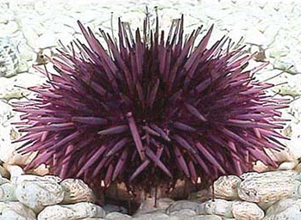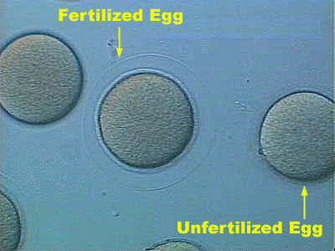

Figure 8 This is a sea-urchin and on the right you can its eggs.

## Lardner and Pujara, 1980

### Introduction

In order to relate the physical properties of the membrane to the measured quantities during cell compression experiments an analysis of the deformation of nonlinear elastic membranes is performed.

Hiramoto (1970) reviewed several techniques for determining the rheological properties of sea-urchin eggs.

The first one to use the compression technique was Cole (1932).

Hiramoto (1963) used a similar compression method and calculated the elastic modulus with a linear elastic model and compared his results with fluid-filled rubber balls.

### Assumptions

* cell is a sphere enclosed within a thin-walled non-linear elastic membrane
* volume of the cell remains constant

### Experiments

Experimental results show time-dependent deformations, but only the elastic deformations of the membrane are considered here

## Hiramoto, 1963

### Assumptions

* cell membrane is linear elastic

### Experiments

Compression test on sea urchin eggs

Compression test on fluid-filled rubber balls

## Yoneda, 1964

### Experiments

Compression test on sea urchin eggs

### Conclusions

The **tension**, or surface force, in the cell membrane **remains constant irrestpective of change in surface area**. This is in conflict with the classical belief that the cortex of the egg of sea urchin is elastic.

However there was some experimental difficulty in estimating the contact area from which the pressure and then the surface tension is calculated.

In Yoneda (1973) he repeats this statement however with the words: “… the **tension is uniform over the surface** of the egg…”

If this is true then as a result of equilibrium equations for uniform tension over the surface, the mean curvature of the deformed cell must be constant, just **like in a soap film**

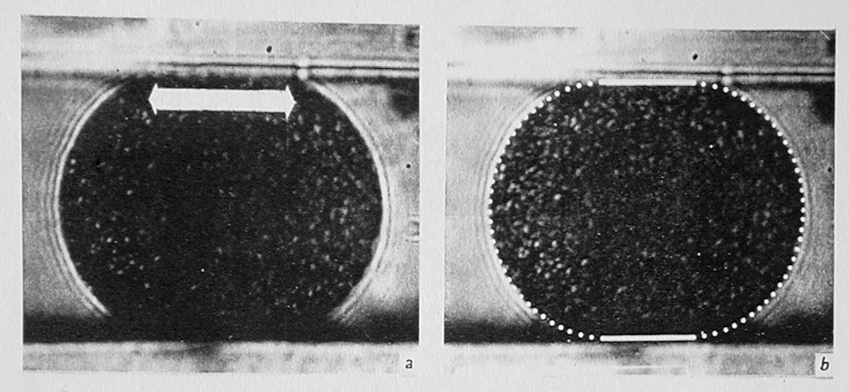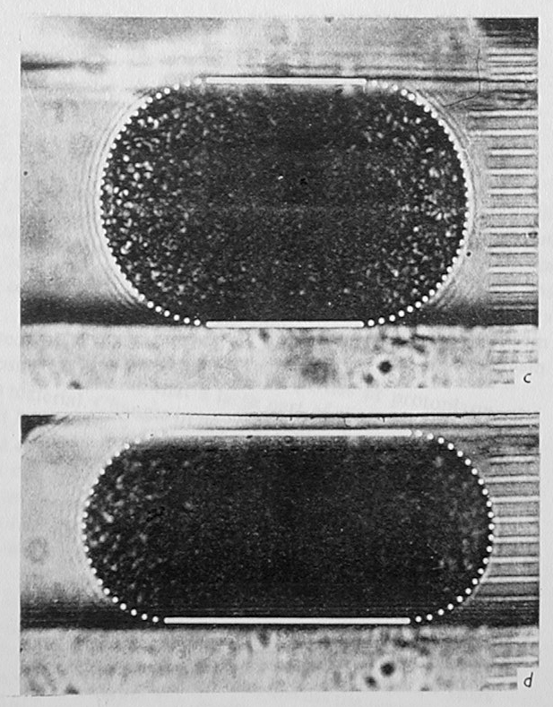

Figure 9. Figures on p 907 of Yoneda, 1964

The theory shows poor agreement with the experiments on a fluid-filled rubber ball.

## First results for compression of tomato cell

See Tomato05 for the exact parameters:

-parameters-

mass 7.2e-9

k 1000

ksecundary 0

kpressure 3.7e18

g 0

dt 1e-7

forcemode 1

scalefactorforforces 1e-8

showforces 0

showtime 50

relaxationtime 1

displacementspeed 5e-2

minstrain -45

crosssectionalarea 3.6e-7

-end-parameters-

This results in a quasi exact fit with the experimental data of Thomas... although in the parameter fitting the kpressure was the only relevant parameter, suggesting a shortcut taken by our model, since it should be dependent on the k value as well.



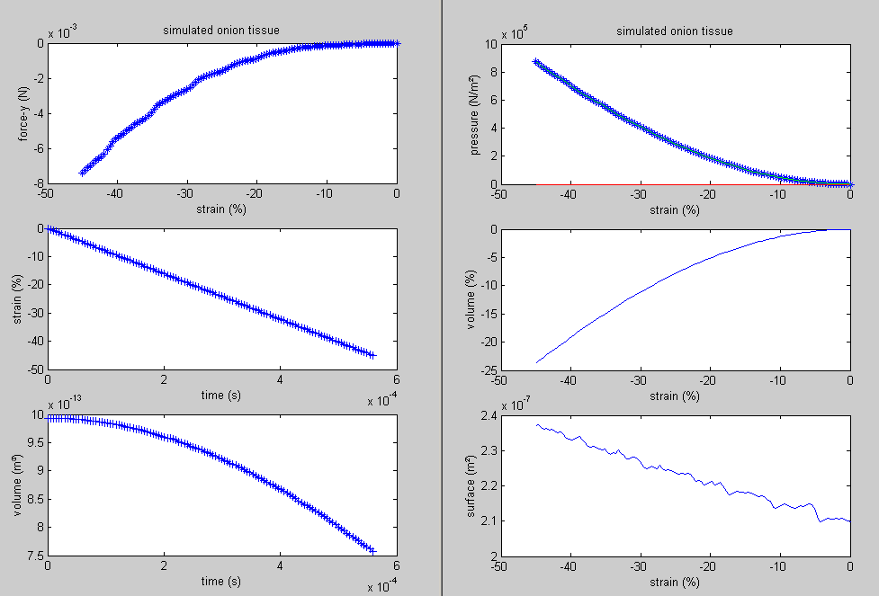

As can be seen from the above figure the volume changes up to 20% for a strain of 40%. If the volume constraint was more stringent, the volume was better preserved, but the force would rise higher then 7.3 E-3N.

Another nice result is the increase of the surface with larger deformations. This is expected since the form of the cell deviates more and more from a sphere.

The form of the force deformation curve seems to be entirely geometric since the plot of the volume already exhibits this kind of curvature. The nearly exact fit of a third order polynomial with a leading factor of the third order confirms this.

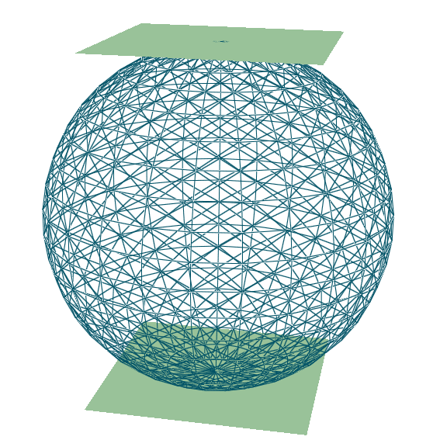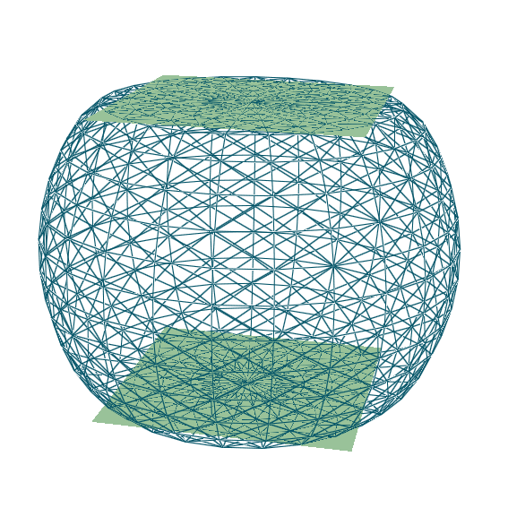

Figures of a tomato cell compression

# Finite Element Method for 2D trusses

Aan de hand van de ‘kapstokprogramma’s’ van 'Oefeningen HJ35: Numerieke modellering in de mechanica' (M. Baelmans, D. Vandepitte, Johan Meyers en Bas Van Hal) seminar 4 KULeuven 2003 heb ik een Matlab progje geschreven in Werk/FEM/Matcell dat een willekeurig vakwerk oplost waarbij verplaatsingen en krachten opgegeven kunnen worden als randvoorwaarden.

**Source**: 'Oefeningen HJ35: Numerieke modellering in de mechanica'

(M. Baelmans, D. Vandepitte, Johan Meyers en Bas Van Hal)

seminar 4 KULeuven 2003

## Problem description

All bars have equal length (5m) and are pin-jointed. The cross section of the bars in the upper boundary (numbers 1, 2 and 3) is 3000 mm², all the others have a cross section of 1000 mm². As the E-modulus of steel we take 200 GN/m² and the Poisson constant is 0.3. He truss carries a vertical point load of 100 kN in node 5.

F = 100 kN

node 1

node 2

node 3

node 4

node

5

element 4

element 2

element 7

element

3

element

6

element

1

element

5

## Preprocessing

Done in Femap.

## Initialisation

nElem = number of elements (=7)

nNode = number of nodes (=5)

nDOF = number of degrees of freedom: x and y position for every node (=2*nNode=10)

The system can be described by the following equation



where we use bold face capital letters (or straight brackets [] ) to denote a matrix and bold face normal letters (or curly brackets {} ) to denote a vector.

**K** = stiffness matrix [ nDOF x nDOF ]

**f** = force term { nDOF }

**d** = degrees of freedom { nDOF }

Degrees of freedom (**d)**

The degrees of freedom, **d**, are built up of all the unknown positions  of the truss in equilibrium (superscript *g* means global coordinates). So we can write

.

We chose to alternate the x and y positions, and start counting from index 1.



Stiffness matrix (**K**)

In order to build up the overall stiffness matrix, **K**, we first determine the element (subscript *e*) stiffness matrix, **K**e.

Element stiffness matrix (**K**e)

For each element we can draw the following figure:

element

u1

u2

N1

N2

N1 and N2 are the forces acting at the begin and the end of the element respectively, both have their line of action in the longitudinal direction of the element. The displacements of the begin and end node are given by u1 and u2 respectively.

If the element is in rest N1 = -N2.

We will model the element as a simple spring, such that the force is given by



Or using the notation of the current context:



Where E is elasticity modulus [GN/m²], A the cross section [mm²] and L the length of the spring in rest [m].

Such that.



Or in matrix notation and using a local (superscript *l*) reference frame





Transformation matrix (**G**)

To transform the local coordinates into global coordinates, we have to perform a rotation over

φ

















Now we have the transformation matrix **G** to go from local element coordinates to global coordinates.

We can rewrite as



Now we have a formula to calculate our element stiffness matrix in global coordinates.



With this we can assemble **K**.

### Assembly

We will use the same notation as Matlab to put a 'mask' on a matrix:

e.g.

If  then 

The assembly task can be done as follows:

loop over all elements

1) index = 

2) **K**(index, index) += 

end loop

Force term (**f**)

**f** is a rowvector of length nDOF initialised with zeros.

On node 5 a force of -10000000 N is working in the y-direction, so element  is set to this value.

## Partitioning

The system equations can be split up (partitioned) in two parts:

1) the free part (subscript *f*)

2) the constrained part (subscript *c*)



indexc = [ , node 1 is constrained in the x-direction

, as well as in the y-direction

 ] node 4 is only constrained in the y-direction

indexf = setdiff( 1:nDOF, indexc ) these are all the other nodes (Matlab code)

**K***ff*  = **K**(indexf, indexf)

**K***cf* = **K**(indexc, indexf)

**f***f* = **f**(indexf)

## Solving the equation

This is easily done in Matlab like this:

**d***f* = **K***ff* \ **f***f*

The reaction forces are given by:

**f***c* = **K***cf* **d***f*

Putting back the degrees of freedom

**d**( index*f* ) = **d***f*

So now we have solved our system and all equilibrium positions of the nodes (**d**) are known.

# Integration schemes

## IntegrationSchemes

Om de nauwkeurigheid van de integratieschema’s na te gaan dient een exacte oplossing gekend te zijn. Om deze te berekenen zal Simulink gebruikt worden.

### System with one mass

Voor een eenvoudig veer-demper systeem kan gemakkelijk de exacte oplossing expliciet berekend worden. Dit resultaat werd gebruikt om de nauwkeurigheid van het Simulink model na te gaan. De maximale afwijking bedroeg 10-7 % van de maximale uitwijking, zoals te zien is op onderstaande figuur.

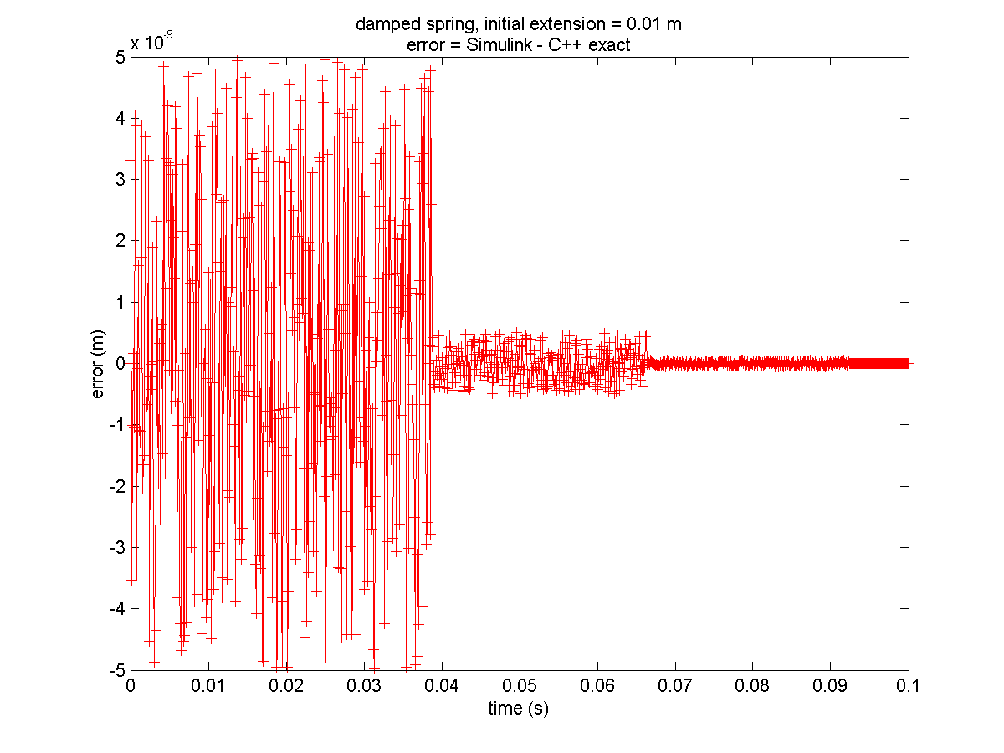

We kunnen er dus van uitgaan dat zowel de exacte oplossing berekend in C++ als het model in Simulink een zeer goede benadering van het gewenste resultaat geven.

We vergelijken de bekomen resultaten met Simulink.

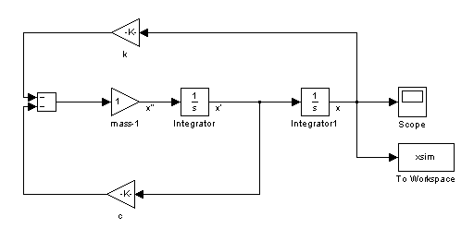

Kiezen we de simulatieparameters als volgt:

x0 = 0.01;

v0 = 0.0;

dt = 1e-4;

m = 1.0;

k = 10000.0;

c = 200.0;

// force model

a = (-k*x-c*v)/m;

// integration

v = v + a*dt;

x = x + v*dt;

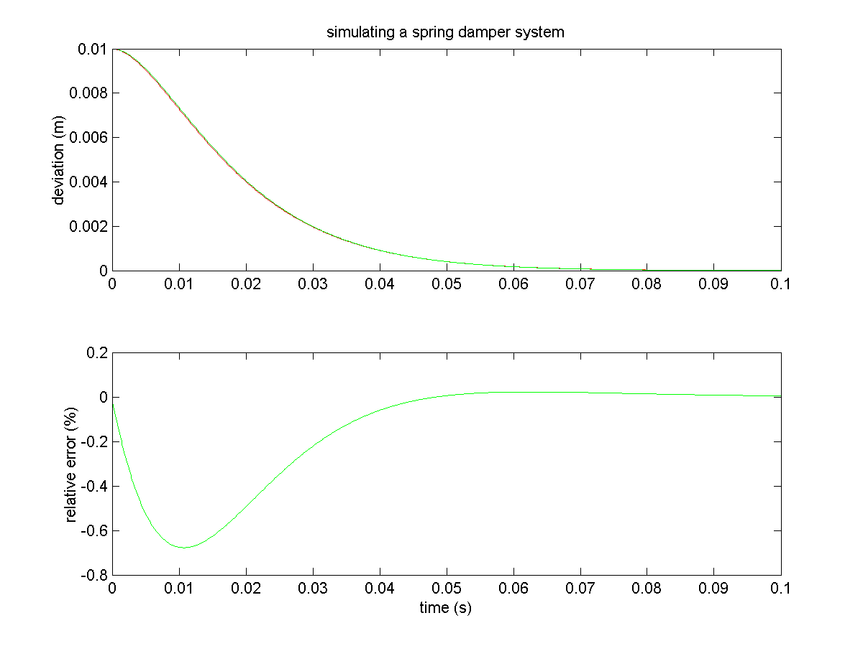

hetgeen overeen komt met een kritisch gedempt systeem, dan bekomt men bovenstaande resultaten. Stellen we k = 1000 dan is ξ = 3.16 en het systeem dus overgedempt, dan bekomt men:

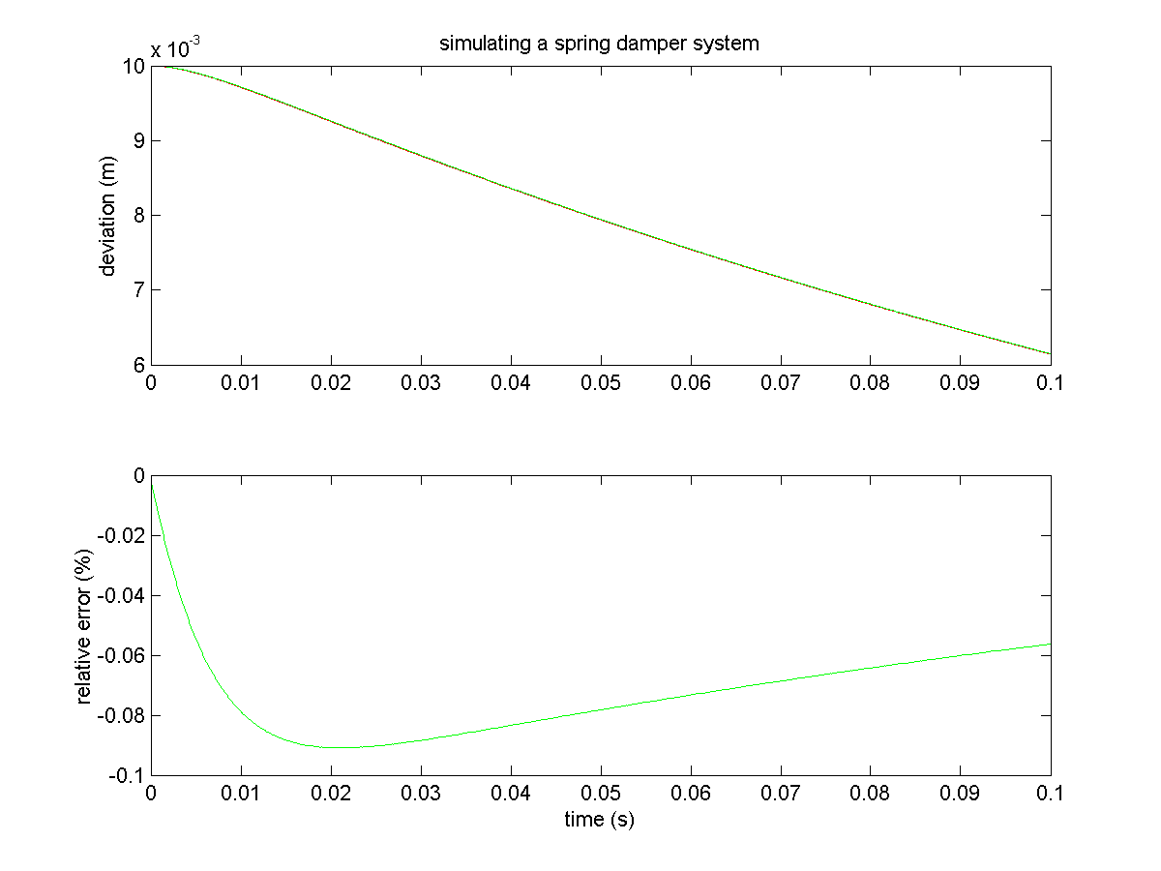

Stellen we k = 100000 dan is ξ = 0.316 en het systeem dus ondergedempt, dan bekomt men:

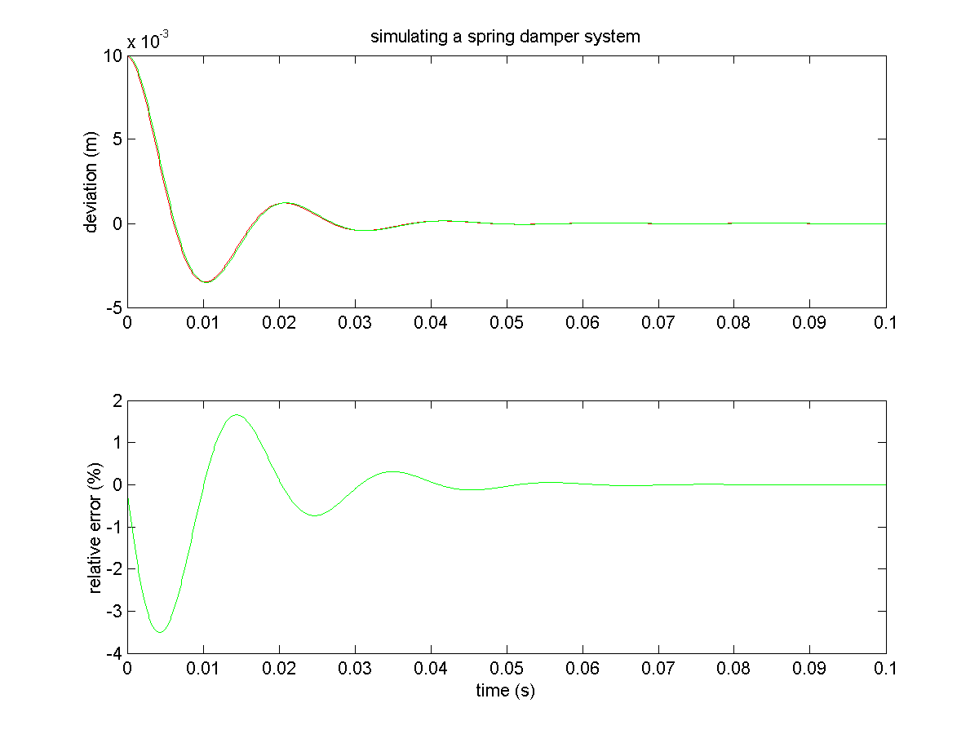

Naarmate het systeem trager reageert (x(t) minder gebogen is) werkt het eenvoudige integratieschema dus beter.

Zodoende kan voor verschillende groottes van de tijdstap dt de fout berekend worden door de exacte waarde na 0.1 s te vergelijken met de berekende waarde (error = (x-x_e)/0.01). Dit wordt weergegeven in onderstaande figuren.

Het kritisch gedempt systeem.

k = 10000

rest cfr. supra

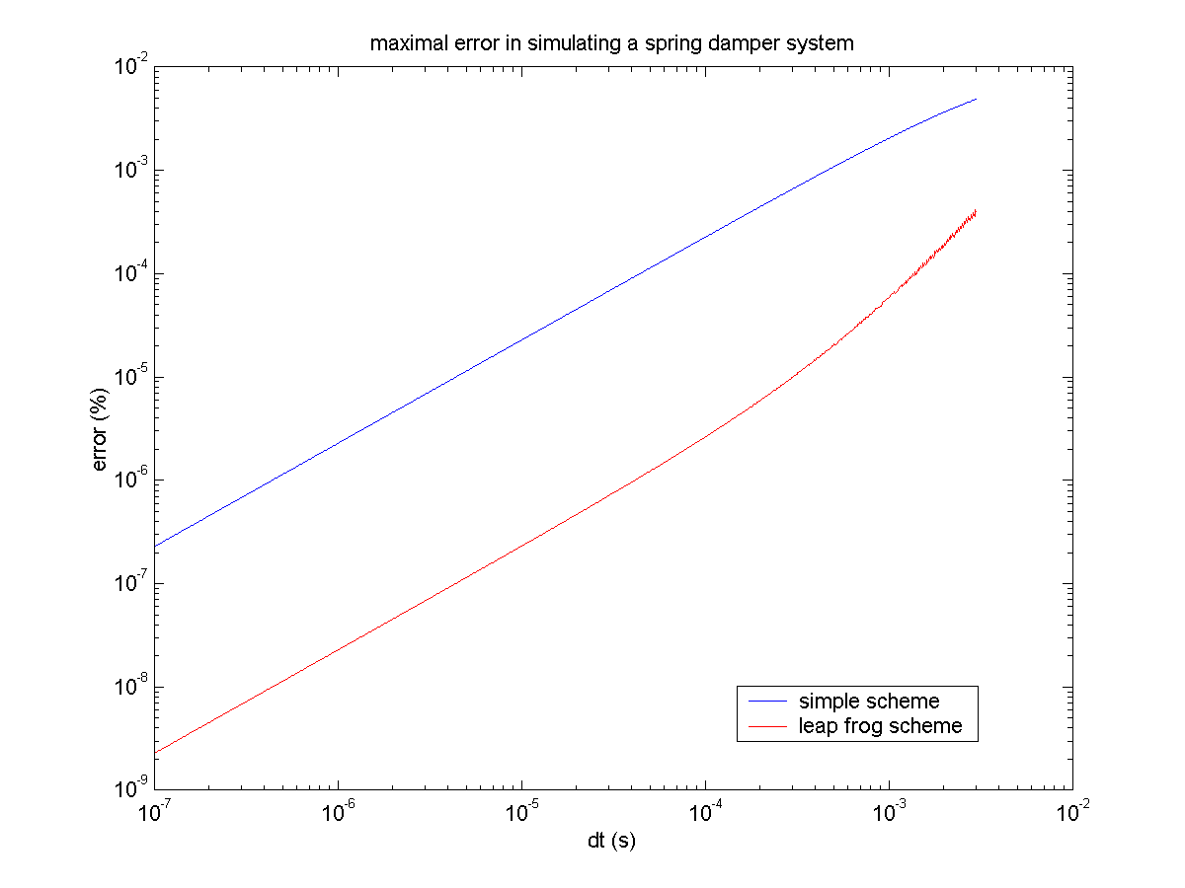

Het overgedempt systeem.

k = 1000

rest cfr. supra

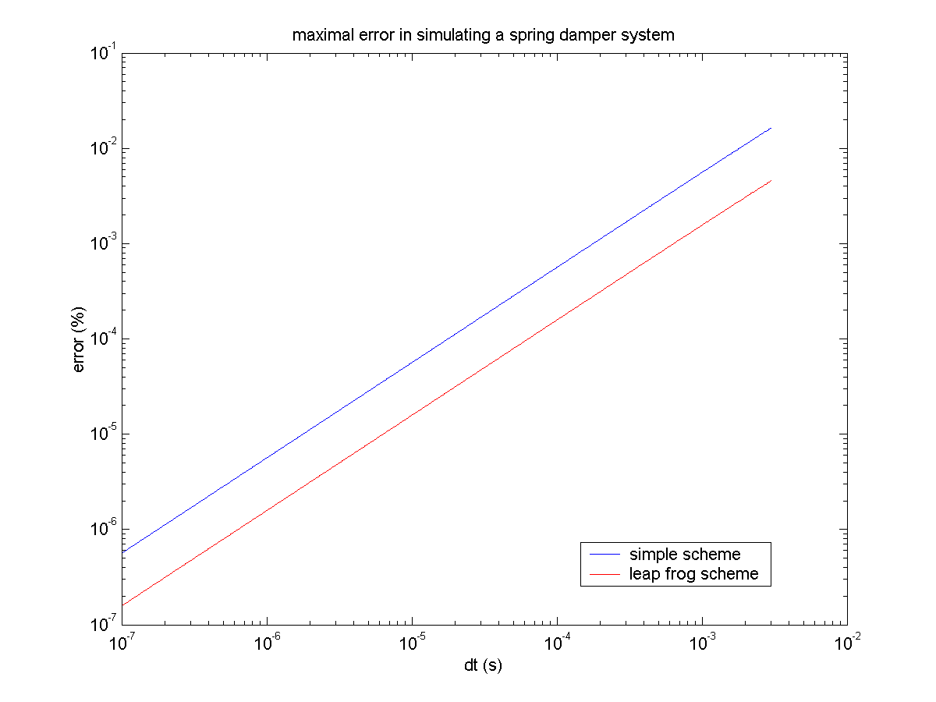

Het ondergedempt systeem.

k = 100000

rest cfr. supra

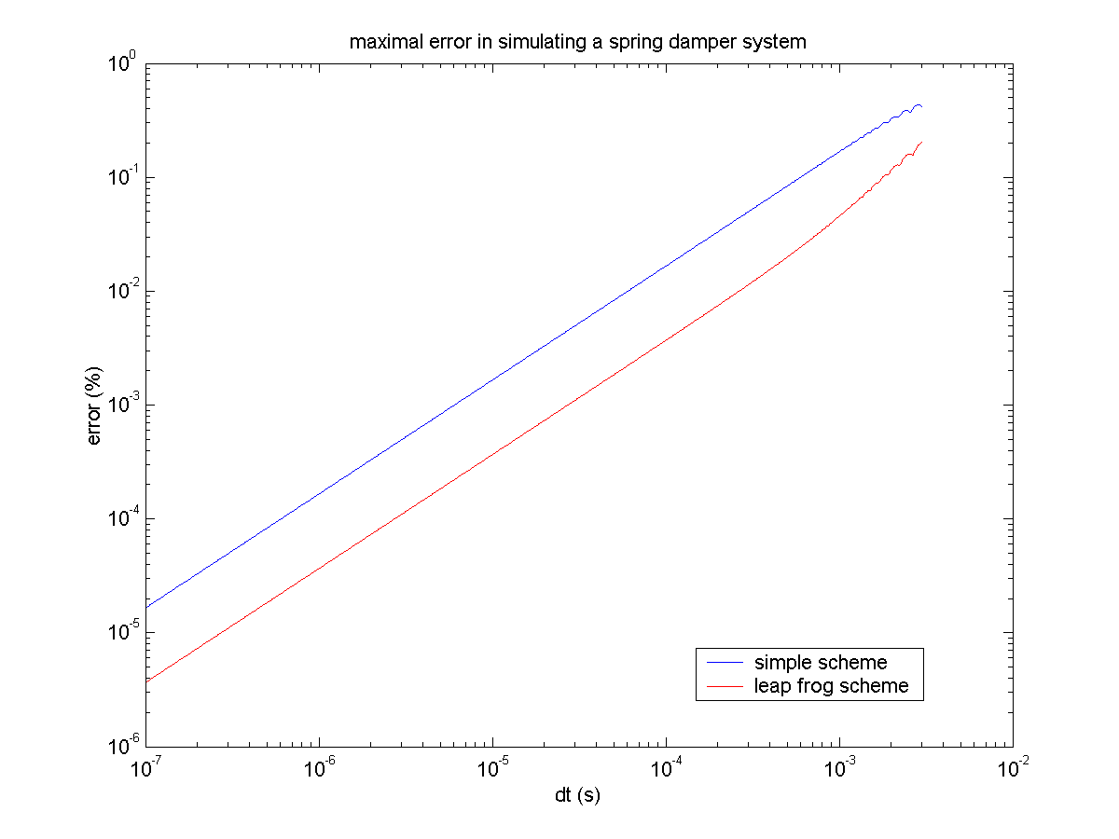

Het is duidelijk dat het leap frog schema betere resultaten oplevert dan het eenvoudig integratieschema.

### System with two masses

Het systeem ziet er als volgt uit.

m2

m1

x2

x1

F

c2

k2

c1

k1

Wanneer we hier het eenvoudige integratieschema gebruiken zoals supra aangegeven, namelijk:

// new acceleration

a1 = (-k1*x1-c1*v1+k2*(x2-x1)+c2*(v2-v1))/m1;

a2 = (-k2*(x2-x1)-c2*(v2-v1))/m2;

// move

v1 = v1 + a1*dt;

v2 = v2 + a2*dt;

x1 = x1 + v1*dt;

x2 = x2 + v2*dt;

// reset

a1 = 0.0;

a2 = 0.0;

//proceed

t = t + dt;

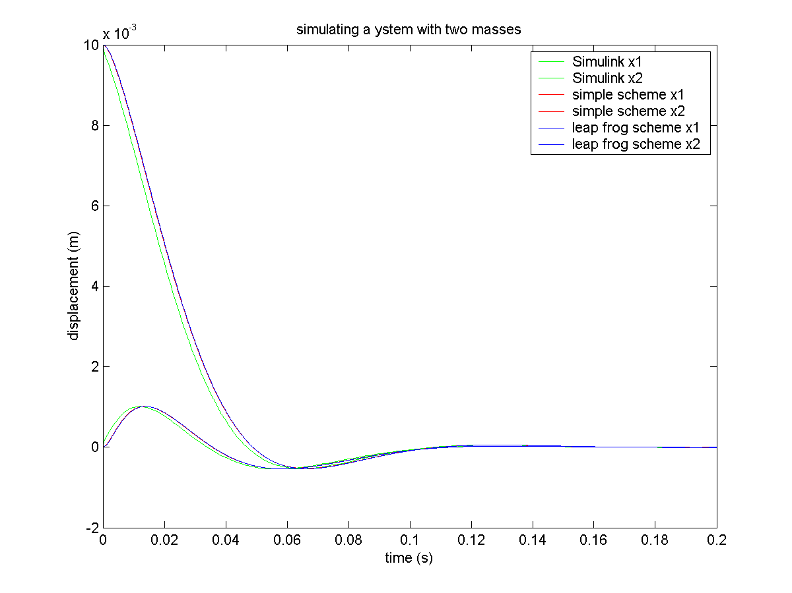

In Simulink leveren de solvers ode45, ode113 en ode23 allen eenzelfde resultaat. In Simulink loopt er in het begin iets een beetje mis, maar het is duidelijk dat dit enkel een kleine verplaatsing over de tijdsas teweeg brengt. Onderdstaande close up laat het foutje zien:

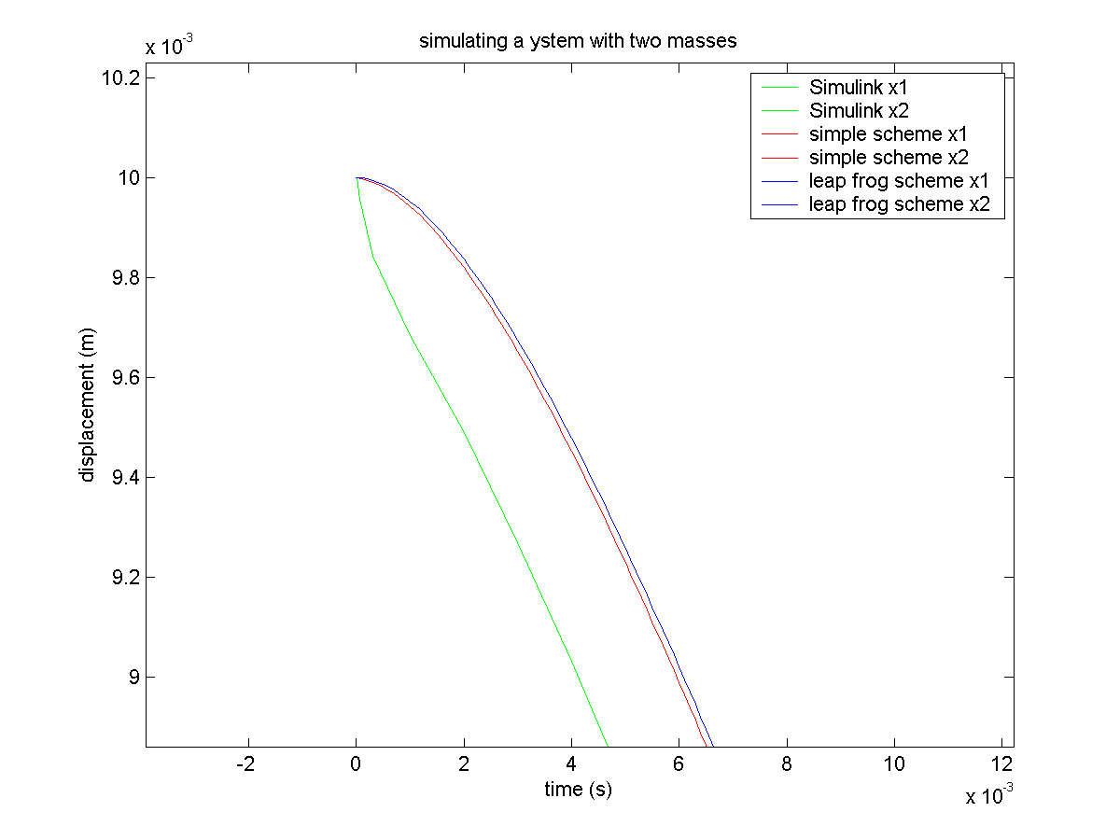

Wanneer beide massa’s initieel geen snelheid bezitten, dan zal de snelheid gradueel toenemen hetgeen overeenkomt met de simulatieresultaten uit C++ in Simulink zien we door een fout in het model eerst een vertraging…

### Leap Frog Schema

Om een betere integratie te bekomen werd een leap frog schema geïmplementeerd als volgt:

v_t = 0.25*(v_tmdt+dt*a_tmdt)+0.75*(v_tmdt2+0.5*dt*a_tmdt); // extrapolation for v(t)

a_t = (-k*x_t-c*v_t)/m; // a(t)=f(x(t),v(t))

// move

v_tpdt2 = v_tmdt2 + dt*a_t; // v(t+dt/2)=v(t-dt/2)+dt*a(t)

x_tpdt = x_t + v_tpdt2*dt; // x(t+dt)=x(t)+dt*v(t+dt/2)

//proceed

t = t + dt;

x_t = x_tpdt; // x(t+dt) ->x(t)

v_tmdt2 = v_tpdt2; // v(t+dt/2) ->v(t-dt/2)

v_tmdt = v_t; // v(t) ->v(t-dt)

a_tmdt = a_t; // a(t) ->a(t-dt)

t-δt

t+δt

t

**r**

**v**

**a**

t-δt

t+δt

t

t-δt

t+δt

t

t-δt

t+δt

t

De snelheid op ogenblik t is dus niet gekend en wordt geëxtrapoleerd zoals te zien is in bovenstaande code. Dit schema is inderdaad grofweg 3 tot 4 maal nauwkeuriger dan het naieve schema dat eerst werd gebruikt zoals te zien is op onderstaande figuur.

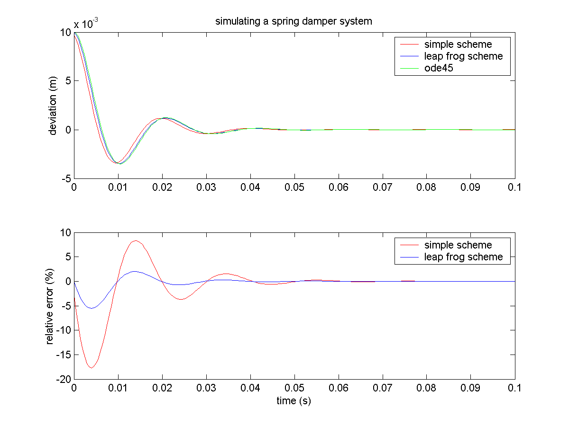

### Het aanleggen van een kracht

Eerst werd een kracht in stappen aangelegd aan een twee massa systeem. Zodoende kon het systeem telkens een evenwichtstoestand bereiken alvorens een volgende stap werd aangelegd. Iedere seconde wordt de kracht met 10 N verhoogd.

Men kan echter ook de kracht continu doen toenemen met de tijd, beide mogelijkheden worden geïllustreerd op onderstaande figuren.

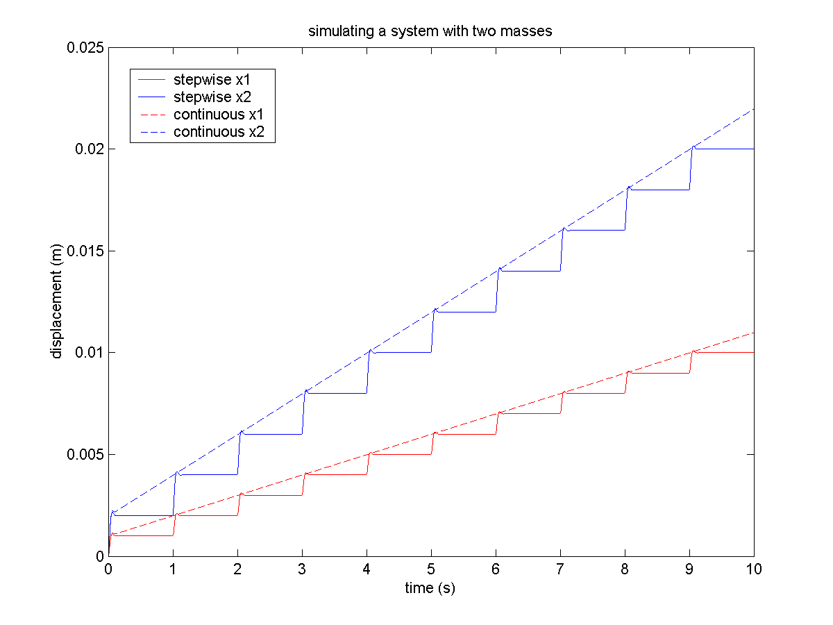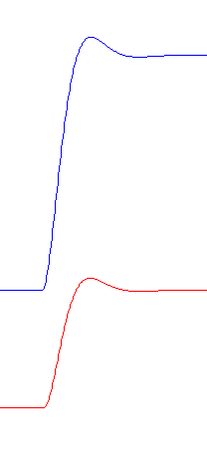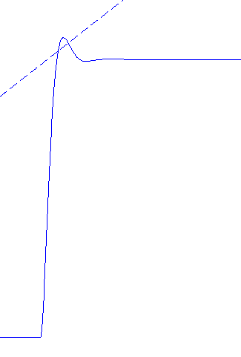

Het is duidelijk dat het systeem een zekere traagheid heeft.

### Simuleren van de trekproef

Bij de micormechanische trekbank wordt het weefsel uit elkaar getrokken, waarbij de verplaatsing en de kracht opgemeten worden.

De treksnelheid kan gevarieerd worden voor 1.6 tot 33 10-6 m/s.

5 10-3 m

2 10-3 m

75 10-6 m

Totaal volume = 7.5 10-10 m³. Veronderstellen we een massadichtheid gelijk aan die van water, nl. 1000 kg/m³, dan bekomen we een gewicht van 7.5 10-7 kg (ofwel 750 10-6 g).

Een typische kracht-vervormingscurve ziet er als volgt uit:.

F

Fmax = 0.7–1.35 N

dx

dxmax = 1.8-2.2 N

m1 = 7.5e-7; // kg

k1 = 1000.0; // kg/s²

c1 = 0.05477; // kg/s

v2 = 20e-6; // m/s

dt = 5e-6; // s

tend = 100; // s

Dit resulteert in de volgende kracht-vervormingscurve:

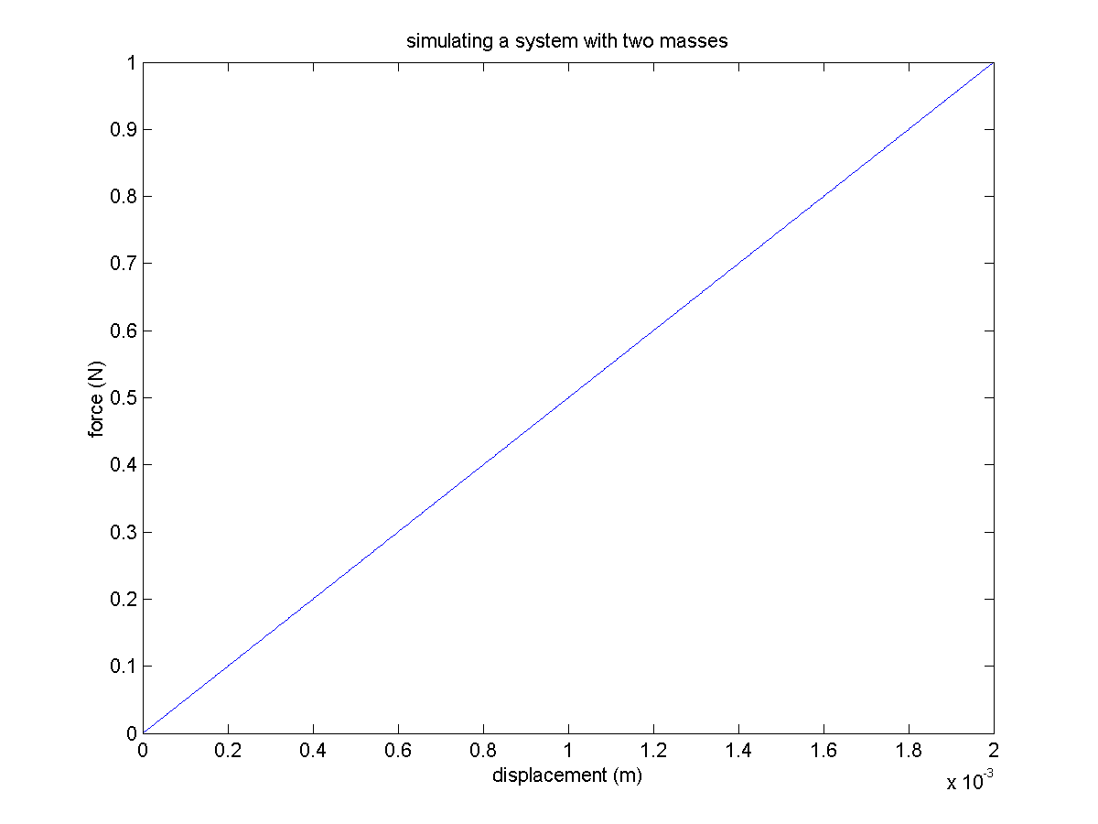

### Berekening van de parameters

bereken massa per hoekpunt

schat de veerkonstante, doe een berekening. Indien de krachtvervormingscurve een kracht aangeeft die een factor a te groot is vb. bij een bepaalde vervorming, dan dient de veerkonstante gedeeld te worden door een factor a.

de dempingsconstante wordt bepaald zodat het geheel kritisch gedempt is .

de tijdstap dient voldoende klein te zijn

## Introduction

### Goals

In [1] a shortlist of desirable qualities for a successful simulation algorithm is given:

* It should be fast, and require little memory.
* It should permit the use of a long time step *δt*
* It should duplicate the classical trajectory as closely as possible.
* It should satisfy the known conservation laws for energy and momentum, and be time-reversible.
* It should be simple in form and easy to program.

In a simulation where the motion of a particle is determined by the interaction with its neighbours it doesn’t make much sense to use higher order precision algorithms, while not taking into account the motion of the neighbours.

## Gear predictor-corrector algorithm

The Gear predictor-corrector algorithm can be used both for translational as rotational equations of motion.

### Predictor step

Defining scaled time derivatives of the position (and/or orientation) as , , , etc., the predictor step for a **fourth order Gear algorithm** can be written in matrix form [1], which is actually a Taylor expansion about time *t*:



The superscript p stands for ‘predicted’.

The matrix is the Pascal triangle matrix and the generalization to the sixth order form is evident.

### Force evaluations

The equations of motion enter through the corrector step. Here a distinction has to be made between first and second order equations of motion. First order equations can be written as , while second order equations of motion are of the form; .

Evaluating the forces with gives the corrected first or second order derivative  or respectively. The error in the prediction step is given by





for first and second order equations of motion respectively.

### Corrector step

Using this error the corrected values are

.

This loop may be iterated until a desired accuracy is obtained.

Gear discussed the best choice for the corrector coefficients *ci*, which depends on how many derivatives of **r**i are used [1,2,3]. They are summarised in the following tables.

|  |  |  |  |  |  |  |
| --- | --- | --- | --- | --- | --- | --- |
| Order of the Gear Alg. | c0 | c1 | c2 | c3 | c4 | c5 |
| 3 | 5/12 | 1 | 1/2 |  |  |  |
| 4 | 3/8 | 1 | 3/4 | 1/6 |  |  |
| 5 | 251/720 | 1 | 11/12 | 1/3 | 1/24 |  |
| 6 | 95/288 | 1 | 25/24 | 35/72 | 5/48 | 1/120 |

Table 1: Gear corrector coefficients for a first order equation of motion

|  |  |  |  |  |  |  |
| --- | --- | --- | --- | --- | --- | --- |
| Order of the Gear Alg. | c0 | c1 | c2 | c3 | c4 | c5 |
| 3 | 0 | 1 | 1 |  |  |  |
| 4 | 1/6 | 5/6 | 1 | 1/3 |  |  |
| 5 | 19/120 | ¾ | 1 | 1/2 | 1/12 |  |
| 6 | 3/20 | 251/360 | 1 | 11/18 | 1/6 | 1/60 |

Table 2: Gear corrector coefficients for a second order equation of motion

For a second order equation of the form , the coefficients *c0* should be replaced by 19/90 in the fifth order Gear algorithm. and by 3/16 in the sixth order algorithm respectively.

The coefficients for the third order Gear algorithm for second order equations of motion are corresponding to the velocity Verlet algorithm which were formally fitted into the Gear scheme.

The predictor-corrector algorithm has advantages over the Verlet algorithm only for small timesteps, but having the velocities available is convenient.

## Verlet Algorithm

### Original Version

Time integration is performed using the Verlet algorithm [1],[4].



Graphically this can be visualized as follows,

.

t-δt

t-δt

t

**r**

v

a

t-δt

t-δt

t

t-δt

t-δt

t

This formulation is correct up to the local error, which is of order δ*t* 4.

The first step of the integration was computed with ordinary Taylor expansion:





From the above formulation of **r**(*t* + δ*t* ) and **r**(*t* - δ*t* ) it is obvious that the algorithm is properly centred, which makes it time-reversible.

The velocities can be obtained though the following formula with an error of order δ*t* 2..



### Leap Frog Scheme

This is a half-step scheme proposed and discussed by [5] and [6]. The positions and velocities are given by



.

.

t-δt

t+δt

t

**r**

**v**

**a**

t-δt

t+δt

t

t-δt

t+δt

t

t-δt

t+δt

t

The current velocities can be calculated from

.

This scheme is numerically more stable since at no stage the difference of two large quantities is taken to obtain a small one.

### Velocity version

This scheme, proposed by [7], stores positions, velocities, and accelerations all at the same time *t*.

First the new positions at thime *t* + *δt* are calculated from

.

The mid-step velocities are computed using



The forces and accelerations at time *t* + *δt* are then computed, and the velocity move completed



This can be represented by the following scheme

t-δt

t-δt

t

t-δt

t-δt

t

t-δt

t-δt

t

**r**

**v**

**a**

t-δt

t-δt

t

## Test Setup

We test the accuracy of the above integration algorithms by comparing them to a known solution. Let us assume a spring-dashpot system with one point attached to *y=0* and the free end beginning at an initial position  with velocity . The system equation is given by

.

Where *k* is the *spring constant* and *c*v the *viscous damping constant*.

This equation can be rewritten in the general form



with

 the *undamped natural frequency*,

the *critical damping constant*,

the *viscous damping ratio*,

the damped vibration frequency,

 the period of the oscillation

The solution of the above equation differs in from, depending on the value of ξ.

### Underdamped Systems

ξ < 1 The equation has two roots which are complex conjugates, corresponding to oscillatory motion with an exponential decay in amplitude.



The *log decrement* is defined as the natural logarithm of the magnitude of two successive peaks in the vibration

 such that .

### Critically Damped System

ξ = 1 The roots of the characteristic equation are repeated, corresponding to simple decaying motion with at most one overshoot of the system's resting position.



### Overdamped System

ξ > 1 The roots of the characteristic equation are purely real and distinct, corresponding to simple exponentially decaying motion.



By comparing the calculated result with the above exact solutions at the appropriate timesteps, one can evaluate the precision of the algorithms.

## Solving an inhomogeneous first order differential equation



Integrating factor μ







Such that we can solve the equation directly



# Smooth Particle Hydrodynamics

Systeemvergelijkingen (PDE’s) oplossen m.b.v. een discrete interpolatietechniek

* momentumvergelijking
* continuiteitsvergelijking
* thermische energievergelijking
* toestandsvergelijking

## Introduction

When the sample points are fixed in space and the fluid flows past them, we speak of Eulerian approaches, such as Finite Element Method, Finite Differences. SPH however belongs to the Lagrangian approaches where the sample points move along with the fluid.

## Fundamentals

### Golden rules from Monaghan

1. If you want to find a physical interpretation of an SPH equation, it is always best to assume the kernel is a Gaussian.
2. It is best to rewrite formulae with the density placed inside operators to yield more accurate results.

### Integral interpolation

From Monaghan, 1992. Any function *A(***r***)* can be interpolated by

 ( ‎13.1 )

where the integration is over the entire space, h is the smoothing length and W is the interpolating kernel satisfying the two properties

 ( ‎13.2 )

and

 ( ‎13.3 )

.

For numerical work the integral interpolant is approximated by a summation interpolant

 ( ‎13.4 )

where the summation index *b* denotes a particle label, and the summation is over all the particles.

Particle *b* has mass *mb*, position **r***b*, density *ρb*, and velocity **v***b*. The value of any quantity *A* at **r***b* is denoted by *Ab*.

It is possible to construct a differentiable interpolant of a function from its values at the particles (interpolation points) by using a kernel which is differentiable. In order to obtain ∇*A* for example, we can use

 ( ‎13.5 )

though to obtain higher accuracy we use

 ( ‎13.6 )

### Kernels

A one dimensional Gaussian kernel used in the original calculations of Gingold and Monaghan, 1977

 ( ‎13.7 )

Spline based function, Monaghan and Lattanzio, 1985

 ( ‎13.8 )

where ν is the number of dimensions and σ is a normalization constant with values 2/3, 10/(7π) and 1/π for one, two and three dimensions respectively.

Super Gaussian kernel in 3D

 ( ‎13.9 )

this kernel is called super because the dominant errror is *O*(*h*4) instead of *O*(*h*2) for the traditional kernels

## Equations of motion

### The momentum equation

Monaghan, 1992

 ( ‎13.10 )

where ∇*a* denotes the gradient taken with respect to the coordinates of particle *a*.

In order to guarantee the conservation laws of energy, momentum and angular momentum, Hernquist and Katz, 1989 symmetrized the Kernel

 ( ‎13.11 )

Benz, 1990 symmetrized the smoothing length

 ( ‎13.12 )

where Πab is given by

 ( ‎13.13 )

and

 is the mean sound speed and can be calculated from

 ( ‎13.14 )

where B comes from the equation of state (and has the units of pressure), discard this term if another equation of state is applied.

 ( ‎13.15 )

 is the mean smoothing length and **F**a is the sum of the external forces acting on particle *a*

With this viscosity, shock fronts are spread over ca. 3*h*.

The values for the viscous constants α and β are not critical and typically (for strong shocks) α = 1 and β = 2, Steinmetz and Müller, 1993 use α = 0.5 and β = 1 for other cases.

η2 prevents singularities and is set to η2 = 0.01*h*2, which means that smoothing of the velocity will only take place when particle spacing is < 0.1*h.*

### The continuity equation

Monaghan, 1992

 ( ‎13.16 )

Hernquist and Katz, 1989 introduced two interpretations for equation ‎13.16. The “scatter” interpretation assumes that each particle has a mass, which is smeared out in space according to *W* and *h*. The density at any point in space is then found by summing the contributions from the density profiles of neighbouring particles. The alternative, “gather” interpretation says that the particles can be regarded as point markers in the fluid. Local properties at any point in space are obtained by sampling all neighbouring particles.

Another formulation is

 ( ‎13.17 )

This latter formula has the advantage that an initial density can be set for each particle, making it easier to deal with edges. Moreover this formulation allows for one single pass over all the particles to compute the rates of changes of all physical variables. The former formula however conserves mass exactly, which is not true for the latter one.

### The thermal energy equation

Monaghan, 1992

 ( ‎13.18 )

## Equation of state

Ideal gas with specific heat ratio γ

 ( ‎13.19 )

Water

Roy, 1995

 ( ‎13.20 )

with *g* the gravitational constant and *H* the maximum depth of the water

## Smoothing length

## h varying with time but constant in space

Steinmetz and Müller, 1993

 ( ‎13.21 )

where *ζ* is a parameter of order unit. The density, *ρ* can be approximated by taken the density from the previous timestep, Miyama et al., 1984.

Benz, 1990 used the following expression

 ( ‎13.22 )

in which the right hand side is rewritten using the continuity equation

Another approach is trying to keep the number of neighbouring particles within a sphere of size 2*h* fixed, with a certain tolerance, Herquist and Katz, 1989.

Steinmetz and Müller, 1993 proposed the following algorithm

The smoothed density and its time derivative with a smoothing length *h\** = *h*/*θ* with *θ* = 0.8.

 ( ‎13.23 )

 ( ‎13.24 )

 ( ‎13.25 )

The average density

 ( ‎13.26 )

 ( ‎13.27 )

 ( ‎13.28 )

Suitable values for the parameters are, *ζ* = 1.2 , *k* = 1/3 (… 1/6), *ζ* = 1 also gives good results but in regions of steep density gradients the mean number of neighbours can drop from typically 35 below 10, for *ζ* = 1.2 these values range from 50 to 20.

## h varying with time and in space

Monaghan, 1992

 ( ‎13.29 )

In this situation momentum can be conserved is the kernel is made symmetric

## Time step

Monaghan, 1992

 ( ‎13.30 )

for the force per unit mass and

 ( ‎13.31 )

 ( ‎13.32 )

where the Courant (safety) factor, *ncour* is typically 0.25, but can be increased untill 0.4, Δtf  is based on the force per unit mass f, and Δtcv combines the Courant and the viscous time step controls.

For a correctly chosen timestep the energy should be conserved to within 0.5 % over 400 time steps.

Following Troy, 1995

 ( ‎13.33 )

Information shouldn’t travel faster than; the particles, the velocity determined by the acceleration of the flow (looking ahead), the velocity of the sound.

## Time integration

 ( ‎13.34 )

Leapfrog method, which is accurate to second order in the time step.





such that the predicted velocity used in the SPH equations is calculated according to



Second-order Runge Kutta (Benz, 1989)

## X-tra

### XSPH variant

“X” is the unknown factor, following Monaghan, 1989.

 ( ‎13.35 )

ε is a constant with (0 ≤ *ε* ≤ 1)

This Δ**v**a must be added to the velocity for updating the positions only. The velocity used in the other SPH equations should not be increased with this term. (Roy, 1995)

Proven to be useful for the simulation of nearly incompressible fluids.

### Individual time steps

Hernquist and Katz, 1989.

All individual time steps are chosen to be a power-of-two subdivision of the largest system sime step, Δ*ts* such that,

 ( ‎13.36 )

where, ni , a strict positive natural number, refers to the time bin of particle *i* and Δ*ts* is an input parameter. Particles can move to a higher time bin at the end of their own time step, but have to wait until the lower time bin is finished to step onto the train of this lower time bin.

The particle positions and the thermal energy equation are advanced with a time step

 ( ‎13.37 )

where nmax is the largest bin currently occupied. This results in half the smallest time step since this is required for the intermediate update of the pressure for the leapfrog algorithm.

When particles change time bins their positions must be updated using

 ( ‎13.38 )

## Implementation

### Initialization

At the start of the simulation the mass, position, velocity, and thermal energy of each particle have to be specified. The initial density must also be specified of one updates it with the incremental formula instead of the weighting of the masses.

### General scheme

Following Roy, 1995.

Initialization

While (time<end_of_time)

Update rates of change:

For all particles

Calculate acceleration due to pressure gradient (equation ‎13.10)

Calculate rate of change of thermal energy (equation ‎13.18)

Calculate rate of change of density (equation ‎13.17)

Handle collisions

Update positions

For all particles

Calculate XSPH velocity variant (equation ‎13.35)

For all particles

Update position, velocity (using leap-frog integrator)

Update thermal energy

Update density

Update pressures

For all particles

Compute pressure using modified equation of state

Compute speed of sound

Calculate new time step

Time += new_timestep

### Particle attributes

According to Roy, 1995

Mass *m* : according to *m=ρV* where *V* is the volume of one particle

Density *ρ* : with a small offset in the initial values

Pressure *P*

Thermal energy *u*

Position **r**

Velocity **v**

Acceleration **a**

### Obstacles

Obstacles are implemented as surfaces that trigger repulsive forces in the particles, modelled for example by springs. They are summed for each particle *a* under the term **F***a*.

### Data structures

In order to avoid the *O*(*n*²) dependency for the particle-particle method of the computing time on the number of particles, n, data structures are considered that allow for more efficient calculations.

### Hierarchical tree

In astrophysics where self-gravity is important tree-methods are generally used.

Hernquist and Katz, 1989.

In the Barnes-Hut method space is divided into cubic cells. The root corresponds to the entire space, this cube is divided into 8 cubic cells (for 3 dimensions) which form the 8 children of the root node. This procedure is repeated for each child until each leaf contains only 1 particle. Empty branches are discarded. Essential information is calculated for each node (e.g. total mass, position of centre-of-mass…). For calculations one starts on top of the hierarchy and descends until



where *s* is the size of the current cell, *d* is the distance between the cell and the particle and *θ* is a fixed tolerance parameter.

### Linked list

If the same *h* can be used for all particles a linked list method is more appropriate. The grid should be built up of cells with width 2*h* such that only neighbouring cells have to be checked.

## Validation

### Double shock tube problem in 1D

Woodward and Colella, 1984

The interaction of two strong shock or blast waves is simulated in one dimension. The initial state consists of three constant states of a *γ* = 1.4 gas in the interval 0 ≤ *x* ≤ 1 with reflecting boundaries on both sides. The density is unity everywhare and the pressure is assumed to be *P* = 1000 from *x* = 0 to 0.1, *P* = 0.01 from *x* = 0. to 0.9 and *P* = 100 from *x* = 0.9 to 1.

These initial conditions give rise to two shock waves propagating into the cold (i.e. low pressure) gas and two rarefraction waves moving into the hot (i.e. high pressure) gas. The Mach numbers *M* of the two shocks are very large in the left and right shock being *M* ≈ 170 and *M* ≈ 51 respectively.

Snapshots of the density and the velocity as a function of the position are taken at times equal to 0.010, 0.016, 0.026, 0.028, 0.030, 0.032, 0.034 and 0.038. Results can be found in Steinmetz and Müller, 1993, Woodward and Colella, 1984, Woodward 1982.

1D testprobleem: interactie van 2 schokgolven

P=0.01

P=1000

P=100

Mach 170

Mach 51

## Resultaten

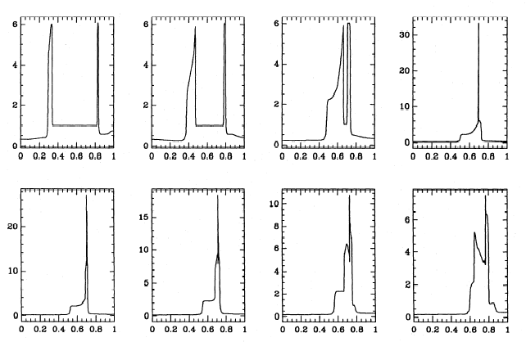

dichtheidsprofiel



snelheidsprofiel

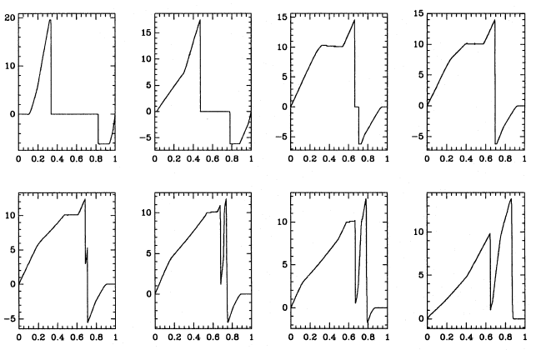

# Molecular Dynamics

## Lennard-Jones potential

x = linspace(0.32,1,1000);

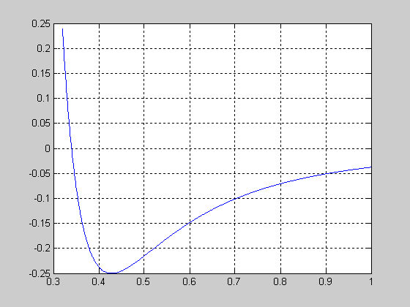

eps = 1;

sig = 0.34;

y = eps*((sig./x).^6-(sig./x).^3);

plot(x,y,'b');

grid on;

Om vloeistoffen te simuleren aan de hand van Molecular Dynamics. Boek: Computer Simulation of Liquids, Allen en Tildesley, 1989.

Lennard-Jones fluid is a system of many point particles of equal mass with an atom-atom pair interaction of the following form:

V(r) = V0 [ (r0/r)12 - 2(r0/r)6 ]

where r is the distance between two particles.

### Properties of Lennard-Jones potantial:

r=r0:    V(r)=-V0; maximum attractive force.

r=infinity:   V(r)=0;   zero force.

r< r0/21/6 : V(r) > 0; repulsive.

The attractive part with a -1/r6 dependence is called dispersive force (or van der Waals force) which is due to induced dipole moments of electron clouds of two atoms.

The repulsive part is due to Pauli exclusion principle of electrons, which forbids two electrons to occupy the same state. The atoms behave as if they are solid balls of diameter r=r0/21/6.

The actual form of the repulsive force is not exactly 1/r12, but it is a good approximation and is also computationally more convenient.

Lennard-Jones system is a relatively simple system to study by molecular dynamics. The principle to simulation other systems, e.g., biological molecules, is the same except that the forces between atoms become more complicated

# Werkschema

* Inzicht in de verschillende simulatietechnieken
* Vaardigheid in het gebruik ervan
* Toepassen van de verworven kennis en vaardigheid op dit project
  + Aanpassen van bestaande technieken
  + Combinatie van verschillende technieken
* Aanpassen/combinaties maken van simulatietechnieken enkel mogelijk in 2e biënnale, na het volgen van de cursussen

## Mijlpalen

1. Netwerk van hexagonale cellen, ΔV → ΔP
2. Turgordruk als onsamendrukbare korrels
3. Plastische vervorming
4. Anisotroop karakter
5. Adhesie → breukvlakken

2e biënnale: combinatie/aanpassing van bestaande technieken

# Publicaties

## Partec04 paper

Voor Bert die naar Partec04 zal gaan. Een overzichtspaper waarin ieders vorderingen binnen de DEM group op een rijtje gezet worden.

## AgEng04

Abstract ingestuurd als contribution to the conference en de session Postharvest & Process Engineering (Bart Nicolaï) paper en poster.

## Paper02

Aan de hand van de data van Wei, 2001 die ik toegestuurd heb gekregen in een Excel document, heb ik de parameters voor een lineair elastisch model gefit.

Ook de text is afgewerkt in een eerste versie met bijhorende figuren.

Een powerpoint presentatie heb ik ook gemaakt onder Z_Birmingham.

Het model is SoftTissue17 met een aparte klasse voor de Springs en monitoring van het volume per cel.

# Gevolgde cursussen

* Inleiding tot Unix: om eventueel grotere simulaties uit te kunnen voeren op de SP-cluster van het rekencentrum
* Numerieke modellering in de mechanica: de basistechnieken van FD, FV, FE (Baelmans, M. en Vandepitte, D.)
* Numerieke benadering en geometrische modellering: als achtergrond voor het schrijven van effieciënte en stabiele code (Vandewalle S.)

## Numerieke Benadering en Geometrische Modellering

Het vak: Numerieke Benadering en Geometrische Modellering (NBGM, Stefan Vandewalle) werd gevolgd. Kennismaking met Matlab doorheen 2 practica, die eveneens zullen dienen als evaluatie. Na een theoretische behandeling van de benaderingstheorie werden verschillende benaderingsmethoden geïntroduceerd: kleinste-kwadraten, minimax, Fourier-transformatie, splinefuncties en Bézier-curven.

Hieruit werden de periodieke splinefuncties gekozen voor het benaderen van de geometrie van de celwand om de volgende redenen:

* geschikt voor het benaderen van gesloten krommen
* vinden hun verloop binnen de convex hull.
* kan zelf de graad kiezen: vb C1, C2 continuïtieit

Om de geometrie van één enkele cel vast te leggen werd een routine, getContour, geschreven in Matlab, gebaseerd op m-files aangereikt in de cursus NBGM. Een figuur van het weefsel wordt ingelezen, waarna de gebruiker de contour van een cel kan overtrekken door het aanklikken van enkele punten.

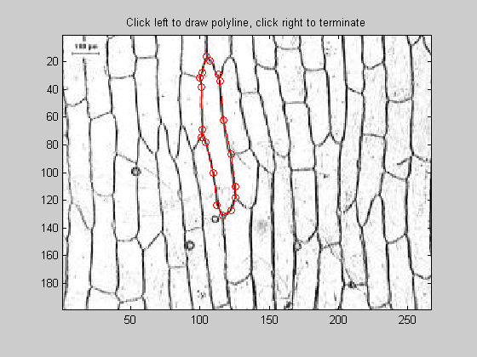

Deze contour wordt opgeslagen onder de vorm van clickResult.mat waarin de x- en y-waarden van de aangeklikte punten (in pixels) bijgehouden worden.

perioSplineGo stelt doorheen deze punten een periodieke spline op die dan kan dienen als continue beschrijving van de contour van de cel.

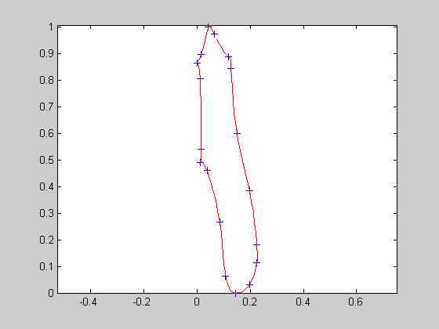

De parameterfuncties x(t) en y(t) zien er hier als volgt uit.

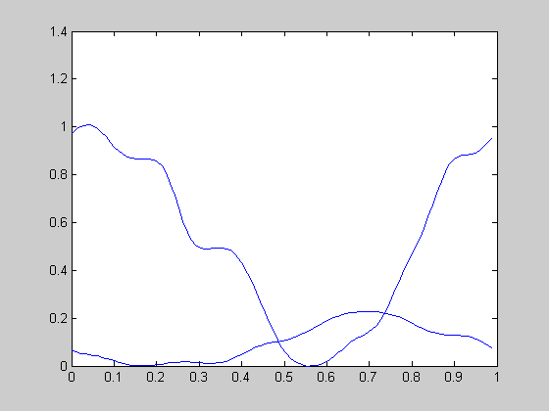

Het zou mogelijk moeten zijn om de dynamica van de celwand te modelleren aan de hand van zulke splines. Er zit reeds veel a priori informatie in (vb continuiteit, gesloten kromme).

In computer graphics werd dit reeds toegepast mbv D-NURBS, dynamic-non uniform rational beta splines (Terzopoulos en Qin, 1994) evenals bij gewone splines waar de knooppunten verbonden werden met lineaire veren (Phillips, Ladd en Kavraki, 2002).

Dynamica in de knooppunten steken, lokale interactie, kromming beschikbaar…

## GraSMech

Cursus over Nonlinear FEM waarbij technieken aangereikt worden ivm contact problems, failure, crack propagation, nonlinear material behaviour, etc.

Niet gemakkelijk allemaal.

# Opportuniteiten

* Simulatie van trillingen van granulaire media (Ph D. van Wassgren, 1997)
* Opblazen van structuren (ballon om lenzen te polijsten, satelietcomponenten, shelters, dam, verwijden van aders… zie map opportunities)
* Simulatie van (mensen-)massa’s op festivals, verkeer, noodscenario’s (ook kuddegedrag en vegetatiespreiding, mieren..) <http://www.red3d.com/cwr/boids/>

# Referenties

1. Allen, M.P. and Tildesley, D.J. Computer Simulation of Liquids. Oxford University Press, New York, 1989.

2. Gear, C.W. The numerical integration of ordinary differential equations of various orders. Technical Report 7126, Argonne National Laboratory, 1966.

3. Gear, C.W. Numerical initial value problems in ordinary differential equations. Prentice-Hall, Englewood Cliffs, NJ, 1971.

4. Verlet, L. Computer 'experiments' on classical fluids. I. Thermodynamical properties of Lennard-Jones molecules. Physical Review, 159:98-103, 1967.

5. Hockney, R. W. The potential calculation and some applications. *Methods comput. Phys.* **9**, 136-211, 1970.

6. Potter, D. *Computational physics.* Wiley, New York. 1972.

7. Swope, W. C., Andersen, H. C., Berens, P. H., and Wilson, K. R. A computer simulation method for the calculation of equilibrium constants for the formation of physical clusters of molecules: application to small water clusters. J*. chem.. Phys.* **76**, 637-649, 1982.

Keegstra et al (1973) The structure of plant cell walls. III. A model of the walls of suspension-cultured sycamore cells based on the interconnections of the macromolecular components. *Plant Physiol*., **51**, 188-196.

Albersheim (1976) The primary cell wall. In *Plant Biochemistry* (Bonner and Varner eds) 3rd Edition, Academic Press, New York, pp 225-274.

Selvendran and ONeill (1985) Isolation and analysis of cell walls from plant material. In *Methods of Biochemica*l *Analysis* (Glick ed) Vol 32, John Wiley pp 25-133.

Carpita and Gibeaut (1993) Structural models of primary-cell walls in flowering plants - consistency of molecular structures with the physical properties of the wall during growth. *Plant J*., **3**, 1-30.

Cosgrove (2001) Wall structure and wall loosening. A look backwards and forwards. *Plant Physio*l.,**125**, 131-134.

Hiramoto, Y. (1963). Mechanical properties of sea urchin eggs I. Surface force and elastic modulus of the cell membrane. Experimental Cell Research, 32, 59-75.

Hiramoto, Y. (1963). Mechanical properties of sea urchin eggs II. Changes in mechanical properties from fertilization to cleavage. Experimental Cell Research, 32, 76-88.

Hiramoto, Y. (1970). Rheological properties of sea urchin eggs. Biorheology, 6, 201-234.

Lardner, T. J. & Pujara, P. (1978). On the contact problem of a highly inflated spherical nonlinear membrane. Transactions of the American Society of Mechanical Engineers, Journal of Applied Mechanics, 45, 202-203.

Lardner, T. J. & Pujara, P. (1980). Compression of spherical cells. Mechanics Today, 5, 161-176.

Yoneda, Mitsuki (1964). Tension at the surface of sea-urchin egg: a critical examination of Cole's experiment. Journal of Experimental Biology, 41, 893-906.

Feng, W. W. & Yang, W. H. (1973). On the contact problem of an inflated spherical nonlinear membrane. (Transactions of the ASME) Journal of Applied Mechanics, 40, 209-214.